Report on the implementation of the ‘Student Research Hub’

D7.3

FINAL VERSION

WP7 – Research to Education

Contractual due date (from GA): M48 - 31 October 2026
Final delivery date: M48 - 20 October 2026
WP leader: Agricultural University of Athens
Contributors: AUA, LRUniv, KU, UNIZD, SETU, UROS, FredU, UCV, EU-CONEXA
Dissemination level: public

Version History Table
Version | Date | Author | Description of Changes | Approved By
0.1 | 28/08/2026 | HM, EC, NN, ZP, FP, FW,CC, RM | First draft created | -WP7 Working group
0.2 | 18/09/2026 | HM, EC, NN, ZP, FP, FW,CC, RM | Comments by the Academic Council | The Academic Council
0.3 | 08/10/2026 | HM, EC, NN, ZP, FP, FW,CC, RM | Final version validated

Executive summary/abstract:

Modern educational practices increasingly recognise undergraduate research as an effective way to enhance learning, spark curiosity, and prepare students for future academic and professional careers. Within the Research Back into Education initiative (WP7), T7.2 Student Research Hub (SRH) addresses the objective of undergraduate research to be accomplished, through authentic hands-on research experiences, students learning to think and act as researchers while developing skills relevant to academic and professional success. Hosted in EU-CONEXUS Research Units, SRH projects bring together bachelor, master's and doctoral students, under the supervision of experienced mentors, in order to address scientific and societal challenges through research projects with a duration of approximately one to two months. The initiative provides students with access to advanced research infrastructure, and data analysis methodologies, aiming to develop research, digital, and green skills. At the same time, through SRH projects, PhD students and early-career researchers gain valuable experience in leadership, supervision and mentoring. By promoting collaboration, critical thinking, innovation, and intercultural engagement, the SRH projects contribute to the development of the next generation of researchers and professionals. This report presents the implementation of Task 7.2, including its procedures, documentation, project offers, dissemination activities, challenges encountered, and the mitigation measures adopted to support successful delivery.

List of abbreviations
SRH | Student Research Hub
WG | Working Group
AC | Academic Council
RC | Research Council
JCU | Joint Communication Unit
WPLG | Work Package Leaders Group
CVWOURA | Closing Virual Workshop On Undergarduate Research Activities

Contents
Version History Table 2
Executive summary/abstract: 3
List of abbreviations 4
Introduction 7
T7.2 Student Research Hub Concept 10
SRH Coordination and Implementation 17
Phase I: Preparatory actions to implement the SRH projects 18
Identification of projects, Mentors and Leaders by each institution 19
Communication strategy 21
Phase II: Implementation 23
Mode of delivery 23
Courses in Moodle 24
Students’ participation 25
Phase III: Post-implementation actions 27
Barriers, challenges and mitigation measures 28
Mentors Recruitment 33
Leaders Recruitment 36
Thematic Development 37
Inter-institutional Coordination and schedule 39
Student Engagement and Participation 40
Communication 43
Efforts and outcomes for T7.2 45
Organisation 45
Satisfaction questionnaire 48
Communication 48
Partners contribution and SRH offers 53
Students’ participation 60
EU-CONEXUS Plus Closing Virtual Workshop on Undergraduate Research Activities 66
KPIs for T7.2 70
Number of students involved in Student Research Hub 70
Students’ satisfaction rate 73
Conclusion: Outcomes and Impact 80
Appendix I. Documents for OLH Implementation 83
Open Call for Academic and Research staff (Level R2, R3 and R4) of EU-CONEXUS to create and teach a Student Research HUB 83
Brochure for PhD Leaders 88
Application form to create a Student Research Hub in EU-CONEXUS on SmUCS 89
Invitation letter for students mobility 92
Appendix II. Webpages for SRH 93
Appendix III. Moodle Guidelines documents 94
Appendix IV-Certificates’ templates 97
Certificate for students’ attendance 97
Certificate for Mentors in SRH 98
Certificate for Leaders in SRH 99
Appendix V. SRH Students’ Satisfaction questionnaire 100
APPENDIX VI: Student Research Hub projects’ offers schedule 104
AUA 104
FREDU 107
KU 109
SETU 111
UCV 114
UNIZD 116
UROS 119
Visuals 122
Appendix VII. Dissemination Materials and Communication Activities 125
Promotional Visual templates 125
Facebook post promoting Student Research Hub offers 127
Instagram post promoting Student Research Hub offers 128
LinkedIn post featuring a Student Research Hub testimonial 129
Other dissemination materials 130
SRH Articles on the website (testimonials, podcast, events) 130
Boosted Video on Social Media: 130
Reels 130
Podcast 130
Appendix VIIΙ. Closing Virtual Workshops on Undergraduate Research Activities Documents and program 131
2023-2024 131
2024-2025 133
2025-2026 136

Introduction

International studies outline the role and importance of undergraduate scientific research, across the natural sciences, social sciences and humanities, demonstrating that students perceive academic involvement in research as a catalyst for enriching their comprehension, igniting a greater passion for learning and teaching, fostering interest in pursuing postgraduate studies, cultivating skills relevant to future employment, and elevating the quality of undergraduate research endeavours. It is suggested that every undergraduate should regularly participate in research and inquiry throughout their degree because it improves learning, critical thinking, employability, and engagement with knowledge creation. Literature studies also highlight that all higher education institutions should experience learning through an inquiry-driven model fostered within a collaborative partnership between a mentee and mentor,. Early undergraduate research is highly valuable, as it improves academic, professional, and personal development, but success depends on strong mentoring, better communication among stakeholders, and providing students with sufficient time and resources to participate effectively.
Given the advantages and obstacles tied to early research involvement, the most effective methods of implementation, encompass apprenticeship models or integrating research into coursework. Irrespective of the chosen approach, modern educational practices have highlighted the beneficial impact of undergraduate research experiences that serve as a catalyst for initiating the pathway towards an advanced degree scientific career and promoting wider participation and social inclusion in higher education^{1,}.
The Student Research Hub (SRH) offers long-term (1-2 months) collaborative research projects in which Bachelor and Master students, PhD students or early career researchers, and mentors work together to address scientific and societal challenges. As part of WP7 – Research Back into Education – the initiative aims to strengthen the integration of research and education across the EU-CONEXUS alliance by transforming students from passive learners into active participants in scientific inquiry. Through interdisciplinary research on Smart Urban Coastal Sustainability topics, students actively engage in scientific procedures related to blue-green thematic areas and solutions, while gaining experience in research methods, ethics, teaching, literature, sustainability, and social responsibility. By participating in real research projects, using advanced EU-CONEXUS infrastructure and equipment, and collaborating within international teams, students develop scientific reasoning, critical thinking, digital, green, creative, and transferable skills that support their academic and professional development. At the same time, PhD students gain valuable experience in leadership, mentoring, tutoring, time management, and project organization. Through this research-based learning approach, the SRH brings research results and innovation directly into education (Figure 1), fostering teamwork, innovation, and intercultural collaboration while preparing students for postgraduate studies and future scientific careers.
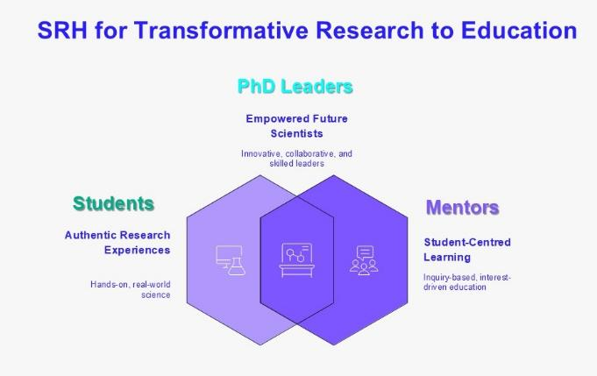
Figure 1. General description of the SRH concept.
The general Objectives of WP7 that are supported by SRH are:
- Deliver research results and innovation back into education, enabling students to become scientists by learning how to conduct research through authentic, hands-on experiences.
- Attract students to science through modern student-centered educational practices, using inquiry-based learning and formulated research experiences that respond to students’ interests, needs, and career aspirations.
- Enhance curricula and support pathways towards advanced degrees and international scientific careers, providing students with opportunities that extend beyond traditional classroom learning.
- Provide multi-institutional research opportunities through EU-CONEXUS partners, giving undergraduate and postgraduate students access to transnational research experiences, fostering intercultural understanding, international networking, and collaboration across disciplines and countries.
- Engage students in active scientific research and creative problem-solving, encouraging them to work on real scientific and societal challenges related to Smart Urban Coastal Sustainability.
- Provide access to advanced equipment, research infrastructures, and methodologies available within EU-CONEXUS partner universities’ research units, allowing students to acquire specialised research competences alongside digital, green, and sustainability-related skills.
- Promote teamwork and collaborative learning, enabling students to develop research skills, critical thinking, innovation capacity, transversal competences, and transferable skills that are highly valued in the labour market.
- Support the development of future academic leaders by assigning PhD students and early-career researchers as project leaders, offering them practical experience in mentoring, tutoring, leadership, organisation, communication, and time management.
Students will participate in research projects, use EU-CONEXUS advanced infrastructure, improve critical thinking and scientific reasoning, develop innovative ideas, digital, creative and transversal skills. In these activities, PhD students will play a key role by guiding undergraduate students as co-learners or explorers, gaining tutorial and leadership experience; in summary: they will apply what they have learned in theory. Ultimately, undergraduate research through SRH prepares students for success in both academic and professional careers.
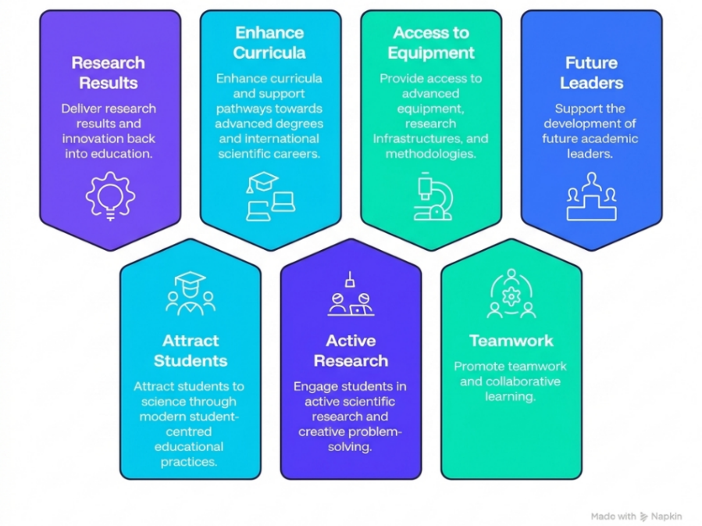
Figure 2. SRH benefits for undergraduate, postgraduate and PhD students.
It is important to note that the multi-institutional research opportunities offered by numerous EU-CONEXUS research teams, in all research areas (Health Sciences and Agricultural Sciences, Natural Sciences and Engineering and Technology, Social Sciences and Humanities, Education) meet the needs of students by offering them structured experiences and promoting their aspirations to pursue an internationally competitive scientific and research career.

T7.2 Student Research Hub Concept
The Student Research Hub (SRH) is a research-based training initiative of approximately two months' duration conducted within EU-CONEXUS partner Universities research units, where undergraduate and postgraduate students collaborate with a Leader (a PhD student or early-career researcher R1 or R2), under the supervision of a Mentor (R3/R4 researcher) to address scientific problems and societal challenges related to Smart Urban Coastal Sustainability. Through an interdisciplinary and inquiry-driven approach, participants engage in authentic research activities, including literature review, data collection, experimentation, analysis, and interpretation of results, while developing research, digital, green, and transferable skills. At the end of each project, students prepare written reports or other assignments and deliver oral presentations showcasing their research outcomes, and the best-performing teams are recognized through mobility awards and opportunities to participate in conferences and scientific events (Figure 3).
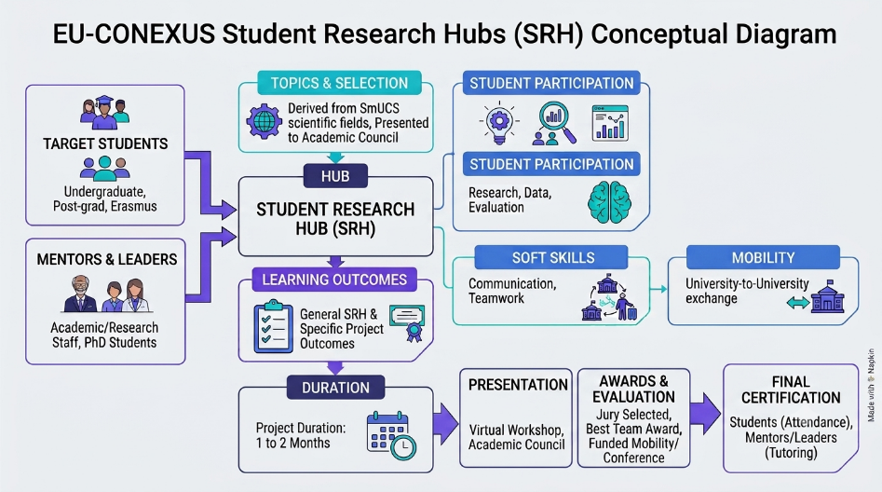
Figure 3. General description of a Student Research Hub flowchart with implementation steps.
Core Components of the Student Research Hub (SRH)
- Format: An intensive research-based programme of approximately from on two months' duration, delivered within the EU-CONEXUS Research Units (RUs).
- Methodology: An inquiry-driven and collaborative approach focused on addressing scientific problems and societal challenges related to Smart Urban Coastal Sustainability through authentic research activities.
- Structure: A research team consisting of:
  - a Mentor (senior academic/researcher, R3/R4),
  - a Leader (PhD student or early-career researcher, R1/R2),
  - undergraduate and postgraduate (Bachelor and Master’s) students
- Research Activities: Students participate in literature review, data collection, experimental procedures, analysis and interpretation of results, and the development of research-based solutions.
- Delivery: Offers a flexible participation model depending on each SRH offer
- Outputs: Participants prepare written reports and deliver oral presentations presenting their research findings and project outcomes.
- Learning Environment: Access to advanced equipment, infrastructure, outdoor environments, specialized software methodologies.
- Certification and Awards: The best-performing student teams are evaluated by a dedicated Evaluation Comitee and receive mobility awards and opportunities to participate in EU-CONEXUS conferences and scientific events.
The initiative involves contributions from AUA, LRUniv, KU, UNIZD, SETU, UCV, UROS, FredU and EU-CONEXA. The Mentoring team of each SRH is comprised from Mentors and Leaders of each University and students affiliated to all partner Universities are eligible to participate. The SRH aims to transform students into active researchers by providing authentic, inquiry-driven learning experiences that combine scientific investigation, teamwork, and problem-solving. Through participation in research projects, students become familiar with advanced equipment, research infrastructure, and methodologies available within EU-CONEXUS Research Units, while developing critical thinking, digital, green, creative, and transferable skills.
The initiative also promotes interdisciplinary collaboration, international networking, and pathways towards postgraduate studies and scientific careers. The detailed learning outcomes for each project are clearly outlined and described in each SRH offer. Students are actively engaged in research by analysing and evaluating their results, taking responsibility of their work, developing innovative ideas as junior researchers and hone problem-solving skills. They are trained on how to conduct interdisciplinary research as part of their curriculum. At the end of each project, students present their findings and share their research experience through the EU-CONEXUS Closing Virtual Workshop on Undergraduate Research Activities.

Table 1. Detailed characteristics of the Student Research Hub project
Aspect | Details
Contributors | AUA (co-ordinator), LRUniv, KU, UNIZD, SETU, UCV, UROS, FredU, EU-CONEXA
Target | Bachelor and Master students (including Erasmus students) affiliated to EU-CONEXUS universities.
Mentors | Academic and/or research staff (Level R3 and R4)
Leaders | PhD students and Researchers (Level R1 and R2)
Topics | Derived from all research scientific fields in Eu-CONEXUS Universities
Duration | 1-2 months (depending on the project and implementation schedule).
Expenses | Covered by EU-CONEXUS Universities’ research units
Thematic Selection | Selected topics presented at Academic Council
Students Participation | It is recommended to foresee a minimum of 30 contact and 70 hours of autonomous hours during the duration of the SRH.
Project List for SRH | Provided by Mentors at the start of the academic year  Uploaded to SRH webpage on EU-CONEXUS website  Includes necessary info & timetable for recruitment
Team Recruitment | - After student enrolment, Leader recruits the team  - Tasks assigned to on-site & remote students
Student Participation | - Assist in experimental procedures  - Perform data collection  - Conduct literature search  - Analyse & evaluate results  - Participate in field activities  - Are trained to scientific methodologies  - Take responsibilities in project implementation
Presentation and writing skills | Students trained to prepare conference presentations, reports, posters or manuscripts
Learning Outcomes | - General learning outcomes of SRH  - Specific project learning outcomes (defined by the Mentors of the SRH)
Mobility | Students’ mobility to another University during the trainings is supported by EU-CONEXUS PLUS, BIPs or other national funding of partner Universities
End-of-Year Presentation | SRH outcomes presented in “Closing virtual workshop on undergraduate research activities”
Evaluation & Awards | Jury selected by Mentors evaluates work  Best student team awarded (1 per partner/year)  Award includes EU-CONEXUS-funded mobility & conference/workshop registration
Certification | - Certificates of attendance given to students for attending the Student Research Hubs  - Mentors and Leaders given a certification for tutoring (mentoring) experience

During the two-month duration of the SRH, the research projects are either integrated into existing research initiatives or focused on developing new research ideas. A question-driven methodological approach is adopted, providing students with an opportunity to gain extended familiarity with the advanced equipment and infrastructure of EU-CONEXUS research teams and/or engage deeply with sophisticated methodologies for data collection and evaluation. Training of students can also include practising on advanced software, literature search and the use of scientific nomenclature in English. An example of the structure of a SRH project is shown in Figure 4.
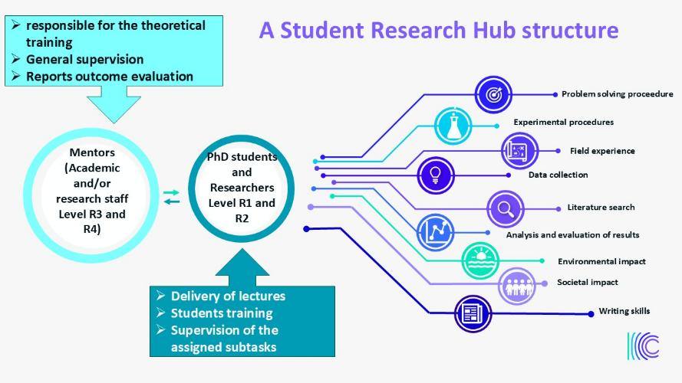
Figure 4. Example of the structure of a Student Research project
By participating in SRH undergraduate students and post-graduate students are benefited by:
- Being informed and consulted about the research on diverse thematic areas
- Projects in EU-CONEXUS research units that might not be directly related to their degree studies
- Training on advanced instrumentation
- Developing innovative ideas and problem-solving skills
- Enhanced CV
- English proficiency
- Teamwork
- Autonomy and responsibility
- Participation in conference announcements and/or publications
- Successful transition in the labour market and higher employability

General Learning Outcomes of SRH for undergraduate students:
- Research attitude with responsibility of their work as junior Researchers
- Analysis and result evaluation skills
- Writing and oral skills with discipline-specific language and rules
- Ability to work with advanced instrumentation (depending on the thematic area)
- Problem solving skills
- Teamwork skills
- Interpretation of multiple information sources.

PhD students as group leaders to gain experience on instructing assignments to a team of students, tutoring, leadership, time management and organizational skills. By participating in SRH, PhD students (and Researchers Level R1 and R2-after GA agreement) will be benefited from experience on assignments with high numbers of students, therefore they gain:
- Tutoring experience
- Leadership experience
- Time management skills
- Feedback for their research
General Learning outcomes for PhD students:
- Respond to questions or tasks that directly emerge from students
- Tutoring and instruction skills
- Organizational skills
- Writing skills
PhD students are also encouraged to participate and attend training programs regarding teaching offered by EU-CONEXUS or partner Universities (WP4, WP5).

SRH Coordination and Implementation

The implementation procedure for an SRH includes the following steps:
- Call for Mentors for the selected SRH.
- Identification of leaders by each Mentor.
- To identify projects for SRH at each institution (i.e Leader and Mentor).
- Filling in the respective application form template.
- Send the application by email to the coordinator team.
- Creation of the respective webpage with all the necessary information for students available at: https://www.eu-conexus.eu/en/student-research-hub/
- Students’ enrolment via the website https://www.eu-conexus.eu/en/student-research-hub/
- Creation of the dedicated workspace in Moodle, in collaboration with the coordination team, the IT, where applicants are registered.
- After the deadline for registrations, depending on the capacity of each project (defined by the Mentor and Leader of each project), there is a selection procedure, defined by each Mentor.
- Educational material has to be uploaded by the Mentors and Leader (i.e. literature, exercises, pictures, videos) in Moodle.
- Delivery of the SRH project in a flexible format i.e (a) on-line courses via the embedded function in Moodle, BigBlueButton. (Courses are recorded so they can be delivered asynchronously) (b) on site in RU infrastructure.
- Each team leader recruits the team members and organises the exact timetable of activities depending on Mentors, leaders and students’ availability according to the proposed project application.
- Evaluation of students by assignments or other research work.
- At the end of each Academic year students from all SRH present their work at the Closing virtual Workshop on undergraduate research activities.
- The best team per university is awarded by the Evaluation Committee a mobility Grant to a conference.
- Satisfaction survey completion by participants

The process of SRH implementation is shown in Figure 5.
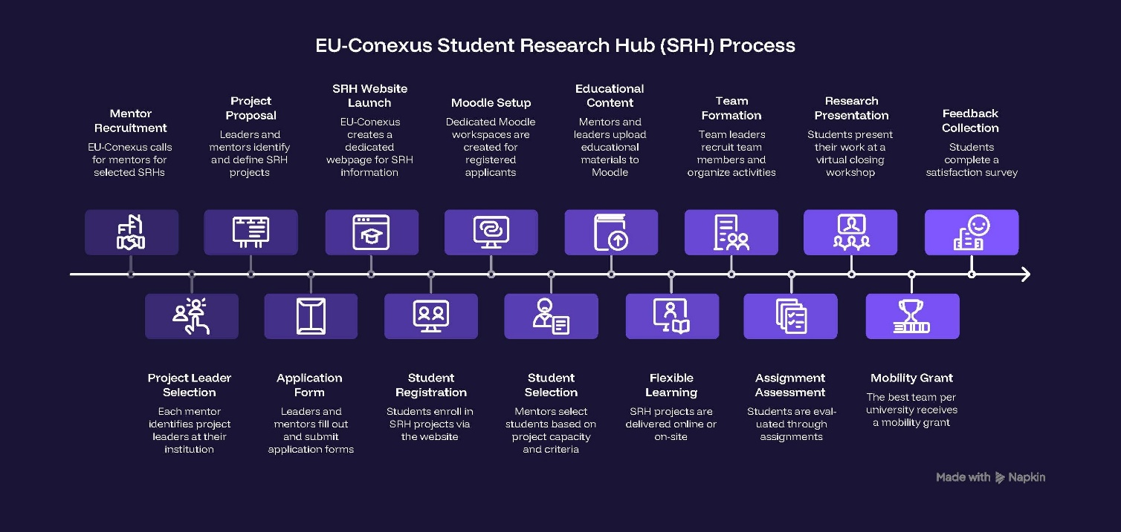
Figure 5. Schematic representation of SRH projects implementation.

Phase I: Preparatory actions to implement the SRH projects
The preparatory phase of Student Research Hub (SRH) implementation encompasses all activities from the initial development of project concepts, identification of Mentors and Leaders and inter-institutional coordination to student recruitment and the establishment of the necessary digital infrastructure. This phase lays the foundation for successful project delivery by ensuring that all organisational, academic, and technical requirements are in place before the commencement of research activities. The process includes the organisation of Work Package (WP) group meetings involving representatives from partner institutions to coordinate responsibilities, define implementation procedures, align objectives, identify Mentors and Leaders, and monitor progress. These meetings provide a structured framework for collaborative decision-making and help ensure consistency and coherence across the alliance. Complementing these activities, bilateral meetings and discussions are conducted among WP coordinators, Mentors, and Leaders to develop project topics, define learning outcomes, establish workloads, and determine implementation schedules.
A structured procedure was established for the preparation of all documentation required to support SRH implementation by the coordination team, including open calls for Mentors and Leaders, proposal templates, application forms, evaluation forms, participation lists, certification documents, reporting templates, and student satisfaction questionnaires. Standardized guidelines and supporting documentation were developed to facilitate the delivery of SRH activities. All documents were reviewed and validated to ensure alignment with the objectives of WP7 and the educational and research goals of the initiative.
Based on these procedures, partners advanced to the planning and organisation of SRH projects. In each application form the content was developed, including the definition of research topics, expected outputs, mode of delivery (on-line, hybrid and period of on-site participation), implementation timelines, and students’ participation requirements. Simultaneously, dedicated webpages were created for each SRH offer and published on the EU-CONEXUS website, serving as the primary source of information for prospective participants and providing details on project objectives, thematic areas, enrolment procedures, workload, and schedules. Before the start of each project, detailed implementation guidelines were provided to all participants. In parallel, a dedicated digital learning environment was established for each SRH project, typically through the Moodle platform, functioning as the central hub for communication, educational resources, project coordination, collaborative work, submission of assignments, and dissemination of project outputs throughout the duration of the research activity. When SRH projects involve physical mobility, WP7 representatives and partner institutions collaborate to identify and secure available funding opportunities and mobility grants, ensuring that students can participate in transnational research activities and benefit from international research experiences.

Identification of projects, Mentors and Leaders by each institution
The engagement of Mentors and Leaders was supported through a combination of governance structures, open calls, targeted dissemination, institutional meetings, standardized procedures, workload flexibility, leadership recognition, and mobility support. These preparatory activities were specifically designed to overcome recruitment barriers, increase participation, and ensure the successful implementation of Student Research Hub projects across the EU-CONEXUS alliance.
The following preparatory actions were implemented to recruit, support, and engage Mentors (R3/R4 researchers) and Leaders (PhD students and later R1/R2 researchers) in the Student Research Hub (SRH) initiative:
- Bilateral meetings between the WP7 coordination team and partner institutions Mentors, were conducted to discuss barriers, workload, implementation procedures, and engagement strategies.
- Internal institutional meetings were organised across partner universities to identify and engage suitable academic staff, researchers, and PhD students for participation in SRH activities. These meetings served to present the objectives, structure, and expected benefits of the Student Research Hub, while fostering awareness and institutional support for the initiative. Faculty members, researchers, and doctoral candidates were encouraged to contribute actively by proposing research topics aligned with their expertise, ongoing research projects, and the activities of their respective Research Units. This process facilitated the recruitment of Mentors and Leaders, strengthened ownership of the initiative within each institution, and supported the development of a diverse portfolio of SRH research projects.
- The WP7 concept and the opportunities offered through SRH were regularly presented to the Academic Council, Research Council, WPLG Education Group, and the Coordination Committee. These presentations aimed not only to promote the objectives, benefits, and progress of the initiative across the alliance, but also to raise awareness among the academic and research community, encourage institutional engagement, and identify potential Mentors (R3/R4 researchers) and Leaders (PhD students and R1/R2 researchers). The meetings provided a platform to discuss implementation procedures, share project opportunities, strengthen collaboration among partners, and facilitate the recruitment of academic staff and researchers aiming to contribute to SRH activities.
- Mentors actively approached PhD students and early-career researchers to encourage them to undertake leadership roles.
- Successful SRH examples and guidance documents were provided to reduce uncertainties and improve understanding of expectations and responsibilities.
- Clear definitions of Mentor and Leader roles, expected workload, learning outcomes, and implementation procedures were communicated to participants.
- Open calls were disseminated throughout the alliance inviting academic staff and researchers to propose SRH projects.
- Structured templates enabled Mentors to submit project ideas in a standardized format.
- Calls were circulated through institutional emails, WP7 representatives, and direct communication with academic departments and research units.
  - Dedicated presentations were delivered during EU-CONEXUS PhD Weeks and annual conferences to promote participation among PhD students and researchers.
  - The benefits of participation for Leaders were actively promoted throughout the implementation of the SRH initiative. Particular emphasis was placed on the opportunity to develop leadership, mentoring, supervision, tutoring, organizational, and time-management skills through guiding undergraduate student teams. Leaders were also encouraged by the prospects of international collaboration, increased visibility of their research activities through conferences and dissemination events, and formal recognition of their contribution through certification of mentoring and leadership experience.
- Mentors and Leaders were given flexibility to determine implementation schedules according to project needs, institutional commitments, and participant availability.

Communication strategy
Collaboration was established with Joint Communication Unit (JCU) in WP10, regarding the creation of dedicated webpage for the Student Research Hub projects https://www.eu-conexus.eu/en/student-research-hub/ initiative. This webpage serves as a centralised platform where all relevant information about the SRH offer is presented in a clear and accessible manner, including the title, thematic area, learning objectives, timetable, prerequisites, and assessment methods or any other additional practical information. The information of each project is uploaded in the relevant webpage (see Appendix II), offering visibility of all details and also facilitating coordination between partners by providing a common reference point for all stakeholders involved in the implementation of SRH activities. It also functions as the main entry point for student enrolment, enabling participants from all partner universities to apply through a unified system (Figure 5). In addition, the webpage supports dissemination by increasing the visibility of SRH activities across the EU-CONEXUS alliance and it is continuous updating with new SRH offers.
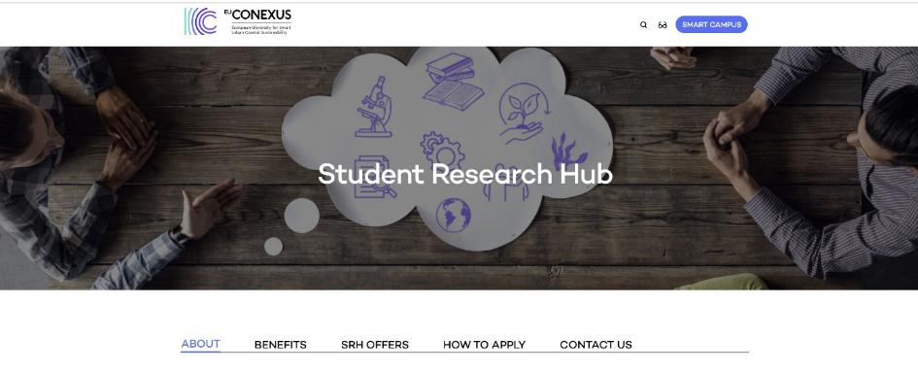
Figure 6.Structure of the SRH webpage
The dissemination of SRH activities followed a multi-channel strategy combining digital, and interpersonal communication tools to ensure wide outreach across partner universities. Various communication channels were used for students’ invitation to participate in WP7 activities as EU-CONEXUS website and social media, institutional e-mails, newsletters and other social media channels and personal communication by lecturers or other students.
Institutional email campaigns served as a primary dissemination channel, delivering targeted information to students regarding new SRH offers, with links to the respective webpages. EU-CONEXUS’, social media platforms were actively utilised to amplify the programme's reach and engage a wider academic audience. Dissemination efforts were further reinforced through the internal communication networks of WP7, which facilitated coordination while enabling direct engagement by Academics at departmental level to encourage the participation of students in these activities.
SRH brochures, webpages, promotional materials, student testimonials, and communication campaigns were developed to increase visibility. Finally, presentations at EU-CONEXUS events, workshops, and conferences, which helped raise awareness and encourage participation among both students and mentors.

Phase II: Implementation

Mode of delivery
The SRH projects were designed with a flexible delivery model to accommodate the diverse nature of research activities, institutional requirements, and participant availability across the EU-CONEXUS alliance. Depending on the objectives and methodological requirements of each project, SRHs could be implemented in hybrid, or fully online modes, allowing Mentors and Leaders to select the most appropriate format for achieving the intended learning and research outcomes.
Projects involving laboratory experimentation, fieldwork, specialized infrastructure, or direct access to research equipment were primarily delivered through on-site participation, enabling students to gain hands-on experience with advanced instrumentation and research methodologies. In contrast, activities such as literature review, data processing and analysis, scientific discussions, project meetings, report writing, and presentation preparation could be conducted remotely through digital collaboration tools and the Moodle learning environment. The hybrid delivery model was widely used to combine physical and virtual participation, enabling students from different EU-CONEXUS universities to collaborate on common research projects while maintaining access to local research facilities and expertise.
A key feature of SRH implementation was the flexibility provided to Mentors and Leaders in defining not only the mode of delivery but also the duration and organization of each project. Rather than applying a rigid and uniform structure, each SRH was treated individually, allowing implementation arrangements to be adapted according to the project's objectives, research activities, student profiles, and institutional constraints. Although the SRH concept was originally designed as an activity of approximately two months' duration, in practice project length varied according to the nature of the research, typically ranging from one to two months, while some projects extended over a longer period when required to achieve their intended research outcomes.
The duration of an SRH was often determined by the selected mode of delivery. For projects involving mandatory physical mobility, the core research and training activities were frequently concentrated within a restricted period of approximately 3–5 days to facilitate student travel and participation. Preparatory work, collaborative assignments, online meetings, data analysis, and reporting activities were completed before and after the mobility period through online engagement. In contrast, SRH projects delivered primarily online could extend over a longer period, providing greater flexibility for students and research teams to organize their work alongside academic commitments. The overall implementation period also included the time required for students to complete project assignments, analyze and interpret results, prepare written reports, and develop the final presentations of their research outcomes.
To enable informed participation for students, the mode of delivery, duration, workload, eligibility criteria, mobility requirements, timetable, and implementation arrangements were clearly described for each SRH project on the dedicated EU-CONEXUS webpages, allowing prospective students to understand the specific requirements and organization of each offer before applying.
Where available, a limited number of mobility grants were provided by partner universities to support the physical participation of students in SRH activities hosted by other EU-CONEXUS institutions. These opportunities enabled selected students to gain direct access to specialized laboratories, research facilities, fieldwork activities, and international research environments, further enriching their learning experience. All travel and administrative arrangements were coordinated by the students’ home universities in accordance with the schedule provided by the hosting institution and project organizers. The selection criteria for awarding mobility support were determined independently by each partner university according to its internal procedures and available funding mechanisms.
This flexible delivery approach ensured broad participation, strengthened international collaboration, and enhanced the transnational research experience offered through the Student Research Hub initiative.

Courses in Moodle
Creating a SRH project in Moodle requires a structured setup that accommodates multi-institutional access, coordinated learning, and tracking of progress and assessments. The site administrator creates a new blank course within the dedicated EU-CONEXUS / WP7 Student Research Hub category (Figure 7).
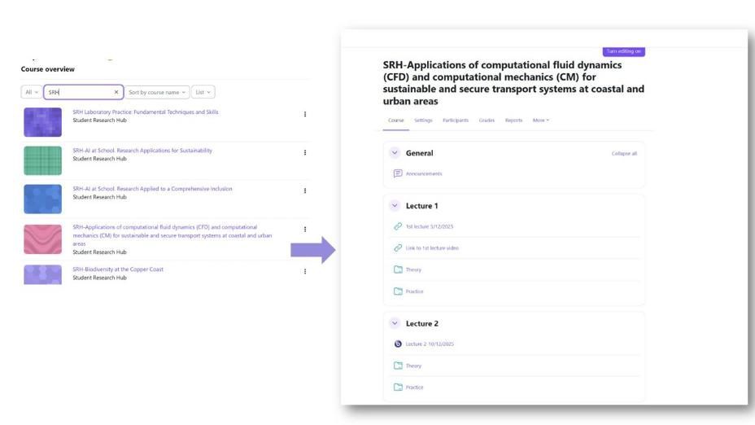

Figure 7.Structure of an SRH in Moodle. List of projects and course organization
All scheduled lectures and materials are uploaded in a structured way as shown in figure 7. Sessions using bigbluebutton are created for the delivery of each lecture and recorded to be available to students. In case other external platform is used (teams or zoom) the link is made available to students too. Any additional educational material or assignment is also uploaded.

Students’ participation
The SRH has been designed in various formats to fit both Mentors and Leaders as well as to offer maximum flexibility to students, ensuring it seamlessly integrates into the diverse timetables of various universities. While specific components may require real-time participation, such as experimental procedures, infrastructure demonstration, live discussions, or interactive Q&A sessions, part of the curriculum is available on-line. This hybrid structure empowers students to access course materials, recorded lectures, and assignments at their convenience. Ultimately, this approach allows participants to learn at their own pace while successfully balancing their academic commitments.

A. Registration and Enrolment Phase
The process begins with student enrolment through the dedicated EU-CONEXUS Student Research Hub (SRH) website, where applicants can review the project descriptions, learning outcomes, workload, implementation arrangements, and participation requirements before submitting their applications. Following the registration period, the list of applicants is provided to the respective Mentors and Leaders, who evaluate applications according to the specific requirements and capacity of each SRH project. Selection criteria may include the maximum number of students that can be accommodated, particularly in projects involving laboratory work or field activities, as well as the applicants’ academic background, motivation, relevance of their studies to the project thematic area, and, where appropriate, information provided in their curriculum vitae.
Once the selection process is completed, accepted students are enrolled in a dedicated Moodle workspace created specifically for each SRH project. This workspace serves as the central digital environment for project implementation, supporting communication and collaboration among Mentors, Leaders, and students throughout the project duration. It hosts all educational and research materials, including literature, presentations, datasets, assignments, and supporting documentation, while also providing access to project schedules, learning outcomes, implementation guidelines, reporting templates, and assessment information. When online meetings or training sessions are required, these can be delivered through the integrated Moodle tools and recorded to facilitate access for participants. In cases where physical mobility is involved, the workspace also provides practical information regarding mobility arrangements, schedules, and local logistics. By centralizing all project-related resources and communication channels in a single platform, the Moodle environment ensures effective project coordination, transparency, and continuous engagement of participants throughout the implementation of the SRH activities.

B. Delivery Models and Learning Activities
The SRH projects were designed as a flexible research-based learning and training activity capable of accommodating the diverse requirements of research projects, partner institutions, and participants. Depending on the nature of the project, activities could be delivered through face-to-face, hybrid, or fully online modes, allowing Mentors and Leaders to select the most appropriate implementation model. The hybrid model proved particularly effective in facilitating collaboration among students and researchers from different EU-CONEXUS universities while maintaining access to local research infrastructure and expertise. The necessary prerequisites for participation and implementation procedures were indicated in each call.
Learning activities were structured around authentic research experiences and integrated into ongoing research projects or newly developed research initiatives within the EU-CONEXUS Research Units. Students actively participated in a wide range of research tasks, including literature review, experimental procedures, field and laboratory work, data collection, statistical analysis, interpretation of results, scientific writing, and problem-solving activities. Depending on the project, training also included the use of advanced instrumentation, specialised software, research methodologies, research ethics, sustainability-related topics, and digital tools relevant to the thematic area. Throughout the project, students worked individually or as members of multidisciplinary research teams under the supervision of Mentors and Leaders, participating in regular meetings, progress reviews, collaborative assignments, and feedback sessions. The final outputs of each SRH included a written report and an oral presentation of the research outcomes, typically showcased during the EU-CONEXUS Closing Virtual Workshop on Undergraduate Research Activities.
A limited number of mobility grants were provided by partner universities to support the physical participation of students in SRH activities hosted by other EU-CONEXUS institutions. These mobility opportunities increased students’ interest on the activities students involvement while supported the international collaboration and transnational character of the Student Research Hub initiative.

C. Completion and Certification
To successfully graduate from a SRH project, students must fulfil the specific tasks, such as assessments, reports, or coursework as specified by the mentors in each SRH. At the end of each SRH project, the Mentors provided the organization committee with the list of students that have successfully completed all the necessary assignments. Upon meeting these requirements, students are formally awarded a certificate of participation, indicating the number of hours’ engagement in each project and thus recognizing their participation.

Phase III: Post-implementation actions
In the SRH, students work either individually or in teams on project assignments, enabling them to develop valuable time management skills. It is required to write a detailed report, enhancing their scientific writing abilities. An oral presentation, showcasing their capacity to articulate and develop ideas related to the project’s research questions is also required. At the end of each academic year, students are invited to present their work and share their experience at EU-CONEXUS community (Closing virtual Workshop on undergraduate research activities). By this initiative, students enhance their oral and communication skills. During the workshop, a jury evaluates the work done and award the best student teams (1 per participating partner/year) for their exceptional work by funding through EU-CONEXA budget mobility and registration to a conference/workshop. The three-member Jury was selected every year by the WG and evaluated the projects through a structured questionnaire with a grading ranging from 1-10 on various questions. Feedback was also obtained from Mentors and Leaders regarding these activities.

Barriers, challenges and mitigation measures

The implementation of the SRH encountered several persistent administrative, institutional, and operational barriers during its initial concept and thematic development phase. Despite the significant efforts undertaken to establish and expand this initiative across the EU-CONEXUS alliance, the development and implementation of SRH projects encountered a number of organisational, institutional, and thematic challenges. As a novel research-based educational activity requiring the active engagement of Mentors, Leaders, and students from different universities and disciplines, the development of project themes depended on effective inter-institutional collaboration, the availability of academic and research staff, alignment with institutional regulations, and calendars as well as students’ interests.
Since the beginning of the project, a number of barriers affecting the implementation of the Student Research Hub (SRH) were identified through WP7 Working Group meetings, bilateral discussions with partners, presentations to the Academic Council, and continuous monitoring of progress. These challenges were systematically analysed and documented in Deliverable D7.1 – Mid-Term Report on Progress of Open Lab Hours and Student Research Hub, where a series of mitigation measures were proposed to address issues related to mentor and leader engagement, thematic development, student participation, institutional regulations, mobility, dissemination, and project implementation procedures. The consortium adopted a proactive approach by continuously adapting the implementation framework and reviewing progress to ensure that the objectives of WP7 could be achieved while preserving the educational value and ambition of the initiative.
The importance of these challenges was further confirmed by the external evaluators during the project review process (Table 2). While the evaluators acknowledged the strong educational value, innovative character, and potential impact of WP7 in bringing research and innovation back into education, they also highlighted several concerns regarding the implementation and progress of the SRH. In particular, they identified difficulties in recruiting Mentors and PhD Leaders, delays in project implementation, uneven participation among partner institutions, and lower-than-expected progress towards the established KPI targets. The evaluators also noted that the SRH model places high expectations on undergraduate students while requiring substantial supervision effort and commitment from PhD researchers acting as Leaders.

These observations, summarized in Milestone M40 – Review of WP7 Implementation Strategies and Current Status, reinforced the findings already reported in D7.1 and validated the need for the mitigation measures proposed by the consortium and validated by the Academic Council. Consequently, additional actions were introduced to increase flexibility in implementation and improve the overall delivery of SRH activities across the EU-CONEXUS alliance.
The main barriers identified during the thematic development phase and the proposed mitigation measures are presented below and reflect the experiences and feedback collected from partner institutions throughout the implementation process.

Table 2. Evaluator’s findings, proposed recommendations, actions taken, efficacy of the mitigation measures and final impact
Deviations for WP7 | Recommendations | Mitigation measures | Status on M24 | Status on M48
Delays faced by several WPs due to various reasons | Accelerate the implementation of key activities by setting realistic timelines and allocating adequate resources to ensure completion of delayed tasks.  Particular attention should be paid to the most common causes of delays encountered thus far | Identification of the main causes of delays (as shown in detail in the following chapter.  Modification of the timeline for the delivery of the offers  Expansion of the thematic areas for SRH projects | Number of implemented SRH: 10  Timeline:  delivery of 3 x 6 SRH projects per participating partner per semester | Number of implemented SRH: 114  Timeline:  Delivery of a total number of 18 projects to per partner throughout the project duration.
Difficulties in securing the participation of both doctoral students and researchers as mentors. |  | Modification of the implementation workload  Expansion of Eligible Leaders beyond phD students  Awards and International Exposure | Number of phD involved: 10  Role of the Leader: PhD students | Number of phD involved: 114  Role of the Leader: PhD students and early-career researchers (R1 and R2)
Student Research Hub activity sets high expectations on the learning outcomes for the BSc students as well as a heavy responsibility for the PhD researcher supervising the activities- “partners faced difficulties in recruiting mentors and PhD students, citing heavy workloads as a primary obstacle” | Regarding the Student Research Hubs (T7.2), it is suggested to reconsider the way the supervision of students is structured. | Revision of workload requirements  Flexible project duration  Flexible implementation modes  Clear definition of roles and responsibilities  Clarification and standardization of procedures | approximately 120 contact hours and 200 hours of autonomous work within a two-month period | Approximately 30 contact hours and 75 hours of autonomous work  Duration 1-2 months
Some mitigation measures have already been considered, such as involving MSc students in the projects (in both roles) and the possibility to offer better incentives to PhD researchers | MSc students were not initially included as participants in these activities; however, it is positive that this is now proposed as a change in the implementation | Flexible Delivery and Scheduling  Adapted Participation Models | Eligible students: undergraduate students | Eligible students: BSc, Master's and Erasmus students
The WP7 KPI “Number of students involved in Student Research Hub” is still very low. | Reinforce mitigating measures and activities in WP7 to ensure that the target will be reached | Increased awareness of SRH benefits  Synergies with WP2 and Minor Programmes  Enhanced Mobility Opportunities | Number of students registrations: 152  Number of students involved: 90  Number of international mobilities: 1 | Number of students registrations:1889  Number of students involved: 1109  Number of international mobilities: 145
 | Reinforce communication efforts through the different channels (web page, social media, brochures etc.), clearly highlighting the added value for participants. The frequency and prominence of announcements for new Student Research Hubs and Open Lab Hours should be increased. | Reinforcement of communication strategy | Communication strategy:  - Emails  - Webpages  - Brochure  - Social media posts  - Presentation in EU-CONEXUS events | Communication strategy:  - Emails  - Webpages  - Brochure  - Social media posts  - Presentation in EU-CONEXUS events  - Boosted video  - Testimonials  - Articles  - Presentation in Institutional events
The contribution of the participants is aligned with commitments in the DoA, although there are some exceptions. In WP7, all partners contributed to the development of the tasks in 7.1 and 7.2; however, their involvement did not fully align with the level of participation initially planned in the DoA | It is also not fully clear how the mitigation measure of adjusting the SRH to be offered with LRUniv withdrawal would be carried out. | Efforts to cover the expected number of offers | No mitigation measure applied | Certain partners achieved to offer up to 22 SRH until the end of the project.
It is noted that the Student Research Hubs offers in particular have been very unequally distributed among partners and one partner (LRUniv) has even withdrawn from the activity for reasons which are not explained in the periodic report. |  | Intensified efforts to have offers from all partner Universities.  Personalized recruitment strategy  Continuous institutional support  Justification of LRUniv withdrawal in the final report | Offers only from AUA, UROS and KU | Offers from all partners

Mentors Recruitment
One of the most significant challenges encountered during the implementation of the SRH was the recruitment and sustained engagement of Mentors. In the initial proposal for the structure of a SRH, it was recommended “to foresee 120 contact and 200 hours of autonomous studies hours during the 2 months duration of a SRH project”.
Based on this concept, many academics and researchers across the partner institutions, faced substantial workloads associated with teaching, research, supervision, administrative duties, and participation in institutional committees. As a result, dedicating additional time to design SRH projects, recruit student teams, supervise activities, and participate in project coordination proved difficult due to the long duration of these activities. This challenge was further exacerbated in some institutions where mentoring activities did not receive formal recognition or financial compensation, reducing the incentive for academic staff to engage in the initiative.
Another important barrier related to the novelty of the SRH concept itself. During the early stages of implementation, several partners reported uncertainties regarding the project's implementation framework and procedures, expected workload, supervision requirements, and implementation procedures. The lack of clarity initially created hesitation among potential Mentors and delayed the submission of project proposals. Considerable effort was therefore required to provide guidance, templates, examples of successful projects, and direct support to ensure a common understanding of the activity across the consortium.
Several partners reported that researchers were significantly more willing to participate when they were approached directly by WP7 representatives or by an already engaged leading Mentor. This demonstrated that active and personalized recruitment strategies were far more effective than general calls for participation.
The identification of suitable Mentors for specific thematic areas represented an additional challenge. The interdisciplinary nature of Smart Urban Coastal Sustainability required expertise from a broad range of disciplines, yet the availability of researchers varied considerably between institutions and scientific fields. In some cases, researchers' expertise did not align closely with the themes being developed within WP7, limiting the ability to create diverse project offers and impeding the expansion of the SRH offerings.
Partner-specific examples further illustrate these challenges. At FredU, representatives reported difficulties in identifying mentors whose research specializations aligned with several of the proposed thematic areas relevant to Smart Urban Coastal Sustainability. At KU, participation was hindered by heavy workloads and competing academic responsibilities. The institution reported difficulties encouraging researchers and doctoral students to submit applications and become involved in SRH activities.
In LRUniv following an internal assessment identified a combination of institutional, regulatory, operational, and financial barriers that limited the feasibility of delivering SRH projects within the university's academic framework. In particular, the participation of PhD students as Leaders could not be formally recognised within doctoral training programmes, reducing incentives for engagement. Furthermore, the SRH model was found to be incompatible with several institutional regulations governing internships and student supervision, including requirements that internships be supervised individually rather than through group-based research activities. Additional challenges included constraints related to supervision models, workload expectations, the absence of suitable funding mechanisms, and insufficient resources to support PhD students, internships, and mobility activities.
These challenges established the mitigation measures within the consortium and justified the introduction of additional actions aimed at facilitating Mentor recruitment, increasing flexibility, and strengthening engagement across all partner institutions.
Mitigation measures
To address the challenges associated with Mentor recruitment and engagement, the WP7 coordination team implemented a series of corrective actions aimed at reducing barriers, increasing awareness, and facilitating participation across the EU-CONEXUS alliance.
- A primary mitigation measure was the adaptation of the SRH workload and implementation framework to better accommodate the availability and commitments of academics and researchers. According to the revised concept, Mentors and Leaders were encouraged to provide an approximate of 30 contact hours over the course of the project, including lectures, mentoring sessions, student support, research supervision, laboratory activities, fieldwork, and on-site training. In addition, they were expected to dedicate approximately 75 hours of autonomous work to project preparation, coordination, assessment of student assignments, supervision of research activities, and evaluation of final reports and presentations. Although the original SRH concept envisaged a duration of approximately two months, greater flexibility was introduced during implementation. While projects generally followed this timeframe, shorter durations were accepted in cases where the research activities were concentrated into more intensive periods, particularly for projects involving physical mobility and intensive on-site training delivered over several consecutive days. Conversely, some SRH projects extended beyond the two-month period when required by the nature of the research, student workload, Mentor availability, holiday periods, examination schedules, or other institutional constraints. This flexible approach allowed each project to be tailored to its specific educational and research objectives while facilitating the participation of Mentors, Leaders, and students across the alliance.
- The clarification and standardization of the SRH implementation framework, as several partners initially reported uncertainties regarding the initiative's objectives, workload, timelines, duration, and operational requirements. To address these concerns, detailed implementation guidelines, standardized proposal templates, application forms, and examples of successfully completed SRH projects were developed and made available to potential Mentors. At the same time, the implementation framework was adapted to provide greater flexibility in SRH project delivery, allowing activities to be implemented in physical, hybrid, or fully online formats, depending on the nature of the project and the needs of participants. Rather than applying a rigid and uniform timeframe to all activities, each SRH project was treated individually, enabling Mentors and Leaders to determine the most appropriate duration, schedule, and mode of implementation according to the project's objectives, research requirements, student availability, and institutional commitments. The expected responsibilities and workload of Mentors and Leaders were clearly defined, while implementation timelines were made more adaptable, allowing project teams to organize their activities in a manner best suited to their circumstances. Together, these measures increased transparency, reduced the administrative burden associated with project preparation, and facilitated the participation of academics and researchers with demanding professional responsibilities.
- Significant effort was therefore invested in personal communication with faculty members and researchers to identify potential contributors and encourage participation in SRH activities. Internal discussions and regular communication were necessary to maintain interest in the initiative and support project development. Although these efforts eventually resulted in several SRH offers, substantial preparatory work was required before researchers committed to participation.
- The consortium strengthened direct communication and institutional engagement through a series of bilateral meetings between the WP7 coordination team and partner universities, aimed at presenting the SRH concept, providing guidance, addressing institutional barriers, and identifying potential Mentors. In parallel, internal meetings and targeted discussions were organised within partner institutions to highlight the educational and research value of the initiative, promote participation, and increase awareness of its benefits among academic staff and researchers. These personalised interactions proved significantly more effective than general calls in motivating researchers to engage and contribute to SRH activities.

Leaders Recruitment
The recruitment and engagement of Leaders, initially defined as PhD students, represented one of the main challenges in the implementation of the Student Research Hub’ Across the consortium, partners reported difficulties in identifying sufficient numbers of PhD students willing and available to assume leadership roles, primarily due to their existing academic, research, and professional commitments. In many institutions, participation in SRH activities was perceived as an additional workload that did not directly contribute to formal training requirements, doctoral progression, or career advancement, reducing motivation to engage in the initiative.
Another significant barrier was the diversity of institutional regulations governing doctoral education and researcher involvement. Several universities reported that participation in SRH activities could not be formally recognized within PhD training programmes, limiting the incentives for doctoral students to act as Leaders. In addition, the supervision and coordination responsibilities associated with leading a student research team were considered demanding, particularly when combined with research, teaching, and administrative obligations.
Partner-specific feedback highlighted these challenges. At UCV, PhD students were reported to have different priorities, as many of them study PhD in their free from primary work (in industry) time and/or were less inclined to participate in activities that did not directly support their academic progression. At LRUniv, participation in SRH leadership activities was not recognised as part of doctoral training, while limited financial support further reduced interest among potential Leaders. Similarly, UROS reported that PhD students already managed substantial workloads, including undergraduate tutoring responsibilities, and therefore perceived the added value of SRH participation as relatively low compared with the additional effort required.
Several partners also observed that while experienced academics were willing to propose and supervise SRH projects, the limited availability of suitable PhD students often delayed or prevented project implementation. In some cases, project planning could not be finalized until an appropriate Leader had been identified, resulting in delays in launching offers and recruiting students.
Mitigation measures
To address these challenges, the consortium implemented a number of mitigation measures.
- The role of Leader was expanded beyond PhD students to include early-career researchers (R1 and R2), significantly increasing the pool of eligible participants and improving the feasibility of project implementation.
- At the same time, the benefits of participation were actively promoted, emphasizing the opportunity to develop leadership, mentoring, supervision, tutoring, organisational, and time-management skills through guiding undergraduate research teams. A brochure was created and disseminated.
- Leaders benefited from dissemination opportunities through conferences, workshops, and other EU-CONEXUS events, as well as formal recognition through certification of their mentoring and leadership experience. The benefits of participation in a SRH were presented each year during the PhD Week events
- Particular emphasis was placed on the opportunity to support student teams competing for the Student Research Hub awards, with the best-performing projects receiving mobility grants and participation opportunities in EU-CONEXUS conferences and scientific events. These awards provided additional visibility for both students and Leaders, showcased their research achievements to the wider international academic community, and reinforced the academic and professional value of participation in the initiative.

Thematic Development
The thematic development of the Student Research Hub was initially based on the Smart Urban Coastal Sustainability framework, which provided the common scientific foundation for all projects. During implementation, however, it became evident that the original interpretation of Smart Urban Coastal Sustainability was perceived by many researchers as being closely associated with environmental, coastal, and blue-green topics, limiting the engagement of academics whose expertise lay in other scientific domains i.e social sciences or education. While researchers were generally supportive of the initiative, many experienced difficulties in directly linking their ongoing research activities to the initially perceived scope of the program. This challenge affected the recruitment of Mentors and Leaders and restricted the diversity of project proposals, particularly from disciplines outside the environmental and natural sciences. Several partners highlighted the need to broaden the thematic interpretation of SRH activities in order to better reflect the multidisciplinary nature of the alliance and fully utilize the expertise available across different faculties and research units.
Mitigation Measures
To address this challenge, WP7 promoted a broader and more inclusive interpretation of the Smart Urban Coastal Sustainability framework, encouraging researchers to develop projects based on their existing research activities while demonstrating their relevance to sustainability and societal challenges.
Through WP7 meetings, bilateral meetings, discussions, institutional consultations, and presentations to the Academic Council, partners were encouraged to propose projects from all scientific fields. As a result, the thematic scope of SRH activities expanded considerably beyond environmental sciences to include biotechnology, agriculture, aquaculture, health sciences, food sciences, engineering, business and management, economics, tourism, education, psychology, social sciences, cultural heritage, linguistics, arts, teacher training, and interdisciplinary studies. This diversification enabled a greater number of researchers to participate as Mentors and Leaders and significantly enriched the catalogue of SRH offers. Notable examples include projects developed by UNIZD in sociology, ethnography, tourism, literature, linguistics, cultural landscapes, and art education; UCV projects in teacher training, inclusion, sports, health sciences, and social intervention; KU projects in green marketing and management; and SETU projects in sustainability, biodiversity, food systems, cultural heritage, and arts-related themes; FredU projects in engineering modelling and simulations, and pharmacy. This broader thematic approach strengthened participation across the alliance while maintaining alignment with the overall objectives of WP7 and Smart Urban Coastal Sustainability.

Inter-institutional Coordination and schedule
The implementation of the SRH projects presented significant coordination challenges due to the participation of students from multiple EU-CONEXUS universities, each operating under different academic calendars, semester structures, examination periods, holidays, internship schedules, and institutional regulations. While most SRH projects were hosted by a single university, they were open to students from across the alliance, making the identification of suitable implementation periods particularly challenging. Student availability varied considerably between institutions, and periods suitable for one university often coincided with examination sessions, mandatory university practical activities, holidays, or intensive teaching periods. These differences affected student recruitment, participation rates, organization of project activities, mobility arrangements, and the scheduling of meetings and collaborative work. The challenge was further intensified in projects involving physical mobility, where travel arrangements had to be aligned with the academic obligations of students coming from different universities and countries.
Mitigation measures
To address the challenges associated with the diversity of academic calendars, student availability, and the different modes of project implementation, the consortium adopted a highly flexible delivery and scheduling approach.
- A major structural shift in SRH delivery was implemented as a key mitigation measure. The consortium revised the model outlined in the Grant Agreement, which originally envisaged the delivery of 3 x 6 SRH projects per participating partner per semester, and replaced it with a significantly more flexible implementation framework based on the total number of 18 projects to be delivered per partner throughout the project duration. This approach allowed partners to schedule projects according to the availability of Mentors, Leaders, and students, rather than adhering to rigid semester-based deadlines.
- Particular attention was given to the diversity of academic calendars across the EU-CONEXUS alliance. Since students participating in SRH projects originated from different universities, suitable implementation periods often varied considerably due to differences in semester dates, examination periods, holidays, internship commitments, and other academic obligations. To overcome these constraints, each SRH project was treated individually and implemented according to its specific needs and participant availability. Mentors and Leaders were given the flexibility to define project timelines, schedules, and modes of delivery, ensuring that activities could be organized at the most appropriate time for the participating students.
- Additional flexibility was introduced through the use of face-to-face, hybrid, and fully online delivery models. For projects involving physical mobility, the core research and training activities were often concentrated within intensive periods of approximately three to five days, enabling students to travel and participate without significant disruption to their studies. Preparatory activities, meetings, collaborative work, data analysis, and reporting tasks were then completed remotely before and after the mobility period. In contrast, projects delivered primarily through online or hybrid modes could extend over longer periods, including summer months, when appropriate, providing students with greater flexibility to balance research participation with their academic responsibilities. The overall project duration therefore frequently included the time required for literature review, data collection, analysis, report preparation, and development of final presentations.

Student Engagement and Participation
During the initial phases of SRH implementation, student interest in the initiative was encouraging and steadily increased across the alliance. However, a noticeable gap was observed between the number of students expressing interest through applications and those who ultimately participated in and successfully completed the projects. While application numbers demonstrated strong demand for research-based learning opportunities, several practical constraints limited the number of students who could be trained. In particular, projects involving laboratory work, field activities, specialised equipment, or close supervision could only accommodate a limited number of participants, resulting in a proportion of applicants not being selected.
On the other hand, student feedback consistently indicated that physical mobility opportunities were highly valued and served as a major motivation for participation in SRH activities. Students expressed a strong interest in engaging in research projects hosted by other EU-CONEXUS universities, as these experiences provided opportunities for international collaboration, and valuable hands-on experience. However, the original SRH framework did not include provisions for mobility support, creating a gap between student expectations and the opportunities available, particularly for projects requiring physical presence. Consequently, expanding mobility opportunities became an important implementation challenge and a recurring request from students throughout the delivery of Task 7.2.
Another challenge was the uneven distribution of participation among partner universities. Student engagement was considerably higher at certain institutions, whereas participation from others remained below expectations. This variation appeared to be linked primarily to differences in academic structures, workload, and scheduling across the alliance. Many students faced demanding academic commitments, including examinations, laboratory classes, assignments, internships, and, in some cases, employment alongside their studies. As a result, participation in a research project of one- to two-month duration was often perceived as difficult to accommodate within existing academic schedules. On the other hand, students were interested in SRHs organised at ‘home’ university to have a physical hands-on experience as universities’ financial capacity to finance mobilities abroad was limited. At UROS in particular, the non-implementation of some SRH offers was not primarily related to a lack of student interest or a low number of applications. Most UROS SRHs were designed as practice-oriented formats and therefore required physical participation. In several cases, interested and otherwise eligible applicants were unable to participate because mobility funding was not available through their home universities. Consequently, the availability of mobility support, rather than the level of student interest, represented a major limiting factor for participation in these UROS offers.In LRUniv’s Bachelor’s and Master’s curricula also revealed very limited opportunities to integrate the proposed SRH structure and workload, with only a single potentially compatible academic pathway that was not directly related to the Smart Urban Coastal Sustainability thematic area.
It should also be noted that variations in student participation among partner universities were influenced by significant differences in institutional size, student population, and disciplinary profiles. Larger universities, such as AUA, UCV, and SETU, naturally had access to a broader pool of potential participants and consequently achieved higher levels of student engagement in SRH activities. In contrast, some partner institutions, such as KU, have a considerably smaller student population, with approximately 3.000 students, including part-time students, which inherently limits the number of potential applicants. Furthermore, the thematic orientation of many SRH projects towards biotechnology, aquaculture, marine sciences, and related fields affected participation patterns across institutions. At KU, for example, the relatively small number of biotechnology students reduced the potential participation in several SRH projects. In addition, KU biotechnology students already receive extensive practical and research-oriented training through the modern laboratories of the KU Marine Research Institute, where they work closely with researchers and scientists as part of their regular studies. Consequently, participation in SRH activities may have been perceived as offering less added value compared to institutions where access to research-based learning opportunities is more limited. These factors should be taken into consideration when interpreting differences in participation rates among partner universities
The diversity of academic calendars among partner universities further complicated participation. Periods suitable for the implementation of SRH projects at one institution frequently coincided with examination sessions, teaching periods, holidays, or internship placements at another. These scheduling conflicts reduced the availability of students to participate, particularly in projects involving physical presence or mobility.
An additional challenge affecting student participation during the early stages of implementation was the limited number and thematic diversity of SRH offers. Initially, the project portfolio was concentrated in a relatively small number of scientific fields and institutions, reducing the opportunities for students from other disciplines to identify projects closely aligned with their academic interests and career aspirations. The strong association of the initial SRH concept with Smart Urban Coastal Sustainability was sometimes perceived as being primarily linked to environmental, marine, agricultural, and technological disciplines, which limited its attractiveness to students from social sciences, humanities, arts, education, business, and other fields.
Mitigation Measures
To address these challenges, the consortium implemented a series of measures aimed to improving accessibility and facilitating participation.
- A flexible implementation framework was adopted, allowing projects to be delivered through face-to-face, hybrid, and fully online modes according to the requirements of each project and the availability of participants. Project schedules were organised individually rather than according to a common timetable, enabling Mentors and Leaders to accommodate different academic calendars and student commitments.
- For projects requiring physical participation, activities were often concentrated within short intensive periods, while preparatory work, meetings, collaborative assignments, data analysis, and reporting activities were completed remotely. The eligibility criteria were also expanded to include postgraduate Master's students and Erasmus students, increasing the pool of potential participants.
- Mobility opportunities were significantly enhanced during the implementation of WP7 in response to the strong demand expressed by students for international research experiences. To address this need, mobility support originally allocated exclusively to Open Lab Hours (OLH) was extended to facilitate participation in Student Research Hub (SRH) projects. In parallel, partner universities worked to identify and secure additional mobility funding through EU-CONEXUS resources, Erasmus+ schemes, national funding, and institutional support mechanisms, enabling a number of students to participate physically in research activities hosted by other partner universities.
- To overcome the limitations associated with the initial thematic scope, partners were encouraged to develop projects across a much broader range of disciplines while maintaining alignment with the wider objectives of Smart Urban Coastal Sustainability. As a result, the SRH catalogue expanded significantly to include projects in various thematics. This diversification increased the relevance of SRH activities for students from different academic backgrounds and contributed to a substantial increase in both applications and participation.
- To strengthen the implementation and attractiveness of the SRH, significant synergies were developed with other EU-CONEXUS activities, particularly Work Package 2 (WP2) and the Minor Programmes. The key objective of these collaborations was to create stronger links between research and education by enabling students to progress from research-informed learning activities to hands-on research experiences. In this context, SRH projects were increasingly developed around thematic areas addressed in EU-CONEXUS Minor Courses, allowing students to further explore topics introduced during their coursework through active participation in research projects. This approach enhanced the relevance of SRH activities to students' academic interests and facilitated the recruitment of participants already engaged with EU-CONEXUS educational initiatives.

Communication
Dissemination efforts also faced notable challenges, limiting the overall impact of the project and restricting students’ access to enrolment opportunities. Feedback collected through evaluation questionnaires indicated that institutional emails and personal communication by lecturers was the most effective dissemination channel, playing a key role in reaching students and generating participation. However, it was observed that differences in academic schedules across partner universities, combined with the limited ability to organise and announce activities in a timely manner, reduced students’ awareness of available SRH offers and, consequently, their ability to enrol. In some cases, delays in communication and insufficient promotion further weakened visibility and mobility options across the consortium. This high-lightened the necessity to enhance dissemination and communication efforts and adopt a more structured and proactive strategy.
In parallel, dissemination efforts were intensified through institutional emails, dedicated webpages, newsletters, social media campaigns, student testimonials, and presentations within partner universities. Mobility opportunities were promoted whenever funding was available, providing additional incentives for participation and enabling students to access specialised research environments across the alliance.
Together, these measures substantially improved participation and reduced the barriers initially identified.
Mitigation measures
- Communication was reinforced across multiple channels, including the project webpage, social media platforms, brochures and students’ testimonials, with a stronger emphasis on clearly communicating the added value and learning benefits of participating in SRH activities.
- The frequency and visibility of announcements for new SRH offers were increased to ensure timely information flow and improved outreach. In parallel, the inclusion of Master’s (MSc) and Erasmus students in partner Universities as eligible participants, who were not initially targeted, contributed to expanding the audience and enhancing participation potential.
- Enhanced promotion through social media, institutional communication channels, and student testimonials to strengthen the visibility and outreach of SRH activities. Social media platforms enabled broader and more dynamic dissemination beyond institutional channels, while institutional communication channels supported regular communication within the partner universities. In addition, student testimonials provided real-life perspectives on participation, helping to build trust, increase motivation, and encourage engagement through peer influence.
- A clearer presentation of benefits, learning outcomes, and participation incentives with emphasis on mobility options and combination with minor programs. Communication materials were refined to explicitly highlight the skills students would develop, the research experience gained, and the added value of international collaboration.

Efforts and outcomes for T7.2

Organisation
Working Group (WG) meetings and bilateral meetings played a central role in coordinating, monitoring, and facilitating the implementation of SRH activities across the consortium. WG meetings served as the primary platform for strategic coordination, where partners jointly defined the implementation framework, aligned institutional procedures, discussed progress, and identified barriers and challenges. Through regular meetings, where continuous update of implementation plans and project schedules were presented, partners were able to harmonise different academic regulations, adjust workloads, introduce flexible implementation models, and propose mitigation measures, ensuring a more coherent and consistent implementation of SRH. During the entire duration of the project 26 WG meetings were held where SRH projects progress has been a topic of discussion. They ensured closer communication with the Coordination Committee, enabling the discussion of delays, progress updates, and KPI achievement.
The Academic Council and Management Board played a central role in the support of SRH activities and the recruitment of Mentors. The Academic Council was responsible for the validation of the overall WP7 concept and the review of the SRH catalogue of offers. The Concept of WP7 T7.2 has been created and was validated by the Academic Council and the Research Council in November 2023, ensuring its academic relevance and alignment with project objectives. Un update on the progress of the SRH offers has been presented at the AC during 11 meetings. In parallel, management and coordination structures such as the Work Package Group Leaders (WPLG) (15 meetings) and Management Board supported continuous implementation through regular weekly meetings throughout the duration of the project. These meetings facilitated systematic progress monitoring, identification of challenges, and alignment of procedures across institutions. Importantly, feedback collected through these coordination mechanisms, was actively used to refine implementation procedures, adjust the thematic scope, and introduce mitigation measures, ensuring a more flexible and responsive approach to SRH delivery.
In parallel, bilateral meetings (22), held between the coordinating team and individual partner universities, allowed for more targeted and context-specific support when necessary. These meetings focused on identifying mentors and leaders or resolve institution-specific challenges, such as limitations in mentor engagement, scheduling constraints, or regulatory differences, and on developing tailored solutions to address them.
Overall, the combination of WG and bilateral meetings ensured continuous progress monitoring, enhanced collaboration among partners, and timely identification and resolution of implementation issues, thereby playing a critical role in advancing the delivery of SRH activities.
Additionally, a series of emails was exchanged to support mobilities of students when necessary.
Moreover, three Closing Virtual Workshops on Undergraduate Research Activities have been organised by the coordination team for the presentation of the outcomes of student research hub during three Academic years of implementation (2024, 2025,2026, see also details in the relevant section).
During the four-year period of the project, the following activities related to the organization of T7.2 have taken place:
  - Preparation of the required document templates for the implementation of Task 7.2: (application forms for the SRH offers, syllabus for SRH, list of participants, Students’ satisfaction questionnaire for SRH, Certificate for SRH Students, Certificate for SRH Mentors, Invitation letter for the mobility of students, Reporting and presentation templates (APPENDIXES I, II, IV).
  - Launch of an Open Call for Mentors to organise and participate in SRH.
  - Creation of dedicated space within Moodle for each Open Lab Hours (SRH) per Academic Year, to host the educational material (educational) and on-line courses (Appendix III).
  - Development of implementation guidelines and standardised procedures to ensure consistency across partners.,
  - Participation lists.
  - In collaboration with the Joint Communication Unit (JCU), the webpage for SRH has been designed and launched at https://www.eu-conexus.eu/en/student-research-hub/ and the GDPR document was prepared (Appendices II and VI). The webpage serves as central hubs for information regarding the activities and student enrolment. This webpage is regularly updated with new offers (Appendix II).
  - PhD leaders Brochure
  - Organisation of WP7 meetings
  - Participation in AC, WPLG meetings
  - Dissemination activities via EU-CONEXUS website, social media, institutional e-mails and meetings, personal communication and WP7 members.
  - Organization of the closing virtual workshop on Undergraduate research activities (preparation of the events, documents-see Appendix VIII)
  - Collection of satisfaction questionnaires and participants’ feedback.
  - Certificates attribution for participating students and Mentors.
The extensive organisational actions undertaken throughout Task 7.2 created the necessary operational framework for the successful implementation of the SRH across the EU-CONEXUS alliance. As a result, a common implementation model, governance structure, and set of procedures were established and adopted by all participating partners, ensuring consistency in project development, student recruitment, monitoring, evaluation, and reporting. Partners have joined forces in WG7 meetings, bilateral meetings and institutional meetings to create the list of SRH offers and identify the Mentors and Leaders to participate.
Despite active engagement efforts, including targeted email campaigns and direct meetings, responses from potential mentors and leaders experienced significant delays, consequently impacting the overarching WP7 timeline. While WP7 activities officially commenced in Year 2 in accordance with the project plan, initial progress has been constrained by delayed feedback to identify potential mentors and start the implementation. A large number of offers has been collected by the end of the project but the initially proposed implementation schedule has been modified as a mitigation measure to attract more Mentors and Leaders.
The recruitment and engagement efforts directed towards Mentors and Leaders resulted in the gradual expansion of the SRH offer catalogue and the diversification of research themes available to students. The detailed catalogue for SRH offers has been created as shown in APPENDIX VI. A total of 117 SRH projects has been delivered throughout the duration of the project with the participation of 1109 students. The majority of the students (661- for activities completed up to M47), have completed their assignment and were awarded a certificate.

Satisfaction questionnaire
Special attention was given not only to the quantity of SRH offers, but also to their overall quality and educational impact. To systematically evaluate this, a satisfaction questionnaire was designed and distributed to participants upon completion of each activity to every student that has participated (>900 individuals).
The questionnaire was structured using a scaled rating system (1-5), enabling a quantitative analysis of student satisfaction across key dimensions of the training, including the quality of teaching and mentoring, relevance of content, organisation and structure, workload distribution, and perceived academic and professional benefits. In addition, open-ended questions were included to allow participants to express their views, highlight strengths, and provide suggestions for future improvements. This combination of quantitative and qualitative feedback ensured a comprehensive assessment of the SRH activities.
The collected responses were systematically analysed and used to inform the continuous improvement of the programme, supporting the refinement of content, delivery formats based on students’ needs, and overall student experience in subsequent SRH implementations. The structure of the questionnaire is given in Appendix III and outcomes of the questionnaires are discussed in the relevant KPIs section.

Communication
Communication and dissemination constituted a key component of the SRH implementation strategy and aimed to increase awareness, attract Mentors, Leaders, and students, and promote the outcomes of research-based learning activities across the EU-CONEXUS alliance. Calls for Mentors (Appendix I) were launched to inform and attract Academic and Researchers in this initiative.
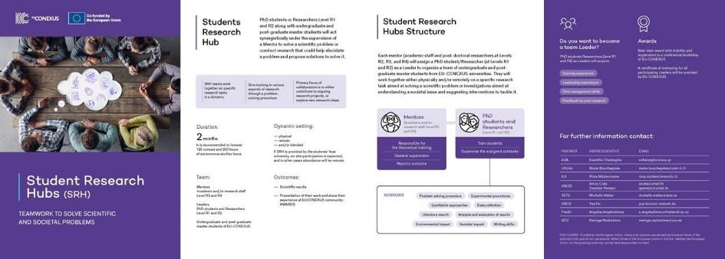
A comprehensive brochure for the SRH has been prepared (Figure 8). This brochure outlines the program's objectives, benefits, and participation guidelines. It has been distributed to WP7 representatives, PhD students, and institutional stakeholders to generate interest and encourage engagement.
Figure 8. Dissemination brochure for PhD students regarding SRH activity
The strategy combined centralised digital tools, institutional communication mechanisms, and targeted promotional actions to reach both students and academic staff. A central component was the EU-CONEXUS webpage (https://www.eu-conexus.eu/en/student-research-hub/), which functioned as the main hub for publishing SRH offers, providing detailed information, and enabling student enrolment. This was complemented by institutional email campaigns, as well as social media promotion, internal academic communication networks, and presentation of the SRH initiatives in conferences and events (Appendices II and VII).
In order to address initial dissemination challenges, the strategy was progressively strengthened through earlier and more frequent announcements, diversification of communication channels and improved clarity in messaging regarding the benefits and learning outcomes of SRH participation. The Joint Coordination Unit (JCU) made every effort to publish and disseminate the submitted SRH offers as promptly as possible through the dedicated EU-CONEXUS communication channels, aiming to maximize student outreach, support recruitment activities, and mitigate the impact of delays in project preparation and approval.
Dissemination efforts were reinforced through the EU-CONEXUS website, institutional email campaigns, social media (Facebook, LinkedIn and Instagram), and presentations at conferences and institutional events, contributing to increased visibility and awareness of the initiative (Table 3). Selected social media posts were also boosted to extend their reach and increase the visibility of individual SRH calls among the target audience. The effectiveness of dissemination activities was continuously monitored through student feedback and participation data, allowing for improvements in communication approaches.
Student testimonials played an important role in the dissemination and promotion of the Student Research Hub (SRH) initiative. Testimonials were collected from participants who successfully completed SRH projects and were used to showcase the educational, scientific, and personal benefits of the program. Through written statements, interviews, videos, and presentations during dissemination events, students shared their experiences of working in multidisciplinary research teams, collaborating with Mentors and Leaders, accessing advanced research infrastructure, and participating in international research environments. These first-hand accounts provided authentic evidence of the value of the SRH experience and helped communicate its impact on students’ research skills, confidence, career aspirations, and professional development.
Student testimonials were disseminated through the EU-CONEXUS website, social media channels, promotional videos, and presentations at conferences and workshops. They served as an effective communication tool for inspiring future participants, increasing awareness of available opportunities, and demonstrating the tangible outcomes of research-based learning. Furthermore, testimonials were highlighted as part of the communication strategy to strengthen student engagement, improve recruitment, and showcase the success stories emerging from SRH activities across the alliance.
These combined actions significantly increased the visibility of the Student Research Hub, supported the growth of student applications, strengthened engagement across partner institutions, and contributed to the promotion of research and innovation within education.
Table 3. Dissemination channels and activities
Channel/Tool | Key Actions Implemented | Number of events | Effectiveness
EU-CONEXUS Webpage | Creation of dedicated SRH pages, continuous updates,  website articles | 117 published SRH offers  9 website articles | Calendar Year 2024:  1349 unique visitors  3228 page views  Calendar Year 2025:  1937 unique visitors  5702 page views  Calendar Year 2026:  2185 unique visitors  8535 page views
WP7 Network (internal dissemination/Institutional Emails) | Standardised email announcements circulated to partner universities for local dissemination of SRH offers and registration deadlines. | 32 email announcements | According to the SRH satisfaction questionnaire, 51% of the respondents identified institutional emails as their primary source of information.
Social Media | Promotion of SRH offers through Facebook, LinkedIn and Instagram (posts, stories) | Facebook: 37 posts  LinkedIn: 37 posts  Instagram: 20 posts & 37 Stories | Facebook  Average reach / post: 837  Average engagement* / post: 22  LinkedIn  Average impressions / post: 804  Average engagement* / post: 14  Instagram  Average reach / post: 2068  Average engagement* / post: 58  Average reach / story: 669  Average link clicks / story: 13
Student Testimonials | Participants experiences and outcomes | 20 | Short presentations of their experience in website, conferences, workshops and other events
Events & Conferences | Short presentations of WP7 activities | 10 | Short presentations of SRH concept and activities to the students, Academic and Scientific communities.
Other Visuals | Development of a consistent visual identity and promotional materials for the dissemination of SRH activities. | 2 sets of promotional visuals | Used across the EU-CONEXUS webpage, institutional emails and social media channels. Representative examples are provided in Appendix VII.
*Engagement refers to the combined number of reactions, comments and shares per post.
Representative examples of the dissemination activities implemented throughout the project, including social media posts published on Facebook, LinkedIn and Instagram, promotional visuals, and selected communication materials, as well as promotional articles are presented in Appendix VII.
The effectiveness of the aforementioned dissemination methods was assessed through satisfaction questionnaires that were distributed to students at the end of each SRH. As indicated in their satisfaction questionnaire, students declared that institutional emails were the most preferred means of communication. From 211 answers received, it was found that Institutional emails including announcements of new offers was the most successful mean of dissemination (Figure 7). It has to be noted, that although UTCB does not participate in WP7, its students are invited to participate in the SRH.
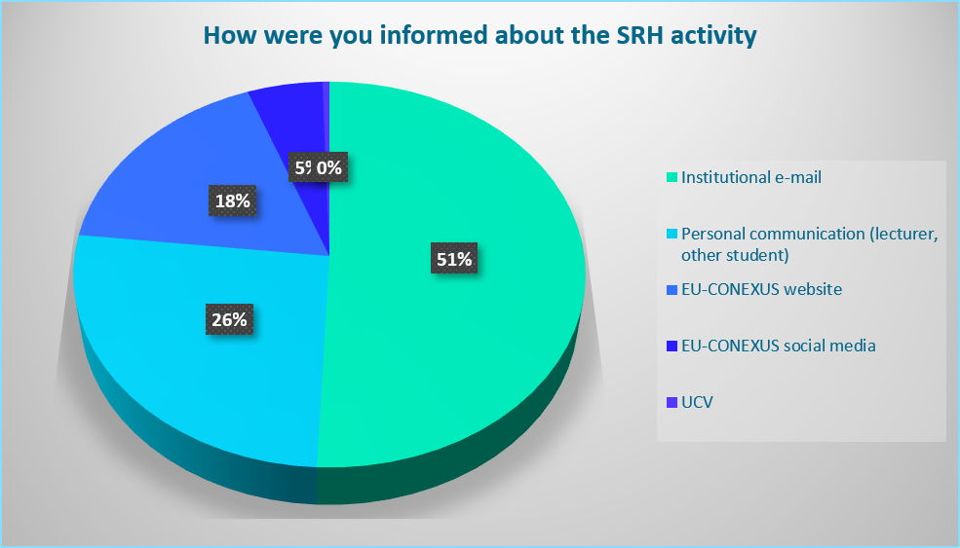
Figure 9. Percentage distribution of responses on how students were informed about the SRH activities
Additionally, the programme was actively promoted through presentations at academic events, local and international workshops, conferences, and doctoral training activities, providing valuable opportunities to raise awareness, stimulate interest, and foster engagement with SRH activities across the wider EU-CONEXUS academic community. The Student Research Hub was presented during the annual EU-CONEXUS PhD Week, where doctoral candidates and early-career researchers were informed about the objectives, structure, benefits, and leadership opportunities offered by the initiative. SRH activities were also showcased at four major international conferences: the EU-CONEXUS Research Conference 2023 – Aquatic and Coastal Ecosystems: Challenges and Opportunities towards Sustainable Development (Rostock, November 2023), a dedicated workshop during the EENVIRO Conference – Sustainable Solutions for Energy and Environment (Bucharest, October 2024), the EU-CONEXUS Conference 2025 – Transformative Research for Urban Coastal Sustainability (Valencia, October 2025), and the EU-CONEXUS Conference 2026 – Challenges, Innovative Solutions and Collaborative Actions for Sustainable Urban Coastal Development (Athens, June 2026). Furthermore, SRH achievements and student outcomes were highlighted through dedicated sessions in the three EU-CONEXUS Closing Virtual Workshops on Undergraduate Research Activities held in 2024, 2025, and 2026. The initiative was also promoted through the “I am Student” activities organised across partner universities, as well as during incoming student welcome events and orientation programmes. These dissemination actions facilitated direct interaction with students, academics, researchers, and institutional stakeholders, providing opportunities to present SRH activities, share success stories, identify potential participants, and strengthen engagement with research-based learning opportunities throughout the alliance.

Partners contribution and SRH offers
Throughout the implementation period, partner universities made substantial efforts to support the development and delivery of SRH activities. Beyond proposing and hosting projects, partners actively worked to identify and recruit suitable Mentors and Leaders, disseminate calls for participation among students and researchers, organize and support student mobility, and secure mobility funding through institutional resources, Erasmus+ schemes, national programmes, and other available mechanisms. Considerable effort was also devoted to strengthening synergies with EU-CONEXUS educational activities, particularly Minor Courses and other WP2 initiatives, in order to increase student engagement and connect research activities with educational pathways. Partners further contributed to the continuous expansion of the thematic scope of SRH projects, enabling participation from a broader range of disciplines and research communities across the alliance.
According to the Grant Agreement, the consortium initially committed to delivering a total of 167 SRH projects. This target comprised 144 projects to be implemented by Spring 2026, corresponding to 18 projects per participating partner (3 projects per semester over 6 semesters across eight partners), together with an additional 23 projects planned to commence in Autumn 2026 and continue beyond the official project end date.
Based on the original target of 167 projects, the 117 SRH projects delivered to date represent an implementation rate of 70% (Table 4). However, the combined impact of the challenges encountered during implementation, including difficulties in Mentors, Leaders, students’ recruitment and engagement, as well as administrative delays, reduced the consortium's delivery capacity.
Several institutions successfully met or exceeded their initial commitments, with some partners offering up to 22 SRH projects, while others achieved the original target of 18 projects. Nevertheless, the level of contribution varied across the consortium, and few partners were only able to partially fulfil their planned objectives under T7.2, or were unable to contribute to the activity at all, due to the challenges outlined in the previous sections. As a result, the overall number of projects offers remained below the initially envisaged target. Despite considerable efforts to increase project availability, enhance dissemination activities, expand the recruitment of Mentors and Leaders, and diversify the thematic scope of SRH activities, the consortium was ultimately unable to fully reach the planned target values. However, these mitigation measures helped maximise participation opportunities and substantially reduce the gap between the achieved and expected outcomes.
In some cases, published SRH offers were not ultimately implemented because applicants did not satisfy the eligibility criteria established for the specific project or because the activities required longer periods of physical mobility that limited student participation. As a result, a sufficient number of students could not be recruited to proceed with the project despite the interest expressed through the application process.
The distribution of SRH projects among partner universities is presented in Table 3, illustrating both the strong commitment of several institutions and the differing implementation achievement across the alliance. The contribution of each partner university to SRH implementation is presented in Table 4, while the complete catalogue of SRH offers is provided in Appendix VI.
Table 4. Number of offers per partner and percentage of implementation according to KPIs
Current situation of applications received-Target value 18 SRH/partner
 | Autumn 2023 | Spring 2024 | Autumn 2024 | Spring 2025 | Autumn 2025 | Spring 2026 | Summer 2026 | Autumn 2026 | Total | Percentage of implementation
AUA | 0 | 4 | 4 | 2 | 5 | 4 | 1 | 1 | 21 | 117 %
KU | 0 | 0 | 1 | 0 |  | 4* | 2 | 1 | 8 | 45%
UCV |  |  |  | 3 | 1 | 10* | 4 |  | 18 | 100 %
UNIZD |  |  |  | 0 | 1 | 13* | 0 | 8 | 22 | 122 %
SETU |  |  |  | 4 | 1 | 7 | 4 | 3 | 19 | 105 %
UROS | 0 | 1 |  | 2 |  | 7 | 6* | 3 | 19 | 105%
FREDU |  |  |  |  | 1 | 0 | 2 | 7 | 10 | 56%
LRUniv | 0 | 0 | 0 | 0 | 0 | 0 | 0 | 0 | 0 | 0%
Total | 0 | 5 | 5 | 11 | 8 | 45 | 17 | 16 | 117 | 70%
* From the proposed offers 11 SRH were not implemented (2 UCV, 3 UNIZD, 3 KU, 3 UROS),as there were applicants that were not eligible to participate or dropped out)
SRH projects were implemented through a variety of delivery modes, including on-site, hybrid, and fully online formats, depending on the nature of the research activities, project requirements, and participant availability. A summarized overview of the delivery modes adopted across the SRH projects is presented in Table 5.

Table 5. Mode of delivery for the SRH projects
Number of SRH  Academic year | Projects including physical mobility (blended) | Projects in fully Online mode | Other details of implementation
AUA | 15 | 6 | 2 combined with minor courses
KU | 3 | 5 | 1 combined with minor courses
UCV | 16 | 2
UNIZD | 4 | 18 | 1 combined with minor courses
SETU | 17 | 2
UROS | 19 | 0
FREDU | 5 | 5 | 1 combined with BIP
Total | 79 | 38

The majority of the SRH projects were implemented in a hybrid mode, combining online and on-site activities in order to maximize accessibility, facilitate mobility, and accommodate the different academic schedules of participating students. Typically, introductory sessions, project briefings, literature review activities, methodological training, and preparatory meetings were delivered online through Moodle and other digital platforms. The period of physical mobility was then dedicated to activities that required direct interaction with the research environment, such as experimental procedures, laboratory work, field visits, data collection, demonstrations of research methodologies, and visits to research infrastructure, facilities, festivals or other related events. Following the mobility period, students often continued their collaboration online through meetings and mentoring sessions focused on data analysis, interpretation of results, report preparation, and the development of final presentations.
The duration of physical presence at the host university varied according to the objectives and requirements of each project. In most cases, the mobility period was concentrated within 3–5 days, enabling students to participate in intensive research and training activities while facilitating travel arrangements and ensuring the efficient use of available mobility funding. The duration was influenced by factors such as the complexity of the research activities, the need for access to specialized laboratories, equipment, fieldwork sites, or research infrastructure, as well as the availability of students, Mentors, and Leaders. In some cases, shorter visits were sufficient for specific training or laboratory activities, while other projects required longer periods of physical participation to accommodate more extensive experimental work, field investigations, or hands-on research training. This flexible implementation model allowed each SRH project to be tailored to its specific educational and research objectives while maximizing student participation and access to international research experiences.
A number of SRH projects were implemented entirely online, particularly those that did not require direct access to specific research infrastructure. These projects were especially suited to activities such as social science research, modelling and simulation, software development, educational studies, surveys, interviews, policy analysis, and other research tasks that could be conducted remotely. In such cases, all project activities were carried out through Moodle or Teams digital platforms.
In a few cases, SRH projects were delivered entirely on-site, with all activities taking place at the host institution. These projects were typically centered on intensive laboratory work or related to broader special and activities, field investigations, specialized local visits, that could not be accessed remotely. As a result, they generally required longer periods of physical mobility compared to hybrid projects, allowing students sufficient time to complete the planned research activities and gain comprehensive hands-on experience within the host research environment.
Overall, the use of on-site, hybrid, and fully online delivery modes provided the flexibility necessary to accommodate different research methodologies, student needs, institutional requirements, and mobility opportunities, ensuring broad participation and effective implementation of SRH activities across the EU-CONEXUS alliance. The detailed schedule, mode of delivery, workload, mobility requirements, and implementation arrangements for each SRH project are described on the dedicated EU-CONEXUS Student Research Hub webpages. A complete overview of these offers is provided in Appendix VI.
Although the majority of SRH offers were successfully implemented, a number of projects could not ultimately proceed. The reasons varied depending on the nature of the project and institutional circumstances. In some cases, the number of applicants was insufficient to form a student group that met the project's requirements, while in others, applicants did not satisfy the eligibility criteria defined by the Mentor. Additionally, although the SRH initiative actively promoted interdisciplinary participation, the academic background, prior knowledge, or technical skills of the applicants did not always match the specific scientific requirements of certain discipline-specific projects. As a result, some projects were unable to recruit a sufficient number of suitably qualified participants.
In addition, some projects required longer periods of physical mobility residence at the host institution. In these cases, internships represented the only available funding mechanism to support student participation. However, administrative and regulatory constraints associated with internship funding, eligibility criteria for students and approval procedures led to the rejection of several mobility applications. Consequently, the necessary conditions for project implementation could not be secured, and these SRH offers could not be delivered.
EU-CONEXA further supported Task 7.2 through the provision of awards for outstanding SRH projects, recognizing exceptional student achievements and promoting the visibility of research outcomes across the alliance. While the initial planning envisaged the selection of one awarded SRH team per participating partner per year, this approach was adapted in line with the overall rescheduling and revised implementation timeline of SRH activities. Consequently, the awards were allocated according to the actual implementation and completion of SRH projects throughout the project period (i.e., three awards per partner during the project lifetime).
Awarded teams received support from the EU-CONEXA budget to cover mobility and registration costs for participation in scientific EU-CONEXUS conferences: a) the EU-CONEXUS Research Conference 2024 - EENVIRO – Sustainable Solutions for Energy and Environment (Bucharest, October 2024), b) the EU-CONEXUS Conference 2025 – Transformative Research for Urban Coastal Sustainability (Valencia, October 2025), and c) EU-CONEXUS Conference 2026 – Challenges, Innovative Solutions and Collaborative Actions for Sustainable Urban Coastal Development (Athens, June 2026). These awards provided to the participating students the opportunity to present their research in international academic environments, strengthen their scientific communication skills, expand their professional networks, and enhance the dissemination and impact of SRH results across the EU-CONEXUS community. A detailed breakdown of the awarded projects provided by EU-CONEXA, beneficiaries, and the utilization of the available awards is presented in Table 6.
Table 6. Awarded teams per University and participating students received mobility awards among partners
Partner University | Number of Awarded teams | Number of awarded students/mobilities in hubs | Total mobilities per partner students
AUA | 3 | 4 | 9
KU | 2 | 3
UCV | 3 | 7 | 6
UNIZD | 3 | 3 | 3
SETU | 2 | 1 | 1
UROS | 3 | 3 | 1
FREDU | 1 | 1 | 1
Total | 17 | 22 | 21

To recognize outstanding research achievements and maximize the impact of the award scheme, SRH awards were allocated to project teams hosted by partner universities, regardless of the university of origin of the participating students. As SRH projects frequently involved students from multiple EU-CONEXUS institutions, award-winning teams which were given the awards, thus reflected the international and collaborative nature of the initiative. Furthermore, in order to provide wider access to mobility and dissemination opportunities, some awards were distributed among more than one student within the same project team, enabling a greater number of participants to benefit from conference participation, workshops, and other scientific dissemination events.
This flexible approach increased the visibility of SRH outcomes, promoted student mobility, and extended the benefits of the award scheme to a broader group of participants across the alliance. However, due to delays in the implementation schedule of certain SRH projects, some partner universities were unable to utilize all the awards initially allocated to them within the project timeframe. Consequently, the distribution and use of awards were adapted according to the actual progress and completion of SRH projects in order to maximize their impact and ensure the effective use of available resources.

Students’ participation
Throughout the implementation period, particular emphasis was placed on increasing student participation and engagement in SRH activities. Partners implemented a range of actions to enhance the visibility, accessibility, and attractiveness of the program. Efforts focused on expanding the thematic diversity of project offers, strengthening synergies with Minor Courses and other WP2 educational activities, providing flexible participation formats, and facilitating student mobility whenever possible. These measures contributed to the continuous growth in student applications and supported broader participation from students across different disciplines and partner universities.
As implementation progressed, the number of projects offers increased, thematic diversity broadened considerably, student applications continued to rise, and the SRH established itself as a highly valued research-based educational activity with consistently high satisfaction rates among participants.
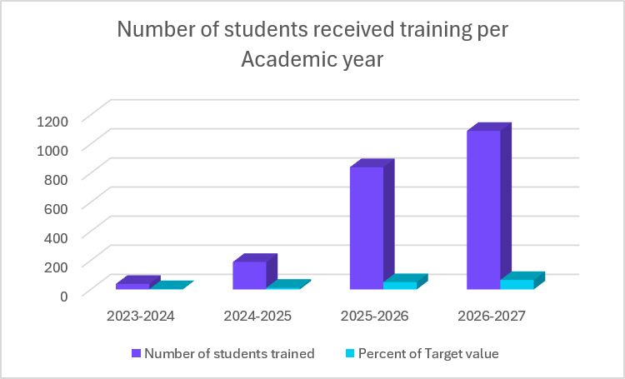
Figure 10. Students’ registrations in SRH projects per Academic year
Overall, student participation in the SRH initiative was satisfactory and demonstrated a clear interest in research-based learning opportunities across the EU-CONEXUS alliance. This was evidenced by the consistently higher number of applications compared to the number of students who ultimately participated in and completed the projects.
Throughout the duration of the implementation Phase, 1889 applications had been received, from which 1109 students were selected to participate in SRH activities.
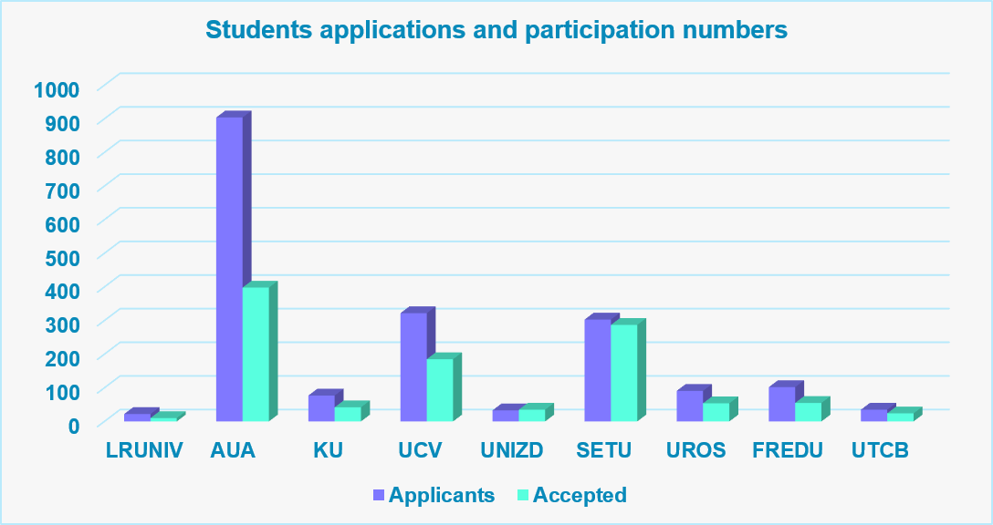
Figure 11. Students’ registrations per partner University and final participants
The difference between the number of applicants and accepted students can largely be attributed to project capacity limitations, particularly for SRHs involving laboratory work, field activities, specialised equipment, or physical mobility, where only a limited number of participants could be accommodated. In projects requiring physical presence, the number of trained students typically ranged from 1 to 20 participants, depending on the capacity of the host infrastructure, supervision requirements, available mobility funding, and the number of places allocated to students from outside the host university. In addition, some applicants did not satisfy the eligibility criteria of specific projects or were unable to commit to the required workload, schedule, or mobility requirements. As a result, only a proportion of applicants could be accepted. Furthermore, some students who were initially selected were unable to participate fully or complete all required assignments due to competing academic commitments, resulting in lower numbers of students receiving certificates compared to those initially trained. (661 Certificates up to M47).
It should be noted that differences in student participation across partner universities were influenced not only by the attractiveness or the capacity of the SRH offers but also by variations in institutional size, student population, and disciplinary composition. Universities with larger student communities and a broader range of academic programs, such as AUA, UCV, and SETU, had access to a larger pool of potential applicants and therefore recorded higher levels of participation in SRH activities. Consequently, participation figures should be interpreted within the context of each institution’s size, undergraduate studies and available student population.
A challenge encountered during the implementation of SRH activities was related to the timely dissemination of project offers. In several cases, delays in the preparation, approval, or finalisation of SRH projects reduced the time available for promotion and student recruitment prior to the start of the activities. As a result, some offers were published within a relatively short timeframe before their implementation, limiting their visibility among students and reducing the period available for applications. This situation was particularly challenging for projects involving physical mobility or requiring specific academic backgrounds, as students needed sufficient time to evaluate the opportunity, organise their academic commitments, and, where applicable, arrange travel and mobility documentation.
To mitigate this challenge, partners intensified dissemination efforts through institutional mailing lists, social media channels, dedicated SRH webpages, presentations in classes and student events, as well as direct communication with academic departments and student groups. These actions improved the visibility of SRH opportunities and contributed to the progressive increase in applications observed during the implementation period.
Participation also varied considerably among partner universities. While some institutions demonstrated consistently high levels of student engagement, others recorded lower participation rates despite dissemination efforts (Figure 12).
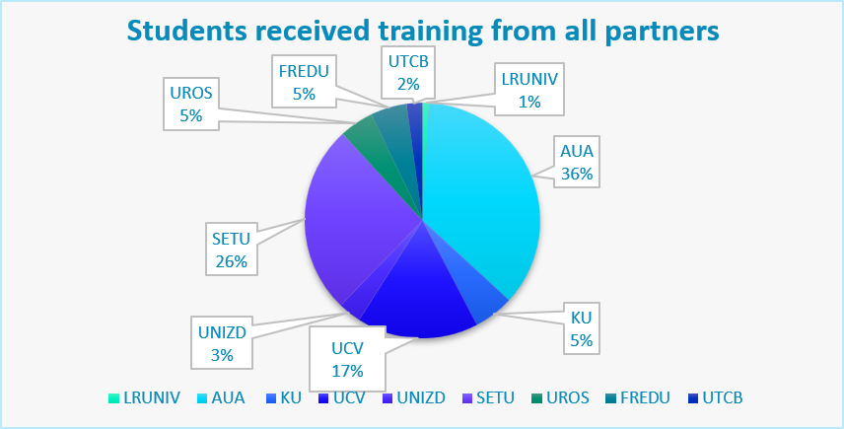
Figure 12. Percentage of students from partner Universities that received training in SRH projects
This imbalance appears to be primarily linked to differences in academic structures, student workload, and institutional schedules across the alliance. Students frequently faced demanding study programmes, examination periods, laboratory classes, internships, employment commitments, and other curricular obligations that limited their availability to engage in additional research activities. The challenge was further intensified by the diversity of academic calendars among partner universities, as periods suitable for participation at one institution often coincided with examination sessions, internship placements, or intensive teaching periods at another. Consequently, despite the strong interest shown in the initiative, many students experienced practical difficulties in integrating SRH participation into their existing academic responsibilities.
Nevertheless, student engagement remained strong throughout the implementation period. Students from AUA, UCV, and SETU demonstrated particularly high levels of interest in SRH activities (Figure 12). Notably, observations from AUA and other partner universities indicated that students were not only selecting projects directly related to their field of study but were also showing interest in research topics beyond their primary academic discipline. This trend highlights the interdisciplinary attractiveness of the SRH concept and its ability to expose students to new research areas, methodologies, and perspectives.
Participation patterns also varied according to the mode of delivery. Projects requiring extensive on-site participation tended to attract primarily local students, as observed in several SRH activities hosted by AUA, UCV, SETU, and UNIZD. This is largely explained by the mandatory physical presence required for laboratory work, field studies, access to specialised infrastructure, and other hands-on research activities, which limited participation from students located at other partner universities unless mobility funding was provided. In contrast, SRH projects delivered in online format generally attracted students from multiple institutions, as this delivery mode reduced geographical and logistical barriers while preserving opportunities for collaboration and research engagement.
An additional and particularly encouraging outcome was the interest expressed by PhD students from universities to participate as trainees in SRH implemented in partner Universities other than the hosting institution. These participants viewed SRH activities as valuable opportunities to acquire new research methodologies, gain exposure to different scientific approaches, and strengthen their own research competences. Their participation fostered knowledge exchange between institutions and created opportunities for broader research collaboration. Furthermore, this development highlights the potential of the SRH initiative to stimulate the creation of parallel or coordinated research projects across the alliance, thereby strengthening inter-institutional cooperation, promoting research networking, and contributing to the long-term sustainability of the EU-CONEXUS research and education ecosystem.
Mobility played a crucial role in attracting students to SRH activities and enhancing their overall research experience. From the early stages of project implementation, student feedback and satisfaction questionnaires consistently highlighted the need for increased mobility opportunities, with many participants expressing a strong interest in undertaking research activities at other EU-CONEXUS partner universities. Students viewed mobility as a valuable complement to the research experience with hands-on training opportunities. However, during the first years of the project, the availability of mobility support was limited, restricting the participation of students in physically hosted SRH activities.
To address this challenge, a series of mitigation measures were implemented, leading to a significant expansion of physical, combined with blended mobility opportunities within WP7. Partners collaborated to organise and support student physical mobility with the reallocation of mobility opportunities through WP7 resources, initially planned for other activities, national funding schemes, Erasmus+ programmes, institutional funding sources, and internship arrangements. As a result, students were able to participate in research activities hosted by other EU-CONEXUS universities, as presented in Table 7.

Table 7. Mobility of students between partner Universities during a SRH
To  From | AUA | KU | UCV | UNIZD | SETU | UROS | FREDU | Total
AUA |  | 2 | 6 | 7 | 2 | 4 | 3 | 24
KU |  |  | 8 |  | 2 |  | 6 | 16
UCV | 7 | 5 |  | 2 | 2 | 4 | 4 | 24
UNIZD
SETU | 2 | 1 | 1 | 18 |  | 2 | 20 | 44
UROS | 4 | 3 | 2 | 3 | 1 |  | 4 | 17
FREDU | 1 |  | 1 |  | 1 |  |  | 3
UTCB |  |  | 1 | 2 | 1 |  | 9 | 13
LRUniv |  |  | 3 |  | 1 |  |  | 4
Total |  |  |  |  |  |  |  | 145

The introduction of these mobility opportunities helped overcome one of the main barriers identified by students and had a positive effect on participation and motivation. Projects offering mobility experiences generated increased interest and attracted a larger number of applications, demonstrating that international research experiences were a strong incentive for student engagement. Beyond supporting participation, mobility also strengthened collaboration between partner institutions, promoted intercultural exchange, and enhanced the educational and research impact of the Student Research Hub initiative.

EU-CONEXUS Plus Closing Virtual Workshop on Undergraduate Research Activities
The EU-CONEXUS Closing Virtual Workshops on Undergraduate Research Activities (CVWOURA) constituted the main dissemination, networking, and evaluation events of the SRH initiative. The workshops were delivered online, enabling broad participation from students, Mentors, Leaders, researchers, and institutional representatives across the alliance. Three workshops were organized during the implementation period, corresponding to the academic years 2023–2024, 2024–2025, and 2025–2026.
During these events, students participating in the implemented SRH projects presented the outcomes of their research activities and showcased their scientific accomplishments, providing an opportunity to disseminate results, exchange experiences, and gain valuable experience in scientific communication and presentation within an international and multidisciplinary environment. The Closing Virtual Workshops on Undergraduate Research Activities attracted a steadily growing audience throughout the implementation period, reflecting the increasing visibility and recognition of the SRH initiative across the EU-CONEXUS alliance. Participation extended beyond students presenting their research outcomes and included Mentors, Leaders, academic staff, researchers, institutional representatives, and other interested stakeholders.
The continuous increase in attendance over the three workshop editions demonstrated the growing interest in research-based learning activities and the importance of the workshops as a platform for dissemination, networking, and exchange of experiences. A detailed overview of the number of attendees and participating institutions for each workshop is presented in Table 8.

Table 8. summary of the three Closing Virtual Workshops on Undergraduate Research Activities
Year | 2023-2024 | 2024-2025 | 2025-2026
 |  | 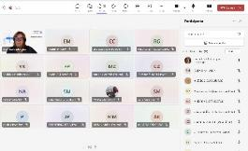 | 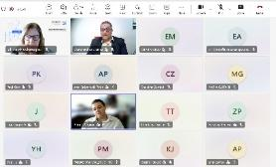
Number of presented SRH | 4 | 18 | 26
Number of attandees | 20 | 35 | 62
Evaluation comittee | Helen Miliou (Professor, AUA)  Zvjezdan Penezić, (Professor, UNIZD)  Charalambos Chasos, (Associate Professor, FREDU) | Helen Miliou (Professor, AUA)  Charalambos Chasos, (Associate Professor, FREDU)  Dr. Mike Kinsella (Lecturer & Researcher, SETU) | Anica Cuka (Professor, UNIZD)  Charalambos Chasos, (Associate Professor, FREDU)  Dr. Yue Hu (UROS)

A three-member Jury (Student Research Hub evaluation Committee) has rated the results of the SRH presented by a structured document (Appendix VIII). The best graded teams each University were awarded with a mobility Grand by EU-CONEXA for the participation at the EU-CONEXUS Research Conferences held in Bucharest (2024), Valencia (2025) and Athens (2026).
The list of awarded SRH teams per partner University and per Academic year are presented in Table 9.

Table 9. List of awarded teams Organised per partner University during the three Academic Years of implementation
Academic Year | Title of the SRH Project | Host University
2023-2024 | Extract preparation, Biochemical Characterization, and In Vitro Testing of Extracts | AUA
2023-2024 | Long-term effect of phosphorus management on soil fertility and Soil P pools-Project 2024 | UROS
2024-2025 | Diagnosis of fish diseases in aquaculture and identification of pathogens | AUA
2024-2025 | Green Management and Marketing: Protein Products. A Curse or a Blessing for Sustainability? | KU
2024-2025 | Evaluating the Sustainability of Rosslare Europort: Strategies for Green Innovation and Resilience-Project 1 | SETU
2024-2025 | Data analysis in physical oceanography: Analysis of the Gulf of Lions | UCV
2024-2025 | Long-term effect of phosphorus management on soil fertility and Soil P pools-Project 2025 | UROS
2025-2026 | SRΗ Computer applications on fish and seafood processing | AUA
2025-2026 | Applications of computational fluid dynamics (CFD) and computational mechanics (CM) for sustainable and secure transport systems at coastal and urban areas | FREDU
2025-2026 | SRH-Green Management and Relationship Marketing:Driving Sustainable Change in Business | KU
2025-2026 | Biodiversity at the Copper Coast | SETU
2025-2026 | Multidisciplinary Oceanographic Research in Coastal Ecosystems | UCV
2025-2026 | Outdoor Activities: Safety, Values and Inclusion [Quality and timeliness of the work produced] | UCV
2025-2026 | Isolation of fungi, fungal spores and conidia from air, soil and plant material [Quality and timeliness of the work produced] | UNIZD
2025-2026 | Evaluation of suitable olive cultivars for sustainable urban gardens [Quality and timeliness of the work produced] | UNIZD
2025-2026 | Problem based learning- a path to sustainable education. Comparison of traditional and modern teaching methods in higher education | UNIZD
2025-2026 | Screening of novel bio-based recycling fertilizers to evaluate their effects on germination, nutrient uptake and biomass yield in selected crops. | UROS

It should be noted that, due to the timing of project implementation and the proximity of several SRH activities to the end of the project period, a number of research projects had not yet reached completion by the time the annual Closing Virtual Workshops on Undergraduate Research Activities were held (particularly in 2025-2026 Academic Year). As a result, the participating students were unable to present their final research outcomes during these events, despite actively progressing with their projects. Consequently, the number of research projects presented at each workshop does not fully reflect the total number of SRH activities implemented within the framework of Task 7.2.

KPIs for T7.2

The performance of Task 7.2 SRH was monitored through two main indicators: the number of students trained, student satisfaction, and in collaboration with the JCU, the communication impact generated by the initiative. Together, these indicators provided a comprehensive assessment of the effectiveness, quality, and visibility of the SRH programme across the EU-CONEXUS alliance. While the number of students trained measured the reach and educational impact of the activity, student satisfaction evaluated the quality of the research-based learning experience and the extent to which the programme met participants’ expectations. In parallel, communication impact reflected the success of dissemination and outreach activities, including student applications, attendance at dissemination events, participation in the Closing Virtual Workshops on Undergraduate Research Activities, website visibility, and engagement with promotional actions. Continuous monitoring of these indicators enabled the consortium to assess progress, identify areas requiring improvement, and evaluate the overall contribution of the Student Research Hub to the integration of research and education within EU-CONEXUS.
.

Number of students involved in Student Research Hub
The primary quantitative KPI for Task 7.2 – Student Research Hub (SRH) was the number of students trained, with a target value of 1837 participants, comprising 1670 Bachelor’s (BSc) students and 167 PhD students/Leaders. Achievement of this indicator was monitored through the student registration lists and participation records maintained for each SRH project, which serves as the main source of verification.
The target for student training was particularly overestimated, aiming to engage and train 1670 students through the Student Research Hub (SRH) activities, as presented in Table 7. This target reflected the strategic objective of WP7 to expose a large number of students to authentic research environments, strengthen the integration of research and education, and provide opportunities for participants to develop scientific, digital, green, and transferable skills through active involvement in research projects. The target was calculated on the basis of the participation of eight partner universities, each expected to offer approximately 21 SRH projects throughout the implementation period (18 projects completed during the project lifetime and three additional projects initiated in Autumn 2026 and completed after the project end), with an estimated average participation of 10 students per SRH project. The corresponding target for 167 PhD students/Leaders was directly linked to the planned number of SRH offers, as each project was expected to be supported by a PhD student or early-career researcher acting as Leader. In practice, however, achieving these targets proved particularly challenging. The assumptions underlying the initial calculations did not fully account for the operational and institutional barriers encountered during implementation and discussed in the previous sections. The final achievement figures for student participation and training are presented in Table 10.
Table 10. KPIs for T7.2 as indicated in the GA: Number of students involved in Student Research Hub
KPI Task 7.2 | Target value  In the GA | Achieved value | Percentage of achievement
Number of BSc, MSc students involved in Student Research Hub | 1670 | 1109 | 66,4%
Number of PhD students involved | 167 | 117 | 70%

In practice, however, achieving these targets proved particularly challenging, as the assumptions underlying the initial calculations did not fully account for the operational and institutional barriers encountered during implementation and discussed in the previous sections. These included difficulties in recruiting Mentors and Leaders, delays in launching project offers, differences in academic calendars, mobility constraints, limitations in laboratory and research infrastructure capacity, and variable student availability.
From the early stages of Task 7.2, a significant challenge was identified in ensuring the timely dissemination of SRH offers. The preparation and submission of project information largely depended on the availability of Mentors and researchers, who were simultaneously balancing teaching, research, supervision, administrative duties, and other institutional responsibilities. As a result, some project offers could only be finalized and published shortly before their planned implementation dates, reducing the time available for promotion, student recruitment, and the organisation of mobility arrangements. This issue had a direct impact on student participation, as prospective applicants had limited time to become aware of the opportunities, evaluate their suitability, align their academic commitments, and, where necessary, make travel and mobility arrangements. The effect was particularly pronounced for projects involving physical mobility or specialised requirements, where additional preparation and planning time were essential to facilitate successful participation.
Moreover, the large number of SRH offers launched during the final phase of the project had a dual effect. On the one hand, it significantly expanded the range of research opportunities available to students and increased the thematic diversity of the programme. On the other hand, it created scheduling overlaps, with some students applying to and being selected for multiple projects simultaneously, ultimately having to choose between competing opportunities. This occasionally affected enrolment and participation rates in individual SRH projects.
Regarding the Leaders, as the number of implemented SRH projects remained below the level originally envisaged, the corresponding number of participating PhD students and Leaders was also lower than initially estimated, given the direct relationship between project implementation and Leader involvement.
To better capture student participation, three indicators were monitored throughout the implementation period: (a) the number of applications received, (b) the number of students accepted and trained, and (c) the number of students receiving a certificate following the successful completion of all project requirements (Figure 13).
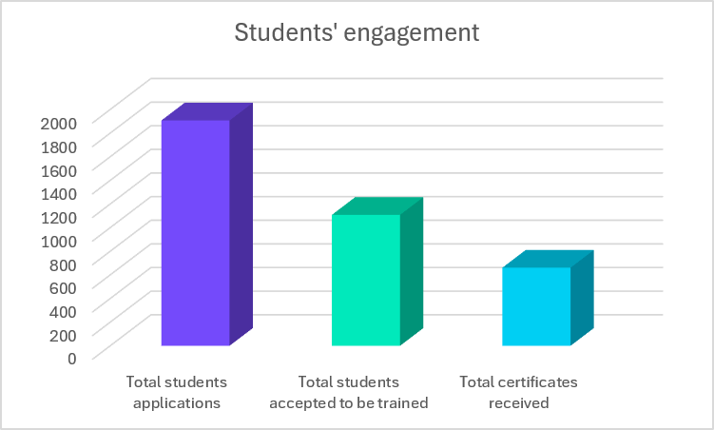
Figure 13. Number of students enrolled in SRH projects, accepted and receiving certificate students.
The difference between the number of applicants and the number of students accepted into SRH projects is primarily explained by logistical and capacity constraints. In projects requiring physical mobility, only a limited number of students could be accommodated. The gap between the number of students accepted and those ultimately receiving a certificate reflects the fact that some participants, despite beginning the training, either withdrew from the project or were unable to complete all required assignments and deliverables within the specified timeframe, for reasons discussed earlier, notably student teaching and assignment loads.
Although the consortium introduced a range of mitigation measures and significantly increased its efforts in project development, dissemination, mobility support, and student recruitment, the original targets remained difficult to attain. Nevertheless, the initiative succeeded in engaging a substantial number of students and early-career researchers in research-based learning activities, demonstrating the strong interest in and educational value of the Student Research Hub across the EU-CONEXUS alliance.

Students’ satisfaction rate
The quality and impact of the SRH activities were continuously monitored through student satisfaction questionnaires administered at the end of each semester addressed to all participating students. These questionnaires served as the primary tool for evaluating their experiences, identifying strengths and weaknesses of the programme, and collecting suggestions for improvement. Additionally, an online survey was being conducted as part of each Closing virtual workshop on Undergraduate research activities.
A question-driven evaluation methodology (shown in Appendix V) was adopted to assess the Student Research Hub (SRH) experience, using a 0–5 rating scale to evaluate multiple aspects of participation, including the quality of research activities, mentoring and supervision, learning outcomes, skills development, project organisation, and overall satisfaction. The results collected to date indicate a consistently positive response from participants, with students assigning high ratings across all evaluation categories.
Overall, the findings demonstrate that students highly valued their involvement in SRH projects and considered the experience beneficial for their academic, research, and personal development as illustrated in Figure 14.
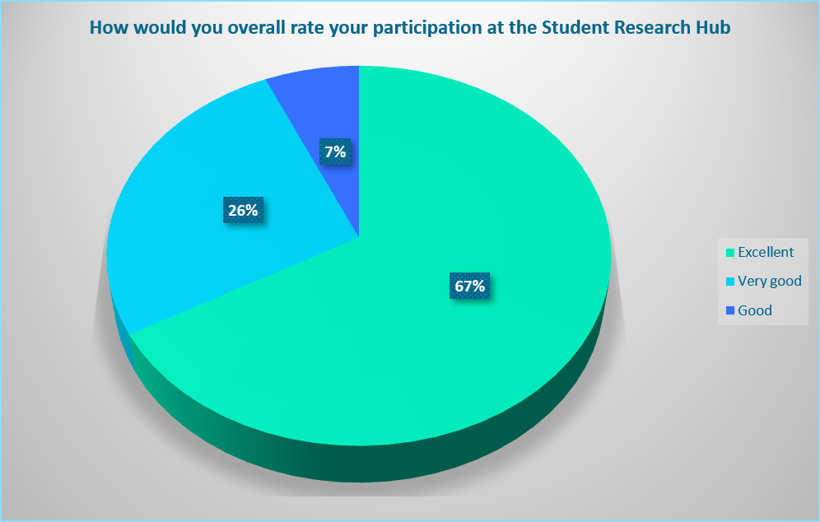
Figure 14. Students’ feedback from their participation in SRH projects. Grading 5 = Excellent, 4 = Very good , 3 = Good, 2 = Poor and 1 = Very poor (update M47)
A student satisfaction survey was conducted among a total student population of 700 students, with 211 students participating, representing a response rate of 30%. Of the respondents, 141 students (67%) rated the program as Excellent, 56 students (26 %) as Very Good, and 14 students (7%) as Good. Based on the combined ratings, the current student satisfaction rate is 92 %, which exceeds the KPI target of 75% (Table 11). In addition, all respondents provided positive evaluations of the program, with no ratings below Good. These findings indicate a very high level of satisfaction among participating students and reflect the program's strong performance in meeting student expectations. As the survey remains open and additional responses are expected, the final satisfaction rate will be reviewed upon completion of the data collection process.
Table 11. Total rating of students’ participation in SRH projects (update: March 2025)
Total rating | Target value | Achieved value | Percent of achievement
 | Up to 75% | 92 % | 100%
Number of answers from questionnaires |  | 211 | 30% of participants

The feedback obtained on SRH highlights students' experiences, the challenges they faced, their needs, and their suggestions for improving the activity.
Students expressed a highly positive perception of the educational experience, particularly regarding the quality of teaching and the research-based learning approach adopted within the initiative. The satisfaction questionnaire assessed several teaching-related aspects, including the overall quality of teaching, the extent to which students achieved a clear understanding of the subject upon completion of the training, the effectiveness of the teaching approach, and the adequacy of the educational materials provided. The results (Figure 15) indicate that the educational materials were appropriate and relevant to the project objectives, while the teaching approach successfully facilitated understanding of complex concepts and methodologies within an authentic research environment.
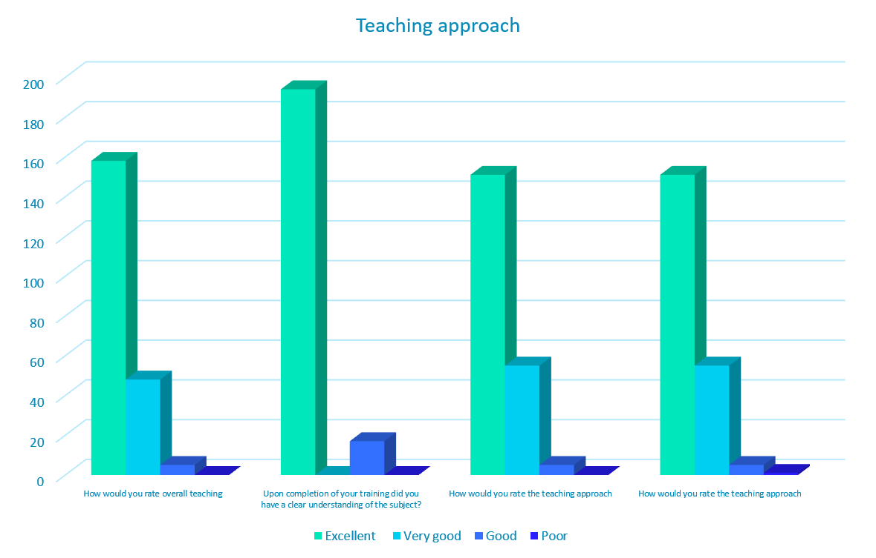
Figure 15. Breakdown of the answers of the satisfaction questionnaire regarding the teaching approach. Grading: 5 = Excellent, 4 = Very good, 3 = Good, 2 = Poor and 1 = Very poor
More detailed feedback was also collected regarding the extent to which the SRH achieved the core educational objectives of WP7, as students’ engagement in scientific procedures, the advancement of their scientific knowledge, and the acquisition of research-related and transferable skills. The results, as shown in Figure 16, indicate that participants were highly satisfied across these dimensions, suggesting that the active research engagement, collaborative learning, and hands-on experience effectively supported the achievement of the intended learning outcomes. Students reported that participation in SRH activities enhanced their understanding of scientific methodologies, strengthened their ability to conduct independent research, and contributed significantly to the development of subject-specific, digital, analytical, and problem-solving skills.
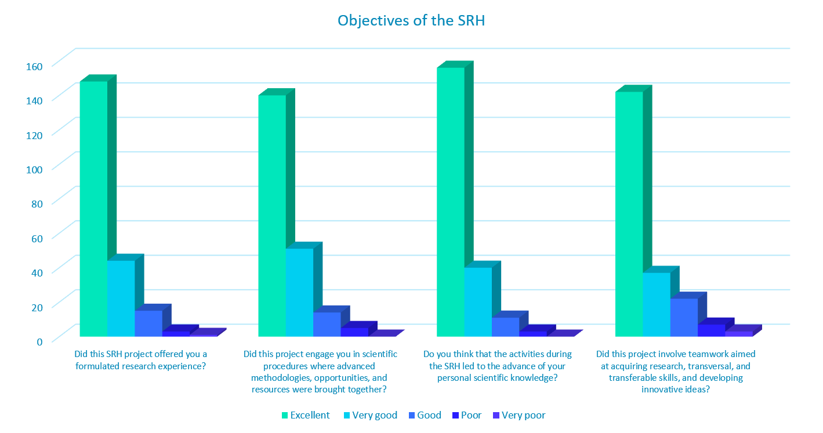
Figure 16. Breakdown of the answers of the satisfaction questionnaire regarding the WP7 objectives. Grading: 5 = Excellent, 4 = Very good, 3 = Good, 2 = Poor and 1 = Very poor
Finally, 70% of participants indicated that their involvement in SRH activities increased their interest in science, demonstrating that the initiative successfully achieved one of its core objectives of attracting students to scientific research and innovation as shown in Figure 17.

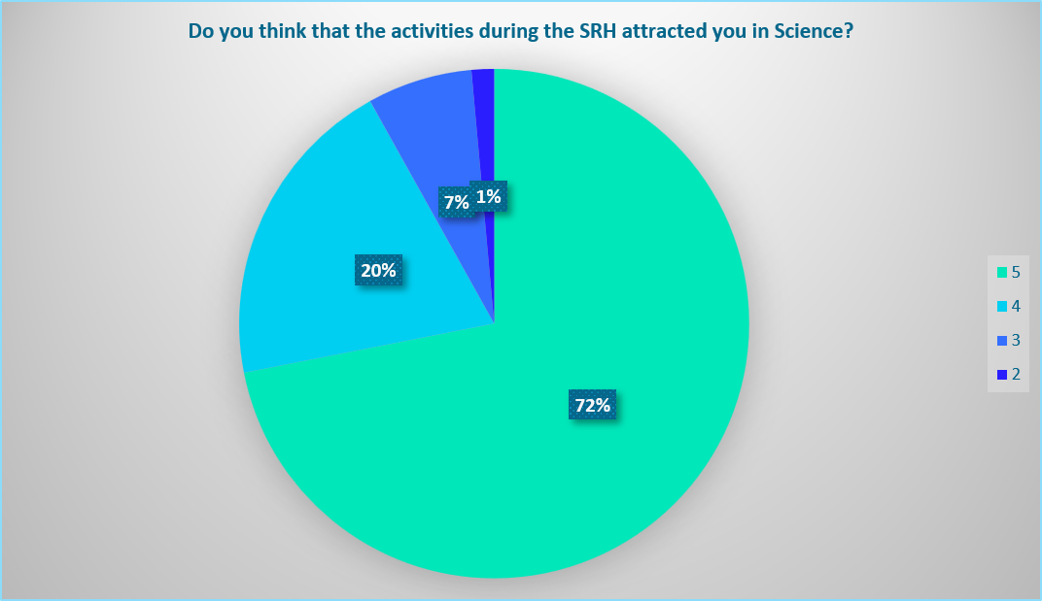
Figure 17. Students attracted in Science after attending a SRH project. Grading: 5 = Excellent, 4 = Very good, 3 = Good, 2 = Poor and 1 = Very poor
Additionally, students were invited to provide suggestions for improving future SRH activities (Figure 18). The feedback from 54 answers indicated that the duration of the projects was the aspect most frequently identified for improvement, suggesting a need for greater flexibility or extended engagement periods in some cases. Other commonly mentioned areas included collaboration within the research team, increased opportunities for on-site participation, and enhancements to the research and training activities offered. Students in some cases, despite the total satisfaction, suggested improvements to the educational material and project content. Notably, a number of respondents stated that no improvements were necessary, and others made on further suggestions, reflecting a high level of satisfaction with their overall experience. Overall, the feedback highlights students’ appreciation of the SRH concept while providing valuable recommendations for further strengthening the quality, interaction, and research experience of future activities.

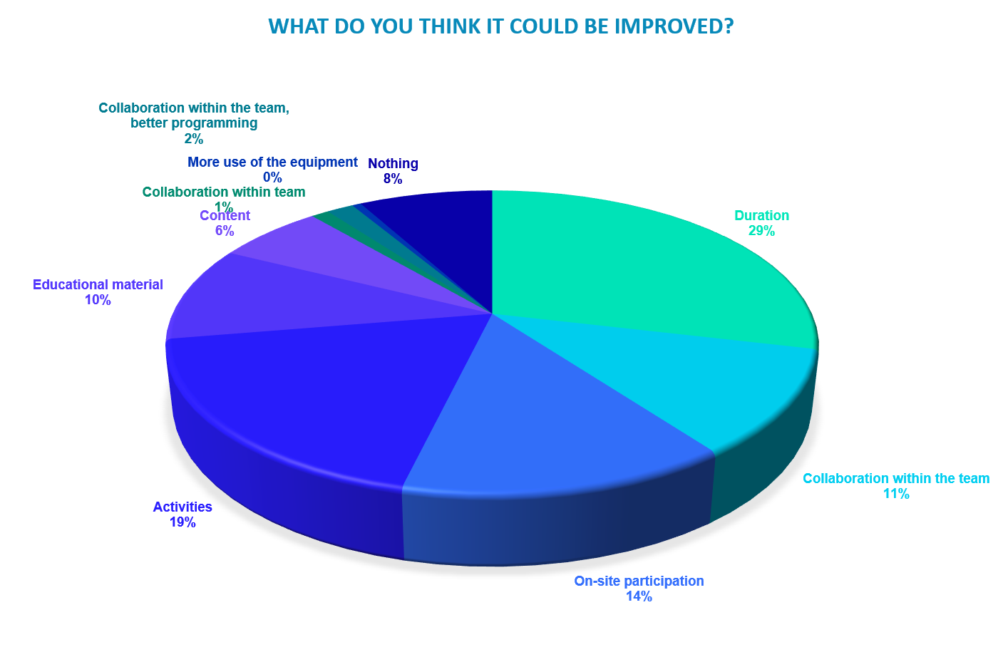

Figure 18. Students’ suggestions for further improvement.
Students are the best ambassadors of the Student Research Hub initiative, as more than 89% indicated that they would participate again in an SRH project, while more than 96% stated that they would recommend the activity to fellow students (Figure 19). These exceptionally high levels of satisfaction demonstrate the strong educational value and attractiveness of the program.
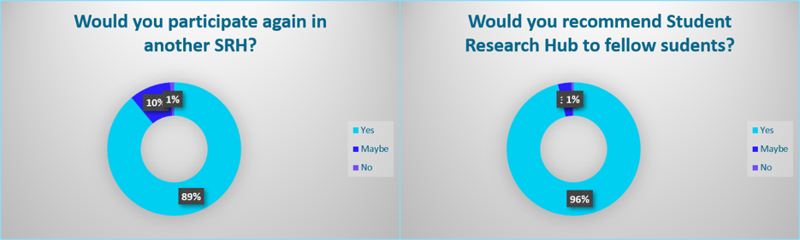
Figure 19. Students’ Appreciation of the SRH activities
Additional feedback was collected through Mentimeter satisfaction surveys conducted during the Closing Virtual Workshops on Undergraduate Research Activities. During these interactive sessions, participants were invited to respond to short questions and share their experiences, opinions, and key takeaways from their involvement in SRH projects with the wider audience (Figure 20). A total of 74 responses were collected, with the results reflecting a high level of satisfaction among participants and providing further qualitative evidence of the positive impact of the Student Research Hub initiative on student learning, research engagement, and overall experience.
2024  (12 answers) | 2025  (22 answers) | 2026  (40 answers)
What words come to mind after the Student Research Hub training session?
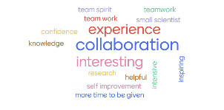 | 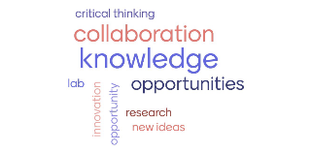 | 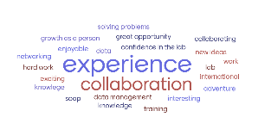
Did the activities help you to make a decision towards a scientific carreer?
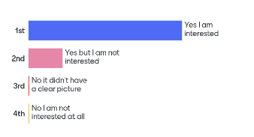 | 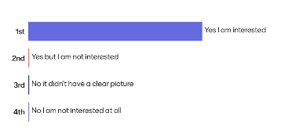 | 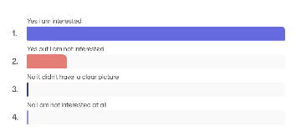
What would you think it could be changed and/or improved?
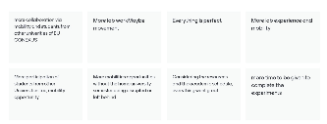 | 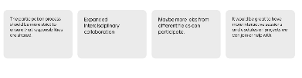 | 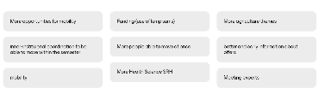
One thing you'll take away with you
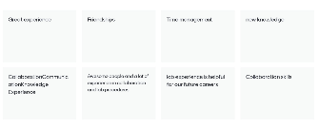 | 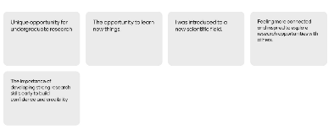 | 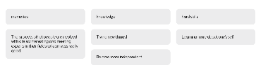
Figure 20. Students’ experience from SRH projects based on Mentimeter survey during the three CVWOUAs
Overall, the feedback confirms the strong educational value and impact of the Student Research Hub, with participants expressing high levels of satisfaction and highlighting the benefits of engaging in authentic research activities within an international and collaborative environment.

Conclusion: Outcomes and Impact
The SRH has emerged as one of the main initiatives of WP7, successfully translating the concept of “Research Back into Education” into a practical and impactful educational activity. By integrating research directly into the learning process, the initiative enabled students to actively engage in scientific inquiry and research, problem-solving, and innovation. Through participation in research projects, students gained first-hand experience of the research process, from the formulation of research questions and data collection to the analysis, interpretation, and dissemination of results.
The initiative brought together undergraduate, postgraduate, PhD students, Academics and Researchers from across the EU-CONEXUS alliance, creating a unique collaborative environment that strengthened the connection between research and education. Students were exposed to advanced methodologies, research infrastructures, and international scientific networks, while developing scientific reasoning, critical thinking, teamwork, communication, digital competencies, and other transferable skills. The interdisciplinary nature of the projects further broadened students’ perspectives to science and opened up a multidisciplinary environment.
Beyond its direct impact on students, the SRH generated significant benefits for Leaders. PhD students and early-career researchers gained valuable experience in leadership, mentoring, supervision, project management, and scientific communication through their role in guiding student teams.
Academic staff strengthened their engagement with innovative educational approaches and research-based learning, while partner universities enhanced collaboration across the alliance through, students’ mobility opportunities.
During implementation, a range of organisational, institutional, regulatory, mobility-related, and scheduling challenges were progressively identified, many of which could not have been fully anticipated during the initial planning phase. These barriers affected both the number of projects delivered, partners’ engagement and, consequently, the number of students and Leaders engaged in the initiative. Nevertheless, the consortium continuously monitored implementation, identified challenges at an early stage, and introduced a series of mitigation measures to maximise participation, project delivery, and impact.
Despite the implementation challenges encountered throughout Task 7.2, the SRH achieved significant results and demonstrated strong student interest in research-based learning. A total of 117 SRH projects were implemented across the EU-CONEXUS alliance, with 1889 student applications from a wide range of disciplines and institutions. From these applications, 1109 students successfully participated in and received training through SRH activities. Although the proposed target values for student participation were not fully achieved, it should be noted that the original KPI was particularly ambitious and overestimated which was based on the successful implementation of a large number of SRH projects across all participating universities, with substantial student participation in each project.
Moreover, the implemented SRH activities were highly rated by participants. The results confirmed that students perceived their involvement in SRH projects as a highly beneficial learning experience, providing opportunities for research engagement, skills development, international collaboration, and personal growth. These findings further confirm the effectiveness of the research-based and student-centred educational approach adopted within the SRH initiative and its meaningful contribution to students’ academic and professional development.
By actively engaging participants in authentic research activities, interdisciplinary collaboration, and problem-solving processes, the programme successfully supported the acquisition of scientific knowledge, research competencies, digital skills, and transferable competences, while fostering greater interest in science, innovation, and research. The feedback demonstrates that SRH activities provided not only academic and research benefits but also lasting personal and professional development experiences that students considered highly valuable.
The consistently positive feedback received from participants, together with the fact that more than 89% would participate again and more than 96% would recommend the initiative to fellow students, demonstrates the strong educational value and impact of the Student Research Hub. Furthermore, approximately 70% of participants reported that their interest in science had increased as a result of their participation, directly supporting one of the core objectives of WP7.
Overall, the Student Research Hub has established a sustainable framework for research-based learning within EU-CONEXUS, successfully bringing research results and innovation back into education while fostering the development of the next generation of researchers, innovators, and professionals. Its achievements provide a strong foundation for future educational and research collaborations, further strengthening the transnational dimension of higher education and research within the EU-CONEXUS alliance.

Appendix I. Documents for OLH Implementation

Open Call for Academic and Research staff (Level R2, R3 and R4) of EU-CONEXUS to create and teach a Student Research HUB
Open Call for Academic and Research staff (post-doctoral researchers Level R2, R3 and R4) of EU-CONEXUS to create a
Student Research Hub
in the context of EU-CONEXUS PLUS: Research to education
Research to education-Overview
International studies outline the role and importance of undergraduate scientific research, across the natural sciences, social sciences and humanities, demonstrating that students perceive academic involvement in research as a catalyst for enriching their comprehension across diverse disciplines.
Additionally, participating in research could ignite a greater passion for learning and teaching, foster interest in pursuing postgraduate studies, cultivate skills relevant to future employment, and enhance the quality of undergraduate research endeavors.
EU-CONEXUS “Research to education” aims to transfer methodologies, scientific thinking and innovation back into education by introducing joint research-based activities (Student Research Hub and Open Lab Hours), which will actively and creatively engage undergraduate and post-graduate master students in research activities related to SmUCS topics, in order to familiarize them to scientific procedures leading to blue-green solutions in coastal and urban development.
Students will profit from the multi-institutional research opportunities offered by more than 400 EU-CONEXUS research teams, providing them with structured experiences and by promoting their aspirations to pursue an internationally competitive scientific career.
What are Student Research Hubs?
Student Research Hubs (SRH): Teamwork to solve scientific and societal problems.
Undergraduate / post-graduate master and PhD students/ Researchers (level R1 and R2) will act synergistically under the supervision of a Mentor (academic staff and post-doctoral researchers Level R2, R3 and R4) to solve a scientific problem or conduct research that could help explain a social problem and propose solutions to solve it.
Student Research Hubs (SRH) are trainings of approximately 2 months. Each Mentor will assign a PhD student as a Leader to organize a team of Undergraduate and post-graduate master students of EU-CONEXUS universities to work together either physically and/or by distance combining their forces in a specific research task. Undergraduate students (Erasmus+ internships, voluntary contributions etc.), will have the opportunity to join physically or blended the local research groups.
The research work of SRH could be part of a current research project, or the setup of a new research idea. Training provided by Mentors and Leaders will include literature search, experimental procedures, data collection, several skills, basic laboratory training for students who start their undergraduate and post-graduate master student’s thesis, and integration of different appropriate qualitative and quantitative approaches.
Undergraduate and post-graduate master students of EU-CONEXUS universities could be asked to contribute in the writing of a scientific publication, or to give oral presentation of their research results.
Leaders will train students on advanced instrumentation, digital and green technologies, and different qualitative and quantitative research methods used in the proposed the thematic area; they will supervise the assigned subtasks to trainees and organize the teamwork for developing cognitive, non-cognitive and job-specific skills of students for a successful transition into the labour market.
Why apply for a Mentor?
Modern educational practices have high- lightened the beneficial impact of undergraduate and postgraduate research experiences that serve as a catalyst for initiating the pathway towards an advanced scientific career.
This initiative aims to provide undegraduate and post-graduate masters students with multidisciplinary training on research topics linked to SmUCs.
Mentors will inspire Undergraduate and post-graduate master students to pursue a scientific career and help them acquire skills, better understanding of scientific methodology and problem-solving procedures. Moreover, to encourage students to prioritize the development and application of creative and higher-level thinking.
Mentors can enhance their teaching methods and consider possible alternative approaches. Certification of Mentoring for all participating applicants will be provided by EU-CONEXUS.
Why Invite a PhD student or a Researcher (Level R1 and R2) to become a Leader?
PhD students or a Researchers (Level R1 and R2) are invited to become leaders of a student team (Undergraduate and post-graduate master students of EU-CONEXUS universities) in order to gain:

Experience on assignments with a group of students
- Tutoring experience
- Leadership skills
- Time management skills
- Organizational skills

Who can apply?
Each Mentor is invited to propose, a thematic related to their Scientific filed of interest.
Academic staff and post-doc researchers (Levels R3 and R4) are eligible to apply as Mentors.
Mentors from all thematic areas related to SmuCs are invited to participate.
How to Implement a Student Research Hub
The Mentor is the individual who proposes the subject and identifies the PhD student or the Researcher (Level R1 and R2) to act as a Leader in the project. The Mentors are responsible for the theoretical training of students, supervision, and reports outcome.
The Leader (PhD student or Researcher Level R1 and R2) is the responsible of the organization of the Undergraduate students’ team to work together either physically or remotely and proceeds with the training according to the project.
Undergraduate Students as well Post-graduate Master Students, from invited both from host but also from all partner universities will be invited to enroll to the SRH via the webpage of SRH in EU-CONEXUS website. (Number of students per SRH= 10).
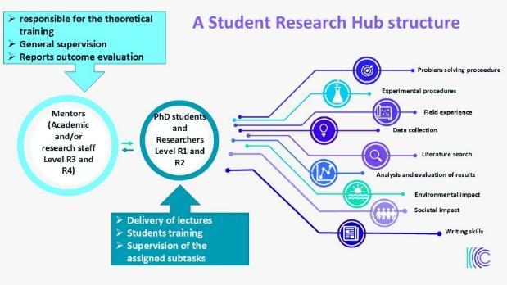
SRH training is implemented mainly on-site but also blended in the cases that students from other Universities than the host are participating. SRH training is implemented mainly on-site but also blended in the cases that students from other Universities than host are participating. During this two-month period, Mentors and Leaders are expected to engage in a minimum of 30 contact hours and dedicate 75 hours to autonomous work. The Structured Research Hours (SRH) last no less than two months; however, the duration may extend beyond this timeframe depending on factors such as Mentor availability, holidays, or exam periods. Applicants should specify the exact duration of the SRH in their application.
The SRH need to have clear title, specify learning outcomes, workload, timetable, prerequisites for participants, assessment, and certification (or recognition in CV)
At the end of each academic year, the outcomes of the SRHs will be presented in “Closing virtual workshop on undergraduate research activities”. A committee selected by Mentors, will evaluate the work done by each SRH and award the best team (1 per participating partner/year) for their exceptional work. These exceptional teams will receive funding from EU-CONEXA budget, for the mobility and registration to a conference or workshop.
Procedure for submitting applications
Interested Mentors should submit their application specifying the topic and implementation timetable as indicated in the application form.
During the application procedure the Mentor will appoint the Leader (PhD student or Researcher Level R1 and R2) and specify the title and the activities of Student Research Hub.
For all the necessary information the applicant can contact each partner University representative:
Partner | Representative | email
AUA | Evanthia Chatzoglou | echatzoglou@aua.gr
KU | Rima Mickeviciene | rima.mickeviciene@ku.lt
UNIZD | Anica Cuka  Zvezdan Penezic | acuka@unizd.hr  zpenezic@unizd.hr
SETU | Mike Kinsella | Mike.Kinsella@setu.ie
UROS | Yue Hu | yue.hu@uni-rostock.de
FredU | Angelos Angelodimou | a.angelodimou@frederick.ac.cy
UCV | Neringa Narbutiene | neringa.narbutiene@ucv.es

Deadline to submit applications for summer semester 2024, 20 January 2024.

For more information, please contact Evanthia Chatzoglou (echatzoglou@aua.gr), or a representative in each university listed in table.
Brochure for PhD Leaders
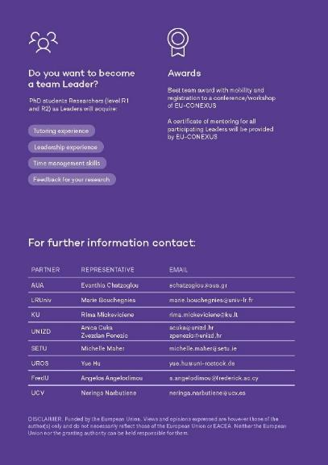
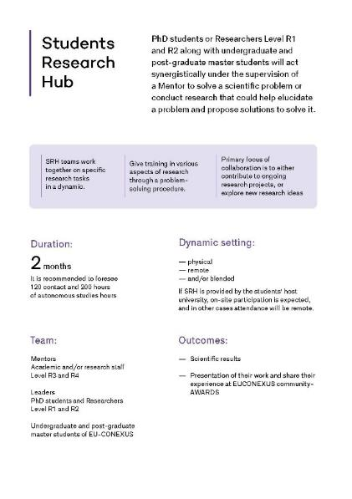
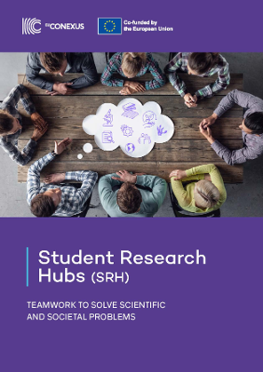
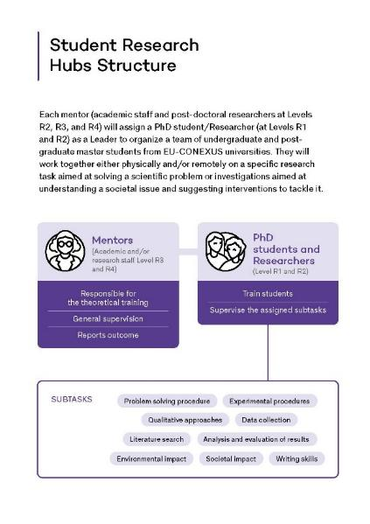

Application form to create a Student Research Hub in EU-CONEXUS on SmUCS
Contact details of the applicant
Full name of the Academic and Research staff
University
Faculty/Department
Email address
Contact phone number
Man hours of engagement
(contact/total)

Information about content proposal
Proposed title
Thematic area
Draft content description (up to 300 words)
General Learning outcomes
Prerequisites for participating students
Assessment method
Certification (ECTS where applicable)

Contact details of the PhD Leader
Full name of the PhD student
University
Faculty/Department
Email address
Contact phone number
Man hours of engagement
(contact/total)

Proposed timetable
Starting date:
Closing date:
Deadline for applications:
Physical presence mandatory | Yes/No
Duration of physical presence: | 1 week/1 month/other (please define)
Alternative activities: | If applicable
Only online courses | No/Yes

 | Implementation schedule | Physically/remotely | Contact hours | Autonomous work for students  (max hours) | Learning outcomes
Activity 1 |  | remotely
Activity 2 |  | remotely
Activity 3 |  | physically
Activity 4 |  | physically
Activity 5 |  | physically
Activity 6 |  | Physically
Activity 7 |  | Remotely
Activity 8  (mandatory) | Preaparation of a presentation for the “Closing virtual workshop on Undegraduate activities” | Remotely |  |  | Enhance proficiency in written and oral communication within a particular field, utilizing specialized terminology
Total Hours |  |  | 41 | 84 | 125

Invitation letter for students mobility
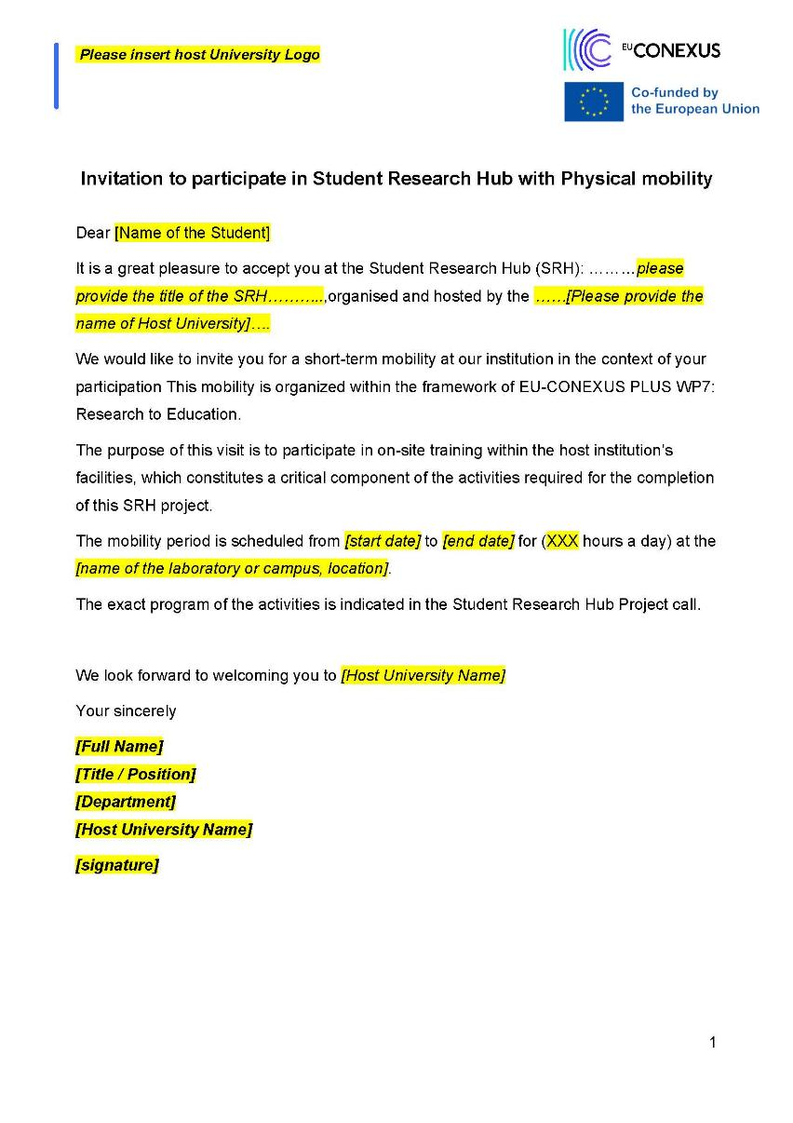

Appendix II. Webpages for SRH

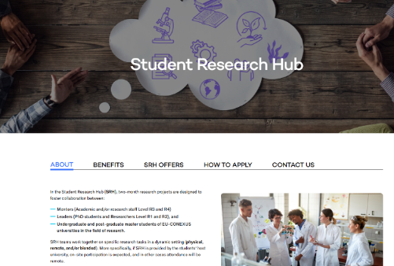 | 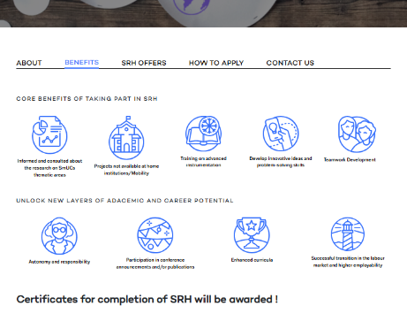
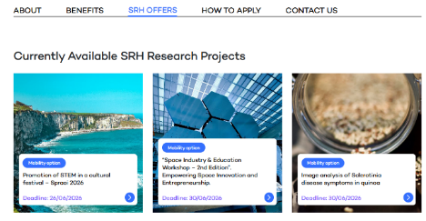  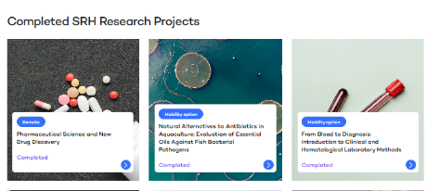 | 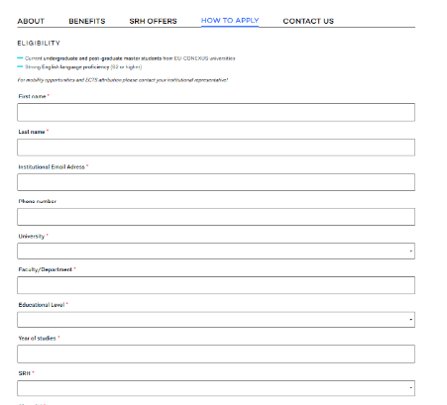

Appendix III. Moodle Guidelines documents

Dear SRH Mentor and Leader:
To start the implementation of your SRH
We have already enrolled you in moodle for your course
- you can log in to activate your EU-CONEXUS moodle account at:
https://moodle.eu-conexus.eu/2025/
- Please use your institutional email and password.
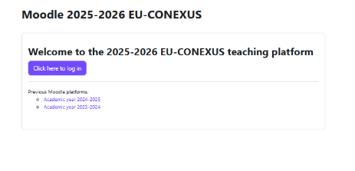
You will find your course in the list:

- If you go to edit mode, you can add any content for your Course.
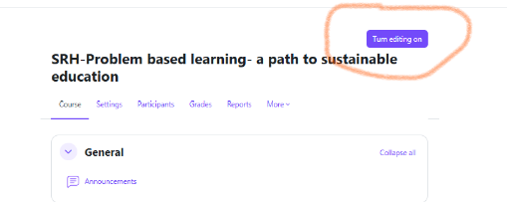

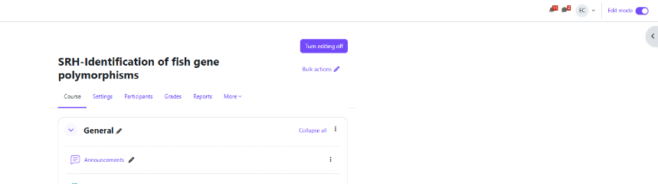

- You can create the course in moodle as follows
- 
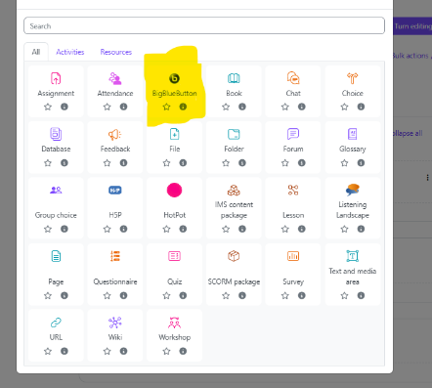
Not mandatory: You can add start time and closing time or not in moodle. If you do not set a time the course will be open all the time.
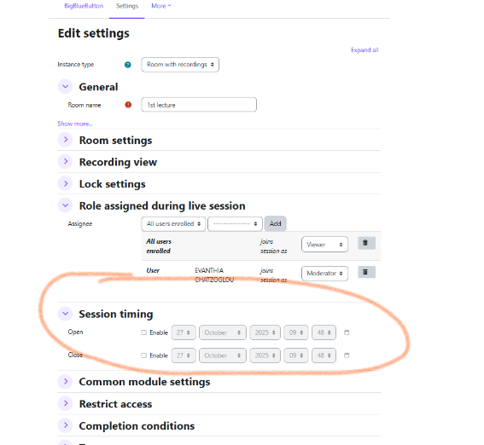
- In case of on-line courses, please remember to record your courses, since the students are allowed to watch the video asynchronously
Please do not use Mozilla Firefox browser, prefer Google chrome instead.

Please remember to stop the recording before closing the session for all participants
After the end of the course the video is automatically saved in the relevant section
- All educational material, reports and presenations can be added in Moodle
- You can use the Announcements for the communication with the students
- If you are not familiar with Moodle, please let me know so I can assist you.

Please let me know if you need any further assistance.
Thank you for your participation and cooperation

Kind regards
Evanthia Chatzoglou
(echatzoglou@aua.gr)

Appendix IV-Certificates’ templates

Certificate for students’ attendance
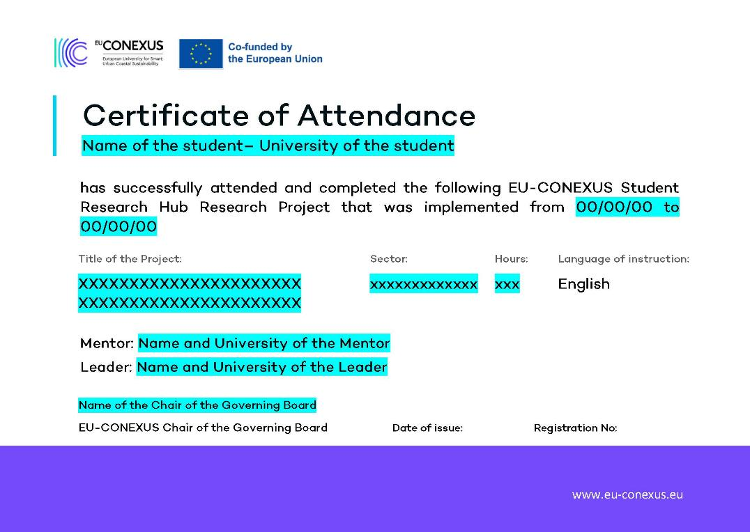

Certificate for Mentors in SRH
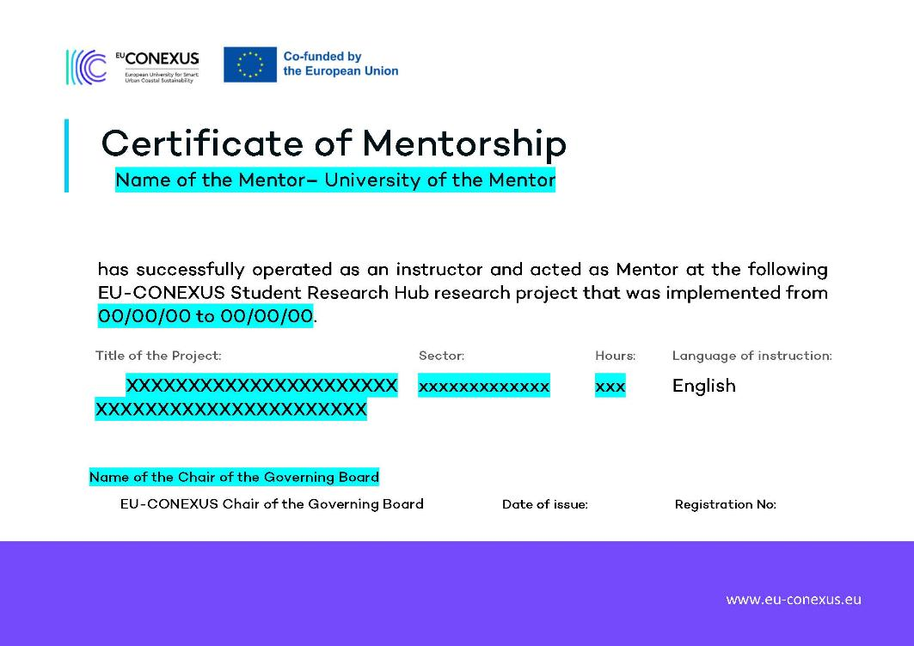

Certificate for Leaders in SRH
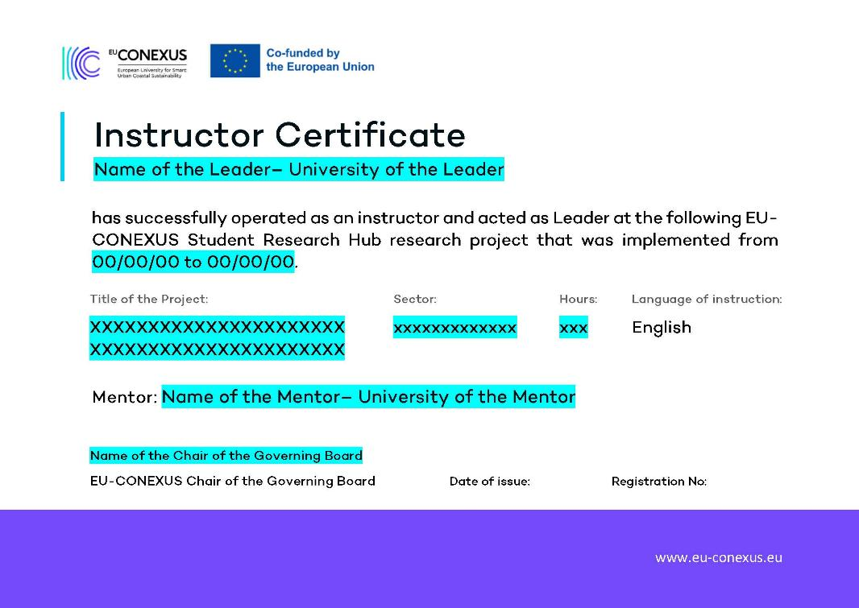

Appendix V. SRH Students’ Satisfaction questionnaire
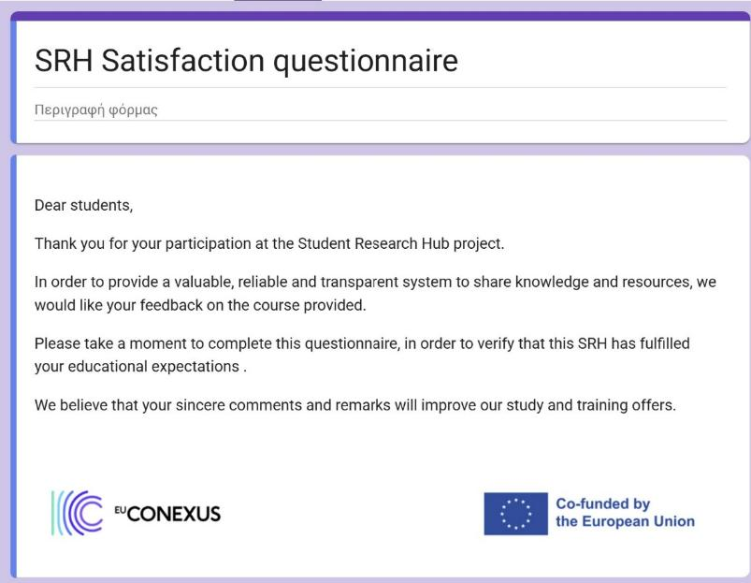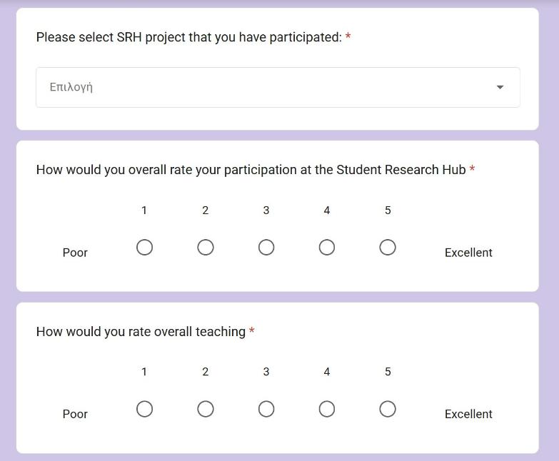
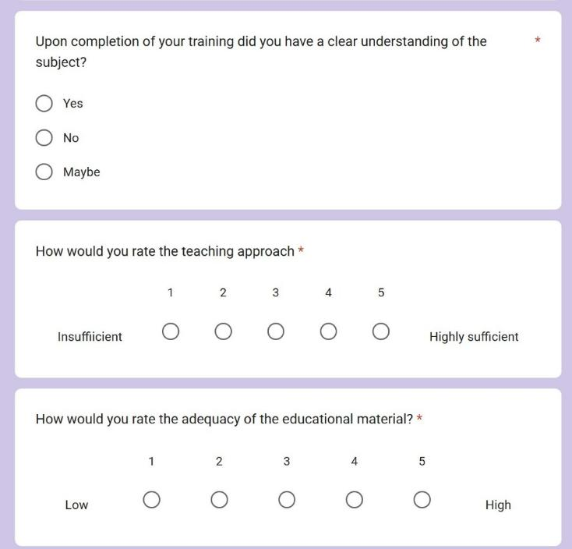
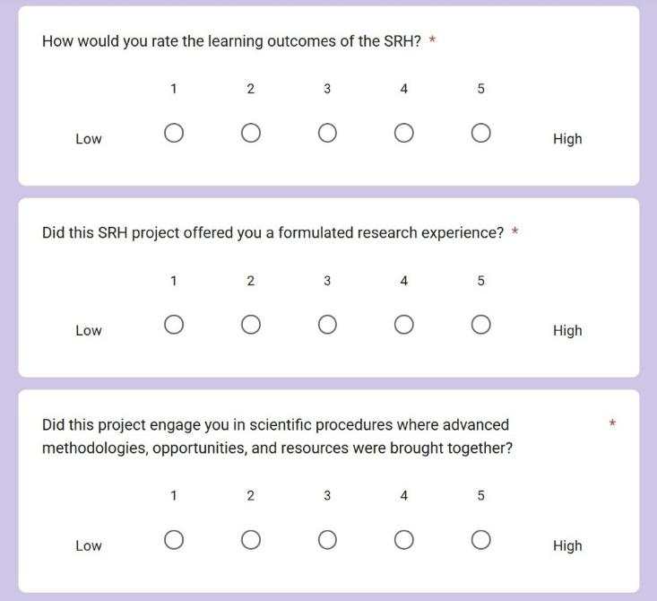
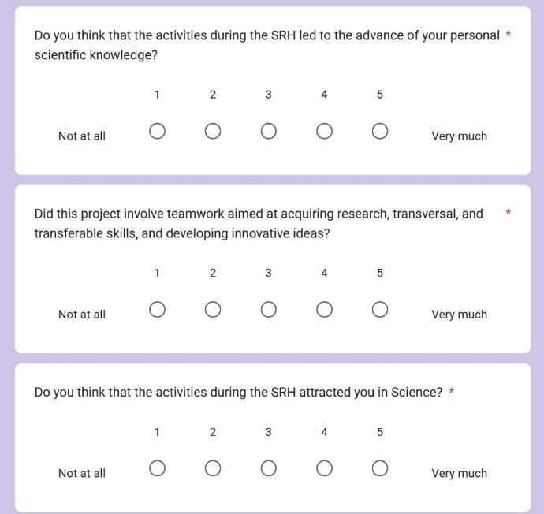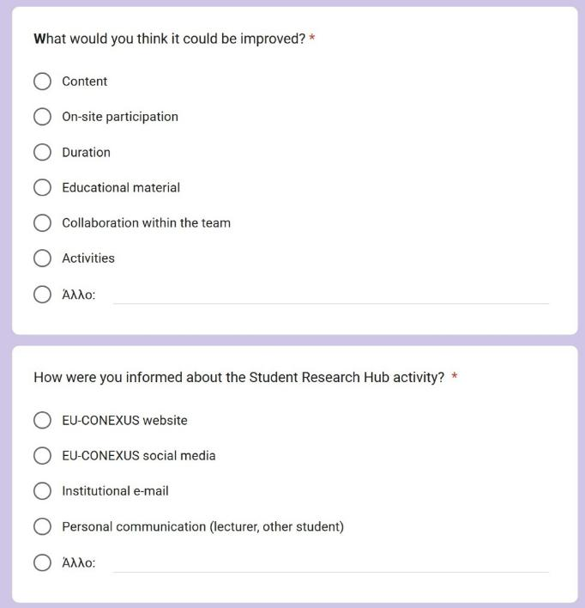
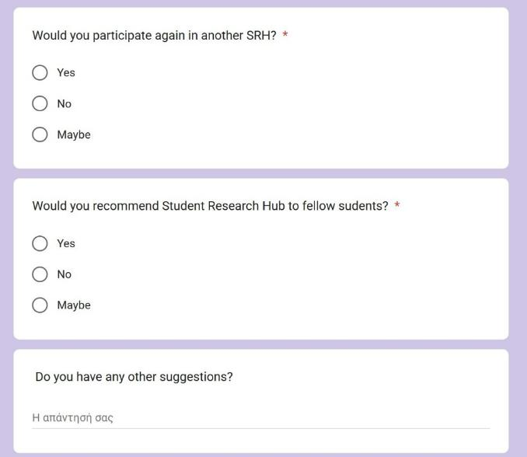

APPENDIX VI: Student Research Hub projects’ offers schedule

AUA
 | SRH project | Institution | Webpage | Number of applications received | Number of students accepted for training | Number of students certificates
 | Biosensors for the aquatic environment | AUA | https://www.eu-conexus.eu/en/student-research-hub/student-research-hub-2-biosensors-for-the-aquatic-environment/ | 10 | 9 | 7
 | Calculation of ISEW (Index of Sustainable Economic Welfare) at regional and local levels of coastal areas. | AUA | https://www.eu-conexus.eu/en/student-research-hub/student-research-hub-1-calculation-of-isew-index-of-sustainable-economic-welfare-at-regional-and-local-levels-of-coastal-areas/ | 6 | 6 | 2
 | Extract preparation, Biochemical Characterization, and In Vitro Testing of Extracts | AUA | https://www.eu-conexus.eu/en/student-research-hub/student-research-hub-3-extract-preparation-biochemical-characterization-and-in-vitro-testing-of-extracts/ | 28 | 10 | 9
 | Microbial additives in aquaculture: Effects on the lipid metabolism of gilthead seabream. | AUA | https://www.eu-conexus.eu/en/student-research-hub/student-research-hub-4-microbial-additives-in-aquaculture-effects-on-the-lipid-metabolism-of-gilthead-seabream/ | 16 | 12 | 7
 | Biosensors for the Environmental Monitoring of Aquatic Systems | AUA | https://www.eu-conexus.eu/en/student-research-hub/biosensors-for-the-environmental-monitoring-of-aquatic-systems/ | 26 | 15 | 9
 | Identification of fish gene polymorphisms | AUA | https://www.eu-conexus.eu/en/student-research-hub/student-research-hub-8-identification-of-fish-gene-polymorphisms/ | 26 | 11 | 8
 | The contribution of coastal small and medium-sized cities to Urban and Regional Development | AUA | https://www.eu-conexus.eu/en/student-research-hub-9-the-contribution-of-coastal-small-and-medium-sized-cities-to-urban-and-regional-development/ | 8 | 8 | 6
 | Diagnosis of fish diseases in aquaculture and identification of pathogens | AUA | https://www.eu-conexus.eu/en/student-research-hub/student-research-hub-6-diagnosis-of-fish-diseases-in-aquaculture-and-identification-of-pathogens/ | 11 | 11 | 9
 | Natural biomaterials: recent advances, and emerging applications | AUA | https://www.eu-conexus.eu/en/student-research-hub/natural-biomaterials-recent-advances-and-emerging-applications/ | 16 | 10 | 10
 | Extract preparation, Biochemical Characterization, and In Vitro Testing of Extracts | AUA | https://www.eu-conexus.eu/en/student-research-hub/extract-preparation-biochemical-characterization-and-in-vitro-testing-of-extracts/ | 24 | 10 | 10
 | Diagnosis of fish diseases with the use of molecular methods | AUA | https://www.eu-conexus.eu/en/student-research-hub/diagnosis-of-fish-diseases-with-the-use-of-molecular-methods/ | 33 | 13 | 13
 | Biosensors for the environmental monitoring of aquatic systems-Call 2025 | AUA | https://www.eu-conexus.eu/en/student-research-hub/biosensors-for-the-environmental-monitoring-of-aquatic-systems/ | 20 | 10 | 9
 | Chemistry and in vitro Bioactivity of Medicinal and Aromatic Plants | AUA | https://www.eu-conexus.eu/en/student-research-hub/chemistry-and-in-vitro-bioactivity-of-medicinal-and-aromatic-plants/ | 42 | 7 | 6
 | Dietary Effects on Haematological Parameters of Fish | AUA | https://www.eu-conexus.eu/en/student-research-hub/dietary-effects-on-hematological-parameters-of-fish/ | 24 | 15 | 15
 | Novel insights on Nutritional Assessment and Body composition analysis | AUA | https://www.eu-conexus.eu/en/student-research-hub/novel-insights-on-nutritional-assessment-and-body-composition-analysis/ | 13 | 13 | 6
 | Chemistry and in vitro Bioactivity of Medicinal and Aromatic Plants-Call 2026 | AUA | https://www.eu-conexus.eu/en/student-research-hub/chemistry-and-in-vitro-bioactivity-of-medicinal-and-aromatic-plants-2/ | 37 | 12 | 11
 | Computer applications in fish and seafood processing | AUA | https://www.eu-conexus.eu/en/student-research-hub/computer-applications-in-fish-and-seafood-processing/ | 16 | 16 | 13
 | The Coastal Health Lab: Understanding and Assessing Lifestyle, Nutrition, and Quality of Life | AUA | https://www.eu-conexus.eu/en/student-research-hub/the-coastal-health-lab-understanding-and-assessing-lifestyle-nutrition-and-quality-of-life/ | 8 | 7 | 7
 | Exploring Exosomes in Marine Systems: A Bioinformatics and Biotechnology Approach | AUA | https://www.eu-conexus.eu/en/exploring-exosomes-in-marine-systems-a-bioinformatics-and-biotechnology-approach/ | 23 | 18 | 14
 | Invasive Alien Species: morphometrics and feeding ecology | AUA | https://www.eu-conexus.eu/en/invasive-alien-species-morphometrics-and-feeding-ecology/ | 17 | 15 | 14
 | Natural Alternatives to Antibiotics in Aquaculture: Evaluation of Essential Oils Against Fish Bacterial Pathogens | AUA | https://www.eu-conexus.eu/en/student-research-hub/natural-alternatives-to-antibiotics-in-aquaculture-evaluation-of-essential-oils-against-fish-bacterial-pathogens/ | 7 | 3 | 2

FREDU
 | SRH project | Institution | Webpage | Number of applications received | Number of students accepted for training | Number of certificates
 | Applications of computational fluid dynamics (CFD) and computational mechanics (CM) for sustainable and secure transport systems at coastal and urban areas | FREDU | https://www.eu-conexus.eu/en/student-research-hub/applications-of-computational-fluid-dynamics-cfd-and-computational-mechanics-cm-for-sustainable-and-secure-transport-systems-at-coastal-and-urban-areas/ | 11 | 11 | 7
 | Computational fluid dynamics (CFD) and computational mechanics (CM) methodologies expedited with Machine Learning (ML) techniques for a sustainable and secure coastal/urban environment | FREDU | https://www.eu-conexus.eu/en/student-research-hub/computational-fluid-dynamics-cfd-and-computational-mechanics-cm-methodology-expedited-with-machine-learning-ml-techniques-for-a-sustainable-and-secure-coastal-urban-environment/ | 10 | 10 | N/A*
 | From Blood to Diagnosis: Introduction to Clinical and Hematological Laboratory Methods | FREDU | https://www.eu-conexus.eu/en/from-blood-to-diagnosis-introduction-to-clinical-and-hematological-laboratory-methods/ | 19 | 4 | 4
 | Enzyme inhibitory activity in medicinal and aromatic plants | FREDU | https://www.eu-conexus.eu/en/enzyme-inhibitory-activity-in-medicinal-and-aromatic-plants/ | 37 | 13 | 13
 | Smart Polymeric Materials for Biomedical Applications: Synthesis, Characterization and Drug Delivery | FREDU | https://www.eu-conexus.eu/en/smart-polymeric-materials-for-biomedical-applications-synthesis-characteri zation-and-drug-delivery/ | 36 | 6 | 6
 | Reproductive Biotechnology: Cell Assessment, Cryopreservation and Data Interpretation | FREDU | https://www.eu-conexus.eu/en/student-research-hub/reproductive-biotechnology-cell-assessment-cryopreservation-and-data-interpretation/ | 40 | 38 | N/A*
 | Computational fluid dynamics (CFD) and computational mechanics (CM) methodology and digital tools (DT) for sustainable and secure coastal/urban environment | FREDU | https://www.eu-conexus.eu/en/student-research-hub/computational-fluid-dynamics-cfd-and-computational-mechanics-cm-methodology-and-digital-tools-dt-for-sustainable-and-secure-coastal-urban-environment/ | 4 | 4 | N/A*
 | AI Literacy, Ethics and Human-Centred Innovation for Undergraduate Students: A Challenged-Based Learning Approach | FREDU | https://www.eu-conexus.eu/en/ai-literacy-ethics-and-human-centred-innovation-for-undergraduate-students-a-challenged-based-learning-approach | 33 | 21 | N/A*
 | AI as Digital Intelligence for Sustainable AEC: Designing Data-Driven Urban Futures in Limassol | FREDU | https://www.eu-conexus.eu/en/ai-as-digital-intelligence-for-sustainable-aec-designing-data-driven-urban-futures-in-limassol/ | 11 | 8 | N/A*
 | Reproductive Biotechnology: Cell Assessment, Cryopreservation and Data Interpretation 2nd call | FREDU | https://www.eu-conexus.eu/en/reproductive-biotechnology-cell-assessment-cryopreservation-and-data-interpretation-2nd-call/ | 15 | 15 | N/A*
*Ν/Α: Student evaluations are currently pending

KU
 | SRH project | Institution | Webpage | Number of applications received | Number of students accepted for training | Number of certificates
 | Green Management and Marketing: Driving Sustainable Change in Business | KU | https://www.eu-conexus.eu/en/student-research-hub/green-management-and-marketing-driving-sustainable-change-in-business/ | 17 | 7 | 7
 | Green Management and Relationship Marketing: Driving Sustainable Change in Business | KU | https://www.eu-conexus.eu/en/student-research-hub/green-management-and-relationship-marketing-driving-sustainable-change-in-business/ | 20 | 14 | 13
 | Leadership in Fostering Innovation for Social Problem-Solving | KU | https://www.eu-conexus.eu/en/student-research-hub/leadership-in-fostering-innovation-for-social-problem-solving/ | 2 | 0 | 0
 | Professional Autonomy Challenges in Health Care | KU | https://www.eu-conexus.eu/en/student-research-hub/professional-autonomy-challenges-in-health-care/ | 1 | 0 | 0
 | Development of Social Services to Ensure Human Dignity in Old Age | KU | https://www.eu-conexus.eu/en/student-research-hub/development-of-social-services-to-ensure-human-dignity-in-old-age/ | 2 | 0 | 0
 | Comparative research into robotic steel welding processes | KU | https://www.eu-conexus.eu/en/comparative-research-into-robotic-steel-welding-processes/ | 17 | 15 | 15
 | Exploring Aging as an Existential Crisis: Implications for Health and Well-Being | KU | https://www.eu-conexus.eu/en/exploring-aging-as-an-existential-crisis-implications-for-health-and-well-being/ | 4 | 4 | N/A*
 | Comparative research into robotic steel welding processes 2nd call | KU | https://www.eu-conexus.eu/en/student-research-hub/comparative-research-into-robotic-steel-welding-processes/ | 27 | 14 | 14
*Ν/Α: Student evaluations are currently pending

SETU
 | SRH project | Institution | Webpage | Number of applications received | Number of students accepted for training | Number of certificates
 | Evaluating the Sustainability of Rosslare Europort: Strategies for Green Innovation and Resilience • Smart & Sustainable Infrastructure | SETU | https://www.eu-conexus.eu/en/student-research-hub/evaluating-the-sustainability-of-rosslare-europort-strategies-for-green-innovation-and-resilience/ | 25 | 16 | 16
 | Evaluating the Sustainability of Rosslare Europort: Strategies for Green Innovation and Resilience • ESG & Sustainability Reporting | SETU | https://www.eu-conexus.eu/en/student-research-hub/evaluating-the-sustainability-of-rosslare-europort-strategies-for-green-innovation-and-resilience/ | 21 | 21 | 20
 | Evaluating the Sustainability of Rosslare Europort: Strategies for Green Innovation and Resilience • Green Innovation & Climate Resilience | SETU | https://www.eu-conexus.eu/en/student-research-hub/evaluating-the-sustainability-of-rosslare-europort-strategies-for-green-innovation-and-resilience/ | 17 | 18 | 18
 | Sustainable Food Systems through Culinary Heritage and Cultural Landscapes | SETU | https://www.eu-conexus.eu/en/sustainable-food-systems-through-culinary-heritage-and-cultural-landscapes/ | 13 | 9 | 9
 | Solid state Materials characterization techniques for research – characterization of Alginate/graphene bioactive formulations | SETU | https://www.eu-conexus.eu/en/student-research-hub/solid-state-materials-characterization-techniques-for-research-characterization-of-alginate-graphene-bioactive-formulations/ | 3 | 3 | 3
 | Rosslare Port Living Lab:  Maritime Decarbonisation  Energy Transition & Smart Systems: Evaluating renewable integration, electrification, and efficiency in smart port operations. – Construction Project Management focus | SETU | https://www.eu-conexus.eu/en/student-research-hub/rosslare-port-living-lab-maritime-decarbonisation-energy-transition-smart-systems-evaluating-renewable-integration-electrification-and-efficiency-in-smart-port-operations-2/ | 17 | 17 | 17
 | Rosslare Port Living Lab: Maritime DecarbonisationEnergy Transition & Smart Systems: Evaluating renewable integration, electrification, and efficiency in smart port operations. – Sustainable Energy Engineering focus | SETU | https://www.eu-conexus.eu/en/student-research-hub/rosslare-port-living-lab-maritime-decarbonisation-energy-transition-smart-systems-evaluating-renewable-integration-electrification-and-efficiency-in-smart-port-operations-2/ | 10 | 9 | 9
 | Reimagining the Electrified Port: Designing the Future Logistics–Energy Ecosystem – Supply Chain Management | SETU | https://www.eu-conexus.eu/en/student-research-hub/reimagining-the-electrified-port-designing-the-future-logistics-energy-ecosystem-supply-chain-management/ | 8 | 8 | 8
 | Biodiversity at the Copper Coast | SETU | https://www.eu-conexus.eu/en/student-research-hub/biodiversity-at-the-copper-coast/ | 14 | 6 | 6
 | Drift: Journeys Across Water and Time.”Sustainability in the Arts | SETU | https://www.eu-conexus.eu/en/student-research-hub/drift-journeys-across-water-and-time-sustainability-in-the-arts-2026/ | 26 | 24 | No GDPR consent
 | Sustainable Food Systems through Culinary Heritage and Cultural Landscapes 2nd call | SETU |  | 13 | 13 | 13
 | Bealtaine Living Earth Festival: Biodiversity, Sustainability and Community Engagement | SETU | https://www.eu-conexus.eu/en/bealtaine-living-earth-festival-biodiversity-sustainability-and-community-engagement/ | 9 | 4 | 4
 | Space Industry & Education Workshop | SETU | https://www.eu-conexus.eu/en/space-industry-education-workshop-2nd-edition-empowering-space-innovation-and-entrepreneurship/ | 38 | 12 | 12
 | Robert Boyle Summer School Student Research Hub | SETU | https://www.eu-conexus.eu/en/robert-boyle-summer-school-student-research-hub/ | 10 | 3 | 3
 | Pharmaceutical Science and New Drug Discovery | SETU | https://www.eu-conexus.eu/en/pharmaceutical-science-and-new-drug-discovery/ | 36 | 36 | 19
 | Promotion of STEM in a cultural festival - Spraoi 2026 | SETU | https://www.eu-conexus.eu/en/student-research-hub/promotion-of-stem-in-a-cultural-festival-spraoi-2026/ | 12 | 4 | 4
 | Research Skills Through Literature Review | SETU | https://www.eu-conexus.eu/en/student-research-hub/research-skills-through-literature-review/ | 28 | 27 | N/A*
 | Surf and Turf Physics: Experiential Coastal STEM Education | SETU | https://www.eu-conexus.eu/en/surf-and-turf-physics-experiential-coastal-stem-education/ | 117 | 97 | N/A*
 | Application of digital analytics in the delivery of performance led urban futures | SETU | https://www.eu-conexus.eu/en/application-of-digital-analytics-in-the-delivery-of-performance-led-urban-futures/ | 22 | 20 | N/A*
*Ν/Α: Student evaluations are currently pending

UCV
 | SRH project | Institution | Webpage | Number of applications received | Number of students accepted for training | Number of certificates
 | Data analysis in physical oceanography | UCV | https://www.eu-conexus.eu/en/student-research-hub/data-analysis-in-physical-oceanography/ | 11 | 7 | 3
 | Multidisciplinary oceanographic research | UCV | https://www.eu-conexus.eu/en/student-research-hub/multidisciplinary-oceanographic-research/ | 49 | 38 | 38
 | Enhancement of two stages production strategy in microalgal cultures for NMPs production | UCV | https://www.eu-conexus.eu/en/student-research-hub/enhancement-of-two-stages-production-strategy-in-microalgal-cultures-for-nmps-production/ | 1 | 1 | 1
 | Enhancement of two stages production strategy in microalgal cultures for NMPs production | UCV | https://www.eu-conexus.eu/en/student-research-hub/enhancement-of-two-stages-production-strategy-in-microalgal-cultures-for-nmps-production/ | 7 | 0 | 0
 | Enhancement of two stages production strategy in microalgal cultures for NMPs production | UCV | https://www.eu-conexus.eu/en/student-research-hub/enhancement-of-two-stages-production-strategy-in-microalgal-cultures-for-nmps-production-2/ | 8 | 0 | 0
 | AI at School. Research Applied to a Comprehensive Inclusion | UCV | https://www.eu-conexus.eu/en/student-research-hub/ai-at-school-research-applied-to-a-comprehensive-inclusio/ | 19 | 5 | 5
 | AI at School. Research Applications for Sustainability | UCV | https://www.eu-conexus.eu/en/ai-at-school-research-applications-for-sustainability/ | 23 | 10 | 11
 | Essential Skills for Working in the Laboratory | UCV | https://www.eu-conexus.eu/en/student-research-hub/essential-skills-for-working-in-the-laboratory/ | 63 | 20 | 11
 | From CTD to Climate: Ocean Data Skills with Open-Source Tools | UCV | https://www.eu-conexus.eu/en/student-research-hub/data-analysis-in-physical-oceanography-2/ | 29 | 19 | 5
 | Outdoor Activities: Safety, Values and Inclusion | UCV | https://www.eu-conexus.eu/en/student-research-hub/outdoor-activities-safety-values-and-inclusion/ | 21 | 13 | 13
 | Building health, inclusion and society through mountain sports | UCV | https://www.eu-conexus.eu/en/student-research-hub/building-health-inclusion-and-society-through-mountain-sports/ | 2 | 1 | 1
 | Scuba diving for scientific research in Coastal Waters | UCV | https://www.eu-conexus.eu/en/scuba-diving-for-scientific-research-in-coastal-waters/ | 28 | 5 | 5
 | Multidisciplinary oceanographic research in coastal ecosystems: analysis of physical and chemical data | UCV | https://www.eu-conexus.eu/en/multidisciplinary-oceanographic-research-in-coastal-ecosystems-analysis-of-physical-and-chemical-data/ | 29 | 24 | 24
 | Multidisciplinary oceanographic research in coastal ecosystems: analysis of biological data | UCV | https://www.eu-conexus.eu/en/multidisciplinary-oceanographic-research-in-coastal-ecosystems-analysis-of-biological-data/ | 15 | 13 | 13
 | Developing intercultural and democratic competences in Higher Education | UCV | https://www.eu-conexus.eu/en/student-research-hub/developing-intercultural-and-democratic-competences-in-higher-education/ | 5 | 5 | 5
 | Laboratory Practice: Fundamental Techniques and Skills | UCV | https://www.eu-conexus.eu/en/laboratory-practice-fundamental-techniques-and-skills/ | 17 | 10 | 10
 | Neurotechnology : Foundational Principles, Ethics, Clinical Applications and Marketplace | UCV | https://www.eu-conexus.eu/en/neurotechnology-foundational-principles-ethics-clinical-applications-and-marketplace/ | 27 | 10 | 10
 | Advanced cadaver-based ultrasound and minimally invasive foot surgery : anatomical dissection, skeletal surgery and guided infiltrations | UCV | https://www.eu-conexus.eu/en/advanced-cadaver-based-ultrasound-and-minimally-invasive-foot-surgery-anatomical-dissection-skeletal-surgery-and-guided-infiltrations/ | 8 | 5 | 5

UNIZD
 | SRH project | Institution | Webpage | Number of applications received | Number of students accepted for training | Number of certificates
 | Problem based learning- a path to sustainable education | UNIZD | https://www.eu-conexus.eu/en/student-research-hub/problem-based-learning-a-path-to-sustainable-education/ | 12 | 11 | 6
 | Environmental Anxiety and Coping: How Do Youth in Coastal Regions Cope with Climate Change? | UNIZD | https://www.eu-conexus.eu/en/environmental-anxiety-and-coping-how-do-youth-in-coastal-regions-cope-with-climate-change/ | 7 | 7 | 1
 | Isolation of fungi and fungal spores and conidia from air, soil and plant material | UNIZD | https://www.eu-conexus.eu/en/student-research-hub/isolation-of-fungi-fungal-spores-and-conidia-from-air-soil-and-plant-material/ | 29 | 7 | 7
 | Evaluation of suitable olive cultivars for sustainable urban gardens | UNIZD | https://www.eu-conexus.eu/en/student-research-hub/evaluation-of-suitable-olive-cultivars-for-sustainable-urban-gardens/ | 22 | 2 | 2
 | Inquiry-Based Approaches to Sustainable Science Education | UNIZD | https://www.eu-conexus.eu/en/student-research-hub/inquiry-based-approaches-to-sustainable-science-education/ | 15 | 11 | 7
 | Comparative stylistics of the German ballad | UNIZD | https://www.eu-conexus.eu/en/student-research-hub/comparative-stylistics-of-the-german-ballad/ | 1 | 0 | 0
 | Entrepreneurial ecosystem in tourism | UNIZD | https://www.eu-conexus.eu/en/student-research-hub/entrepreneurial-ecosystem-in-tourism/ | 3 | 0 | 0
 | Experimental Forms of Ethnography | UNIZD | https://www.eu-conexus.eu/en/experimental-forms-of-ethnography/ | 1 | 0 | 0
 | Exploring the Blue Economy Through Data | UNIZD | https://www.eu-conexus.eu/en/student-research-hub/exploring-the-blue-economy-through-data/ | 5 | 5 | 2
 | From Question to Creation: An Experiential Learning Model | UNIZD | https://www.eu-conexus.eu/en/student-research-hub/from-question-to-creation-an-experiential-learning-model/ | 20 | 16 | 16
 | Natural language processing (NLP) for climate research: | UNIZD | https://www.eu-conexus.eu/en/student-research-hub/natural-language-processing-nlp-for-climate-research-practical-text-analysis-workflows/ | 3 | 3 | 2
 | Nature and Art Education | UNIZD | https://www.eu-conexus.eu/en/student-research-hub/nature-and-art-education/ | 3 | 3 | 1
 | The Role of Local Communities in Sustainable Development | UNIZD | https://www.eu-conexus.eu/en/student-research-hub/the-role-of-local-communities-in-sustainable-development/ | 4 | 4 | 1
 | Transhumance between Mountain and Coastal Landscapes | UNIZD | https://www.eu-conexus.eu/en/student-research-hub/transhumance-between-mountain-and-coastal-landscapes/ | 6 | 6 | 2
 | Community archives | UNIZD | https://www.eu-conexus.eu/en/community-archives/ | 4 | 4 | N/A*
 | Conceptual Metaphors and Green Discourse – Green metaphors | UNIZD | https://www.eu-conexus.eu/en/conceptual-metaphors-and-green-discourse-green-metaphors/ | 9 | 9 | N/A*
 | Growing Old in Europe: Moral Economy of Sustainable Care for Older Adults | UNIZD | https://www.eu-conexus.eu/en/growing-old-in-europe-moral-economy-of-sustainable-care-for-older-adults/ | 1 | 1 | N/A*
 | Languages on Display: Understanding Public Texts | UNIZD | https://www.eu-conexus.eu/en/languages-on-display-understanding-public-texts/ | 3 | 3 | N/A*
 | Medieval lessons in sustainability: organizing agriculture around late-medieval Dalmatian towns | UNIZD | https://www.eu-conexus.eu/en/medieval-lessons-in-sustainability-organizing-agriculture-around-late-medieval-dalmatian-towns/ | 1 | 1 | N/A*
 | Phytoplankton Cultivation and Biotechnology | UNIZD | https://www.eu-conexus.eu/en/phytoplankton-cultivation-and-biotechnology/ | 28 | 7 | N/A*
 | RAS System Dynamics and Environmental Control | UNIZD | https://www.eu-conexus.eu/en/ras-system-dynamics-and-environmental-control/ | 25 | 9 | N/A*
 | Tourism and the Economic Geography of Small EU-CONEXUS Islands: Community Resilience, Landscapes, and Sustainable Development Pathways | UNIZD | https://www.eu-conexus.eu/en/tourism-and-the-economic-geography-of-small-eu-conexus-islands-community-resilience-landscapes-and-sustainable-development-pathways/ | 14 | 14 | N/A*
*Ν/Α: Student evaluations are currently pending

UROS

 | SRH project | Institution | Webpage | Number of applications received | Number of students accepted for training | Number of certificates
 | Long-term effect of phosphorus management on soil fertility and soil P pools | UROS | https://www.eu-conexus.eu/en/student-research-hub/long-term-effect-of-phosphorus-management-on-soil-fertility-and-soil-p-pools/ | 4 | 1 | 1
 | Long-term effect of phosphorus management on soil fertility and soil P pools 2nd call | UROS | https://www.eu-conexus.eu/en/student-research-hub/2nd-call-long-term-effect-of-phosphorus-management-on-soil-fertility-and-on-soil-p-pools/ | 4 | 4 | 1
 | Nitrogen translocation in the soil profile as affected by long-term fertiliser management and cover crops | UROS | https://www.eu-conexus.eu/en/student-research-hub/nitrogen-translocation-in-the-soil-profile-as-affected-by-long-term-fertiliser-management-and-cover-crops/ | 3 | 3 | 3
 | Gill parasites (Monogenea) of white fish (Leuciscidae) in waters of Mecklenburg-Western Pomerania | UROS | https://www.eu-conexus.eu/en/student-research-hub/gill-parasites-monogenea-of-white-fish-leuciscidae-in-waters-of-mecklenburg-western-pomerania/ | 6 | 1 | 1
 | Nutrient uptake of plants treated with cold plasma and soil conditioners under drought stress conditions. | UROS | https://www.eu-conexus.eu/en/student-research-hub/nutrient-uptake-of-plants-treated-with-cold-plasma-and-soil-conditioners-under-drought-stress-conditions/ | 8 | 3 | 3
 | Screening of novel bio-based recycling fertilizers to evaluate their effects on germination, nutrient uptake and biomass yield in selected crops | UROS | https://www.eu-conexus.eu/en/student-research-hub/screening-of-novel-bio-based-recycling-fertilizers-to-evaluate-their-effects-on-germination-nutrient-uptake-and-biomass-yield-in-selected-crops / | 10 | 1 | 1
 | The use of innovative cold plasma and soil conditioners in a field experiment – effects on yield and soil quality | UROS | https://www.eu-conexus.eu/en/student-research-hub/the-use-of-innovative-cold-plasma-and-soil-conditioners-in-a-field-experiment-effects-on-yield-and-soil-quality/ | 9 | 3 | 3
 | Development of a Micro-Lecture on Waste Management or Circular Economy | UROS | https://www.eu-conexus.eu/en/student-research-hub/development-of-a-micro-lecture-on-waste-management-or-circular-economy/ | 20 | 5 | 5
 | Nutrient gradients in Temperate Alley Cropping: A Field- to-Lab Training on Soil Nutrient Dynamics | UROS | https://www.eu-conexus.eu/en/student-research-hub/nutrient-gradients-in-temperate-alley-cropping-a-field-to-lab-training-on-soil-nutrient-dynamics/ | 9 | 1 | 1
 | From Macroscopy to Histology: Organization of the Central Nervous System | UROS | https://www.eu-conexus.eu/en/student-research-hub/from-macroscopy-to-histology-organization-of-the-central-nervous-system/ | 29 | 6 | 6
 | Remote Sensing and 3D Imagery Driven Phenotyping for Plant Physiological Trait Analysis and Yield Prediction in Winter Wheat | UROS | https://www.eu-conexus.eu/en/remote-sensing-and-3d-imagery-driven-phenotyping-for-plant-physiological-trait-analysis-and-yield-prediction-in-winter-wheat/ | 7 | 1 | 1
 | Long-term effect of phosphorus management on soil fertility and Soil P pools 3rd call | UROS | https://www.eu-conexus.eu/en/long-term-effect-of-phosphorus-management-on-soil-fertility-and-on-soil-p-pools/ | 5 | 0 | 0
 | Phosphorus Analysis in High-Carbon Andosols: Method Adaptation for Challenging Soil Matrices | UROS | https://www.eu-conexus.eu/en/phosphorus-analysis-in-high-carbon-andosols-method-adaptation-for-challenging-soil-matrices/ | 14 | 0 | 0
 | Image analysis of Sclerotinia disease symptoms in quinoa | UROS | https://www.eu-conexus.eu/en/student-research-hub/image-analysis-of-sclerotinia-disease-symptoms-in-quinoa/ | 8 | 1 | 1
 | Phenotyping with 3D-Scans and Computer Vision in Wheat | UROS | https://www.eu-conexus.eu/en/phenotyping-with-3d-scans-and-computer-vision-in-wheat/ | 14 | 1 | N/A*
 | Drought effects on root traits and yield components in dwarf and tall winter rye | UROS | https://www.eu-conexus.eu/en/drought-effects-on-root-traits-and-yield-components-in-dwarf-and-tall-winter-rye/ | 7 | 0 | 0
 | Vegetation composition, Trophic Status and Yield assessment of rotational Pastures in Mecklenburg-Western Pomerania | UROS | https://www.eu-conexus.eu/en/vegetation-composition-trophic-status-and-yield-assessment-of-rotational-pastures-in-mecklenburg-western-pomerania/ | 4 | 0 | 0
 | Vegetation composition, Trophic Status and Yield assessment of rotational Pastures in Mecklenburg-Western Pomerania – 2nd call | UROS | https://www.eu-conexus.eu/en/vegetation-composition-trophic-status-and-yield-assessment-of-rotational-pastures-in-mecklenburg-western-pomerania-2nd-call/ | 5 | 1 | N/A*
 | Metabolomic Characterization and Bioactivity Assessment of Major Saponin Classes in Genetically Diverse Quinoa | UROS | https://www.eu-conexus.eu/en/metabolomic-characterization-and-bioactivity-assessment-of-major-saponin-classes-in-genetically-diverse-quinoa/ | 8 | 5 | N/A*
*Ν/Α: Student evaluations are currently pending

Visuals
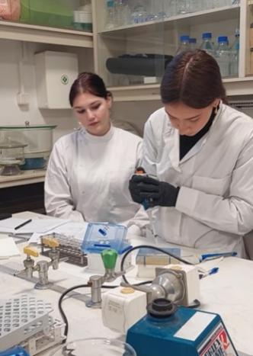 | 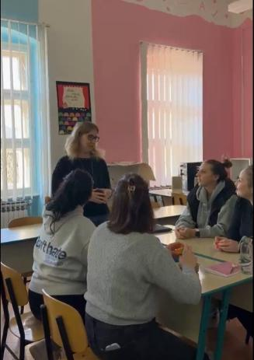 |  | 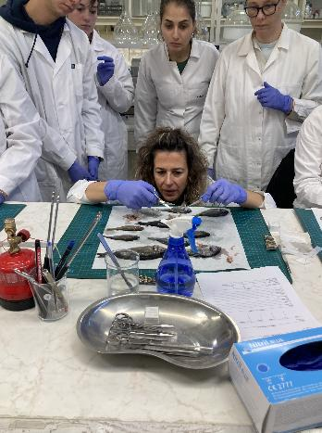 |  | 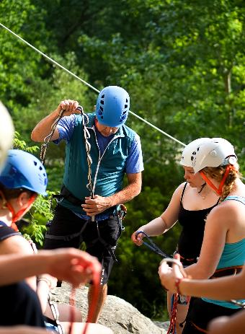
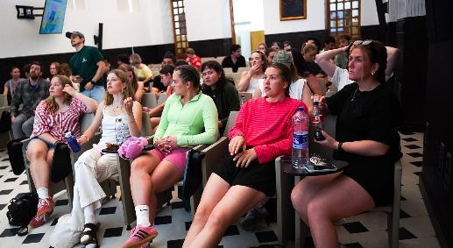 |  | 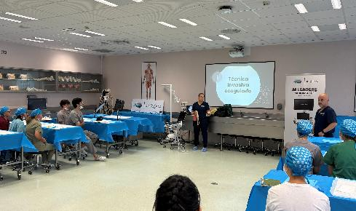 |  | 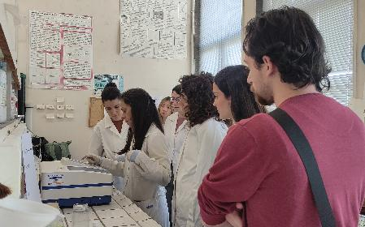
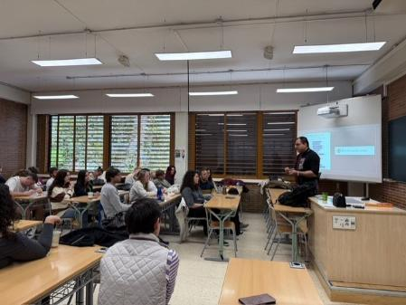 |  | 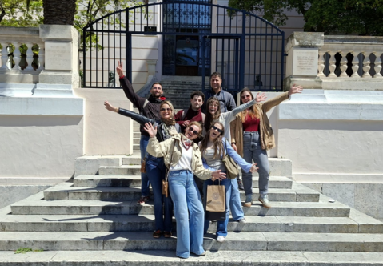 |  | 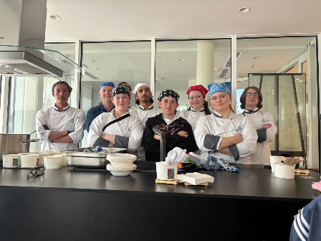
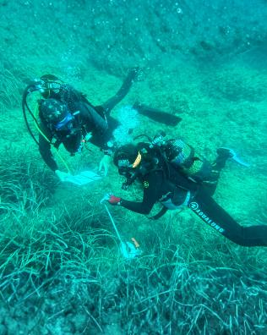 |  | 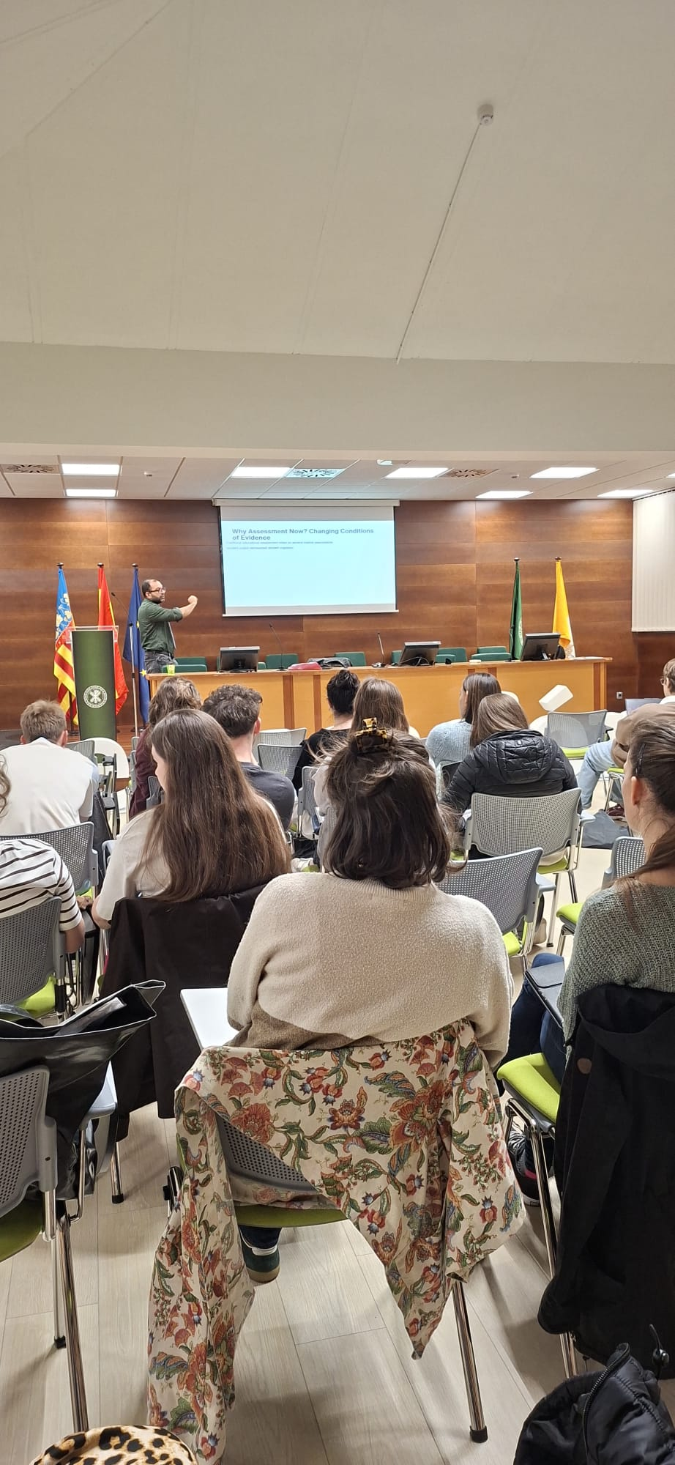 |  | 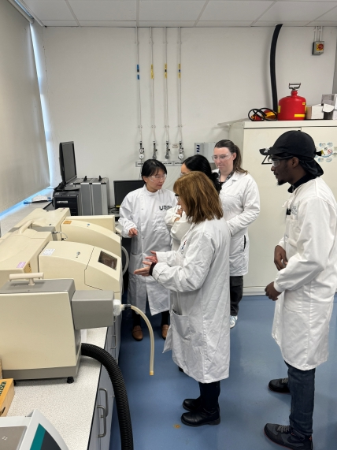

Appendix VII. Dissemination Materials and Communication Activities

Promotional Visual templates
Series I
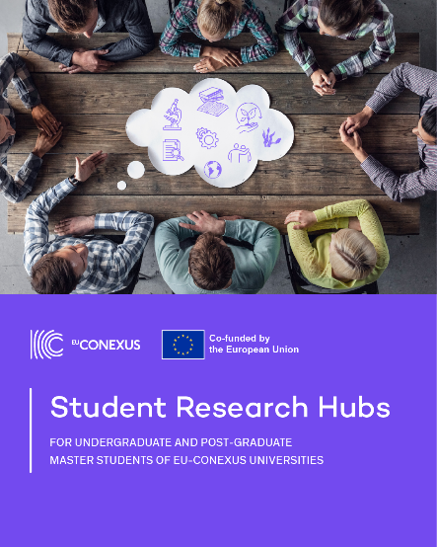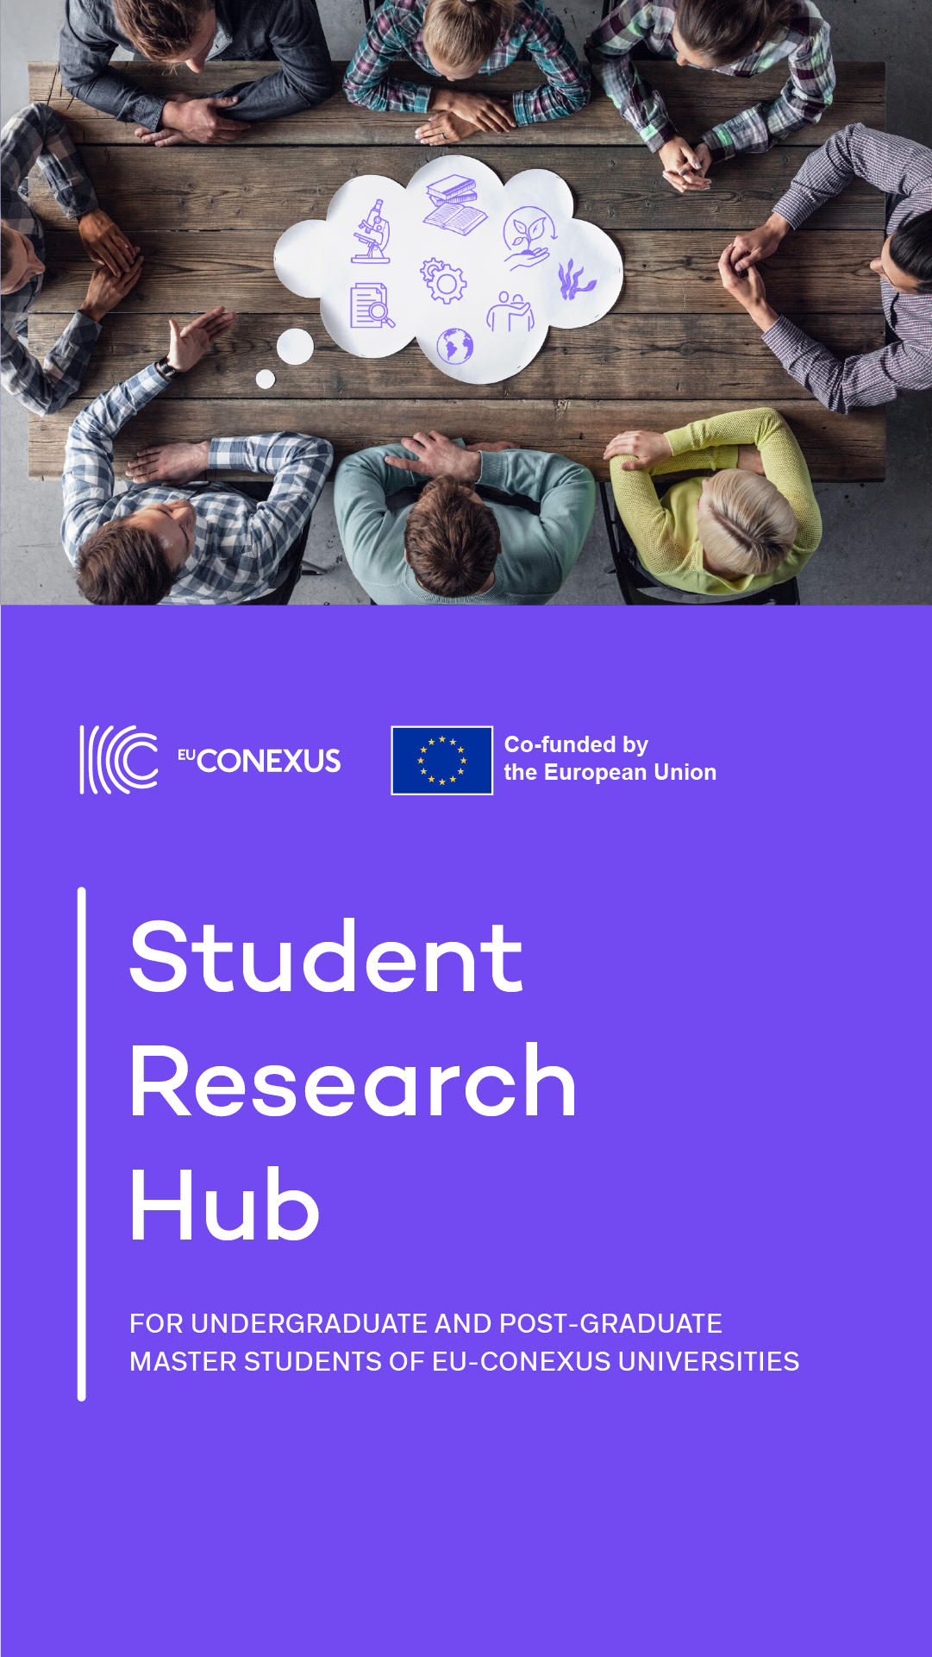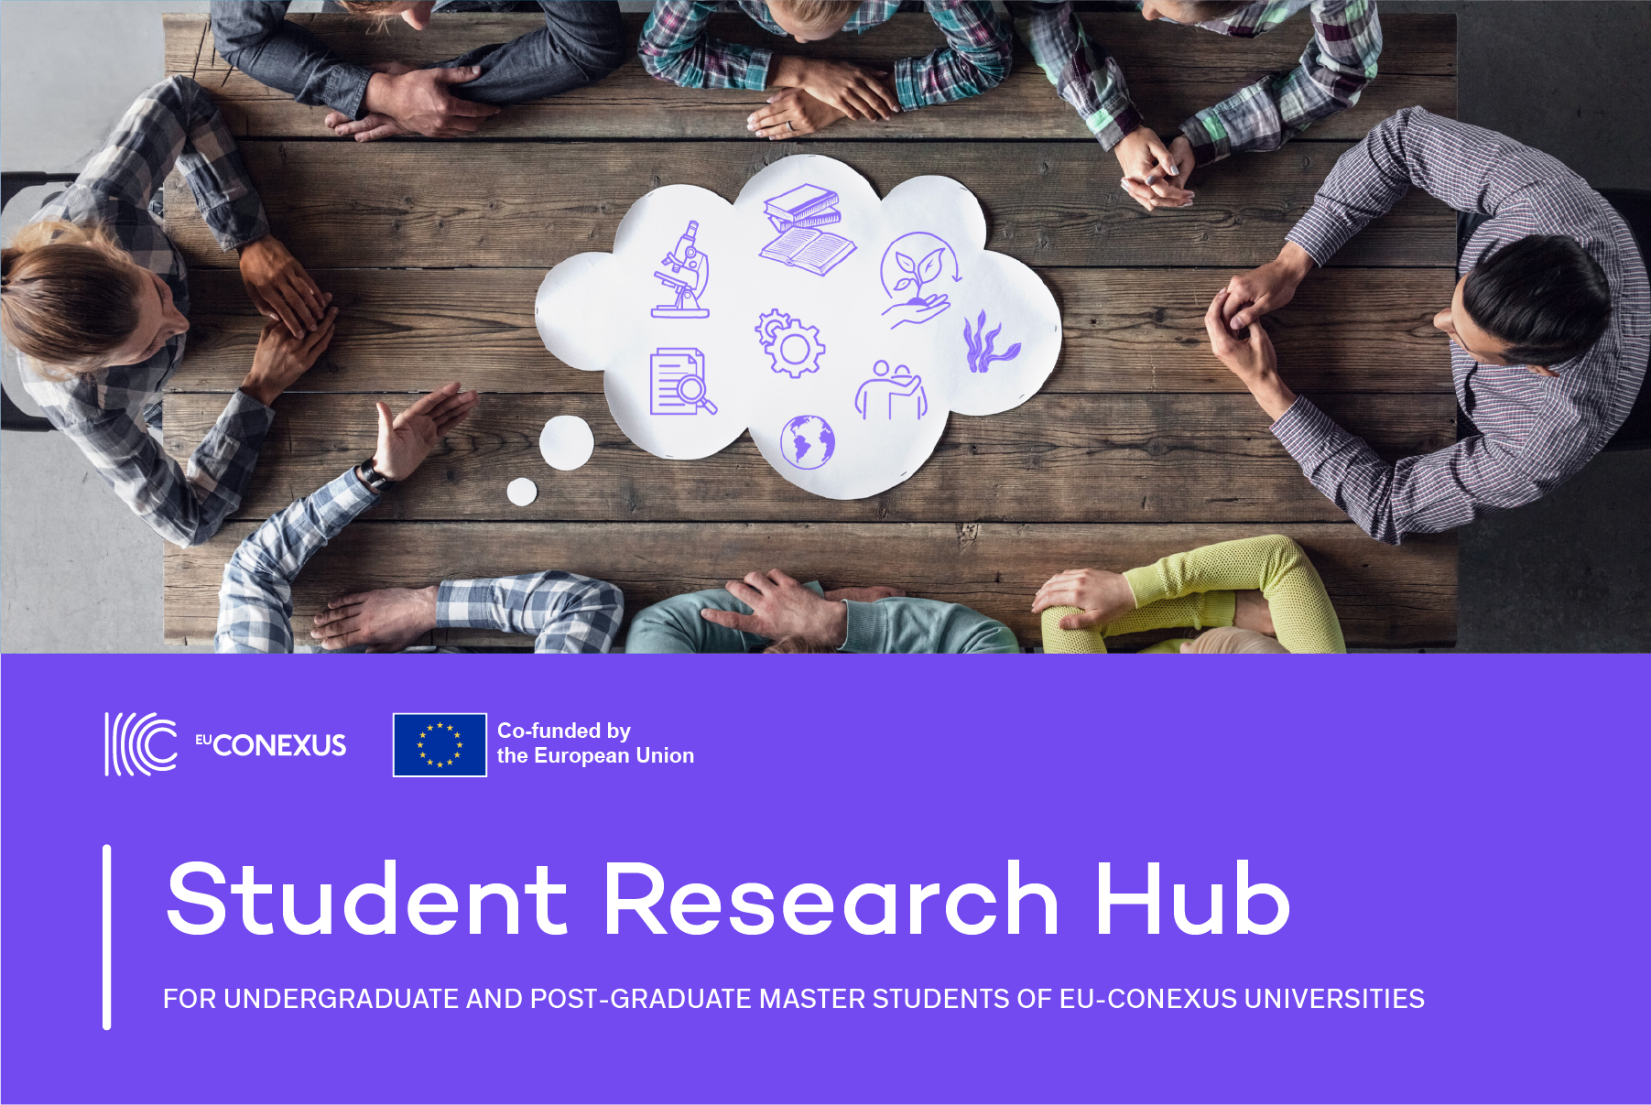

Series II
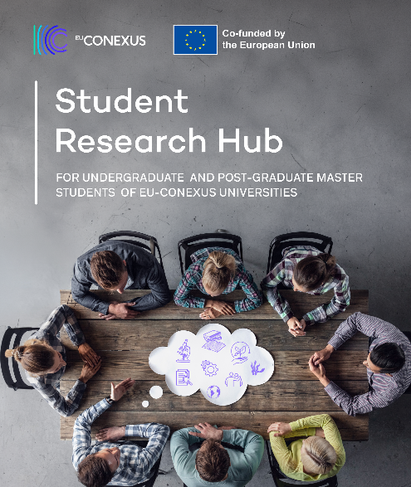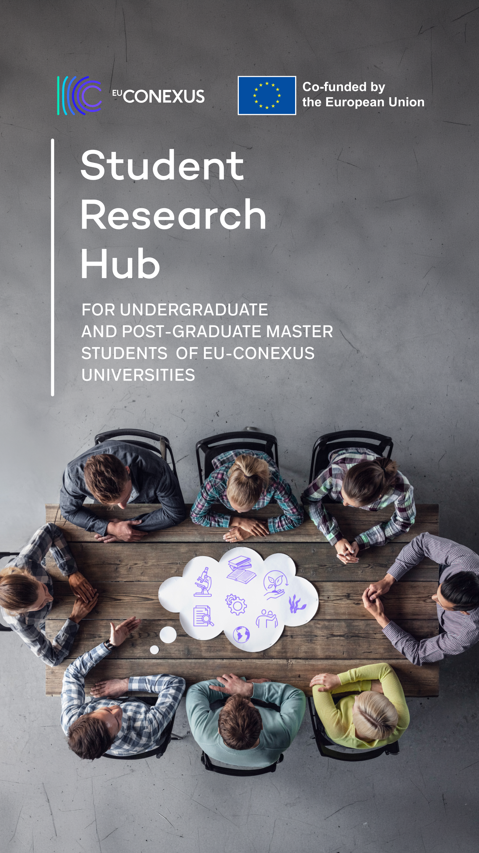

Facebook post promoting Student Research Hub offers
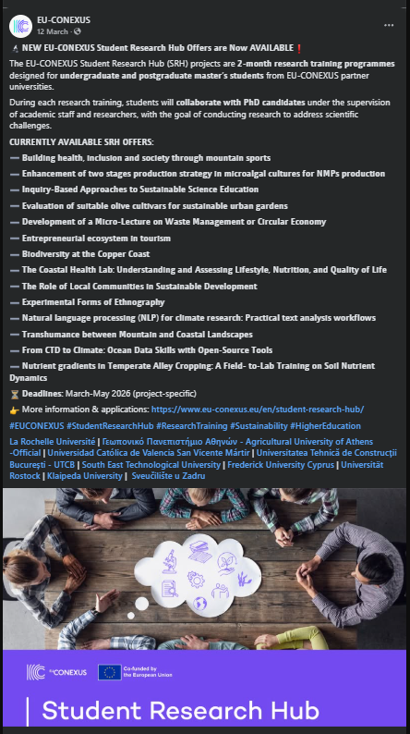

Instagram post promoting Student Research Hub offers
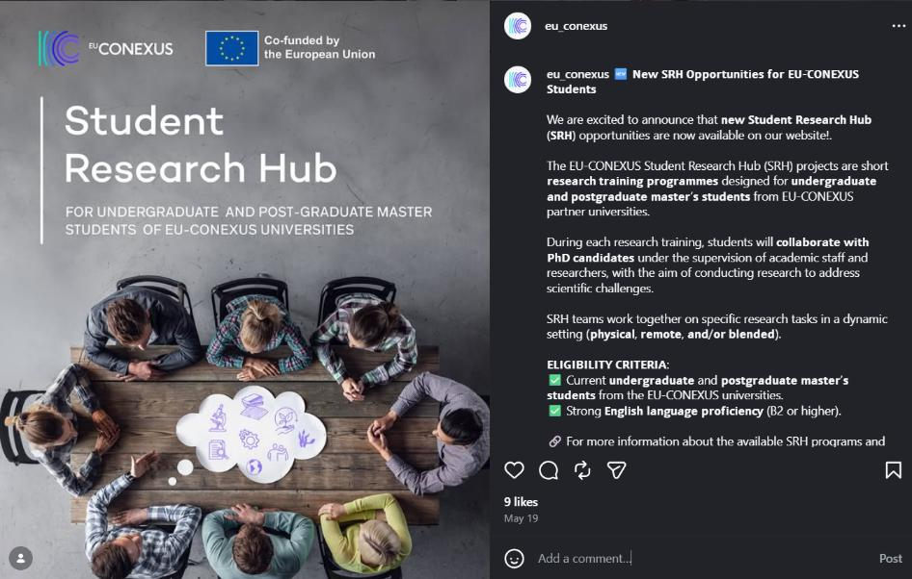

LinkedIn post featuring a Student Research Hub testimonial

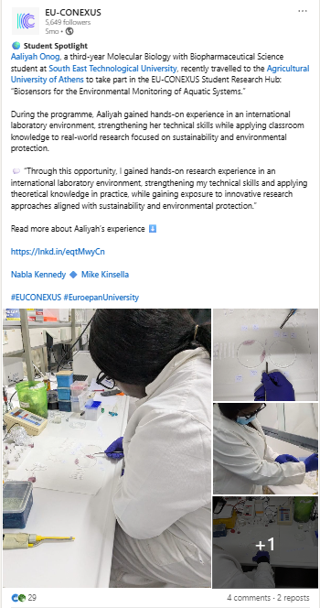

Other dissemination materials

SRH Articles on the website (testimonials, podcast, events)
- EU-CONEXUS Closing Workshop Highlights Student Research Achievements 2025
- EU-CONEXUS Closing Workshop Highlights Student Research Achievements 2026
- EU-CONEXUS Information Day at the Agricultural University of Athens
- EU-CONEXUS mobility enhances Aaliyah’s research skills
- EU-CONEXUS Student Research Hub: Exploring Sustainable Solutions at Klaipėda University
- SmUCS Weekly Bite: Nurturing the fish we eat: scientists are innovating feed to support fish health
- Biology student Sasha’s research brings her to Athens
- Building Belonging at South East Technological University: Connect Fest & Re-Connect Fest Bring Students and Staff Together

Boosted Video on Social Media:
  - Facebook: https://www.facebook.com/share/r/14e5LVpWLMr/
  - Instagram: https://www.instagram.com/reel/DUVBI5biOHt/?igsh=MTl3ZnFlYmlodWdhbw==

Reels
SRH in Athens:
https://www.instagram.com/reels/DD65T-it8R2/

Podcast
New Podcast Episode – EU-CONEXUS student research hub on Sustainable Food Systems

Appendix VIIΙ. Closing Virtual Workshops on Undergraduate Research Activities Documents and program

2023-2024
Program
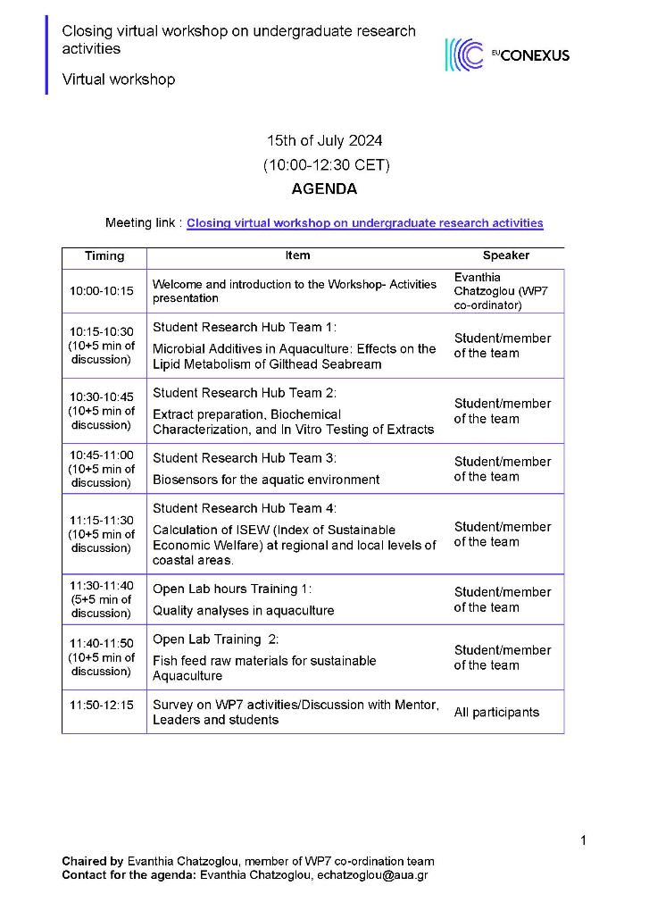
Pictures
 | 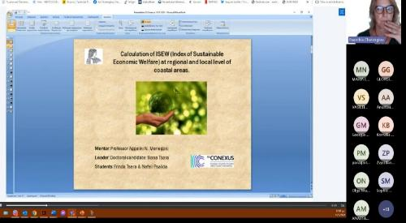
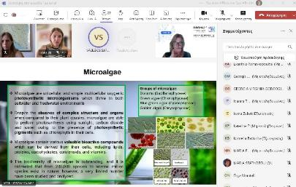 | 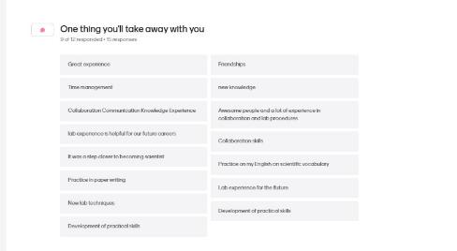

2024-2025
Program
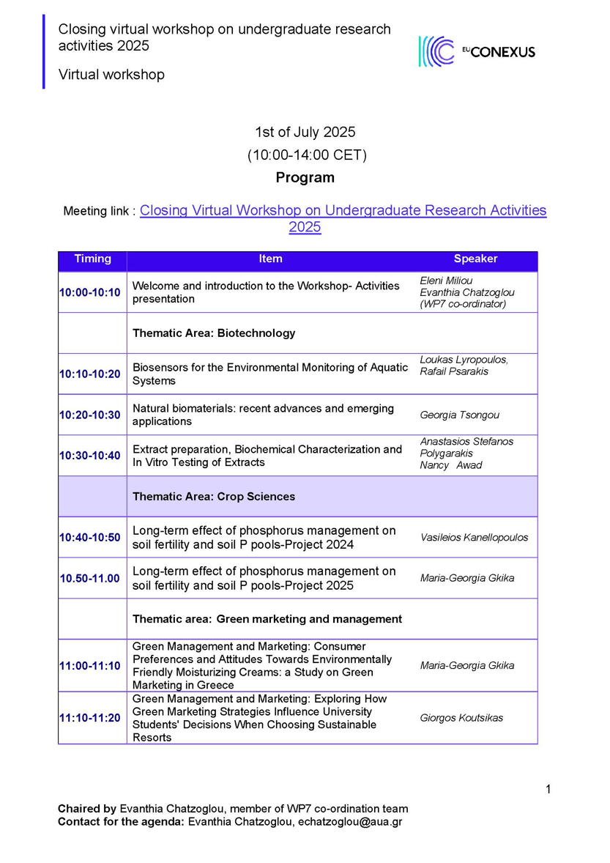
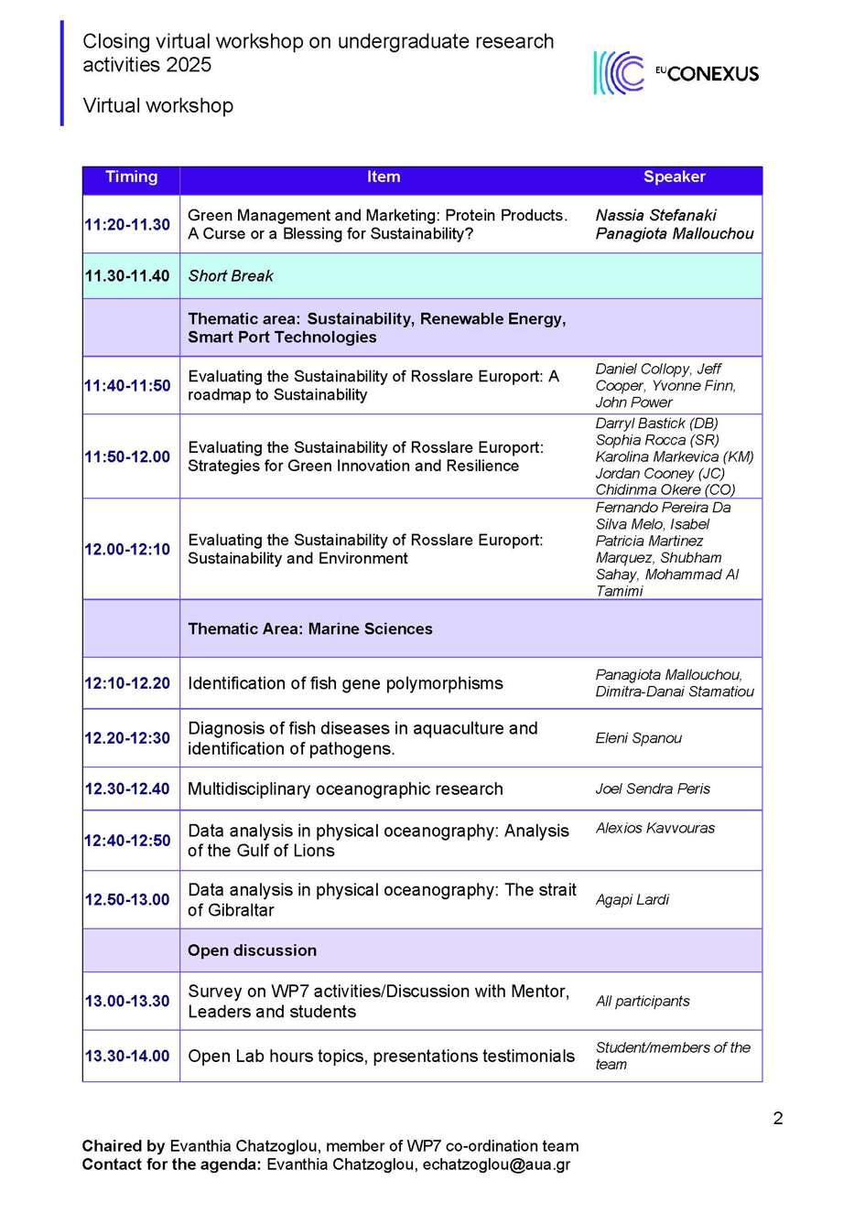

Pictures
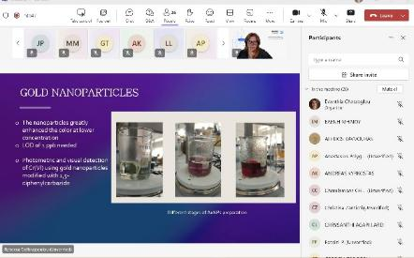 | 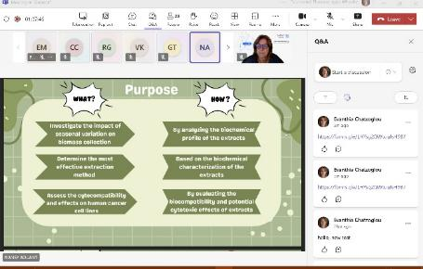
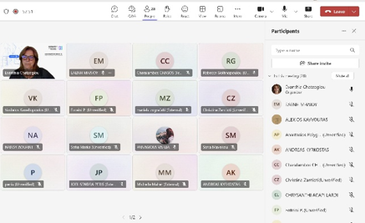 | 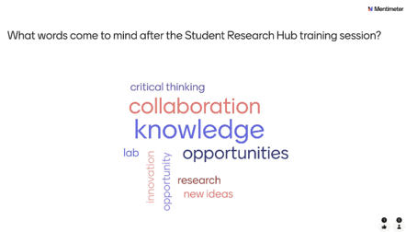

2025-2026

Program
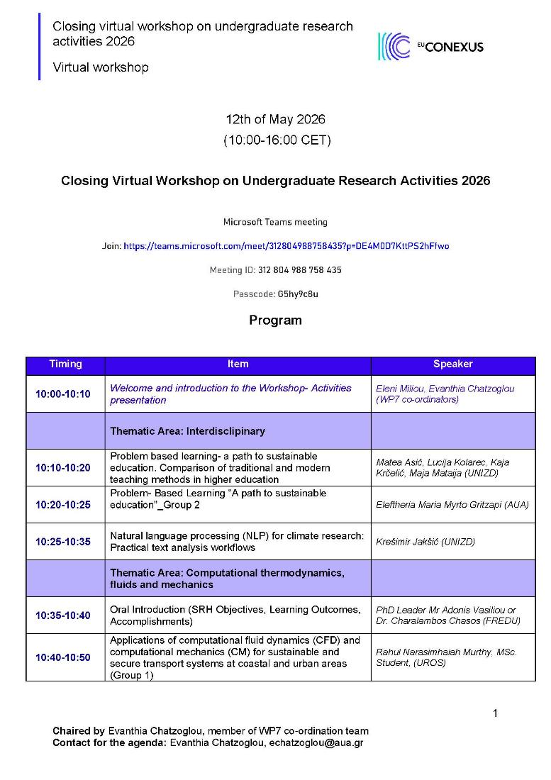
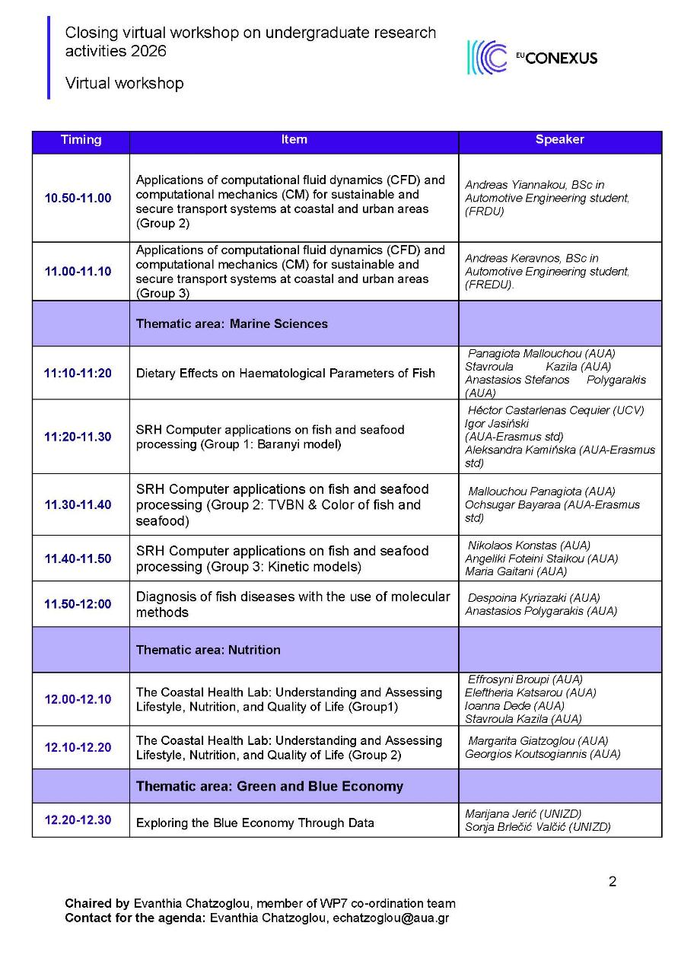
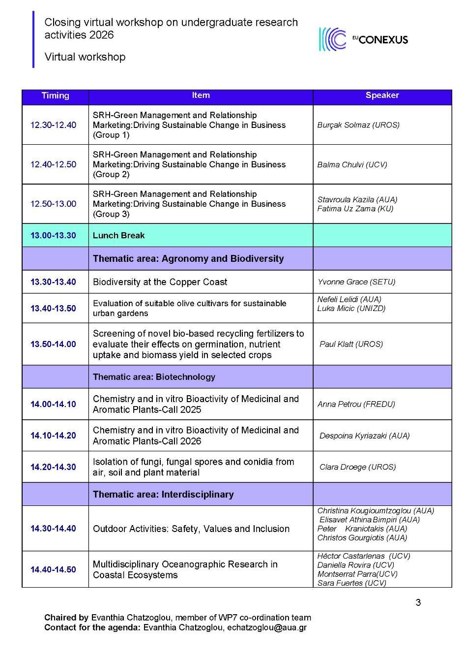
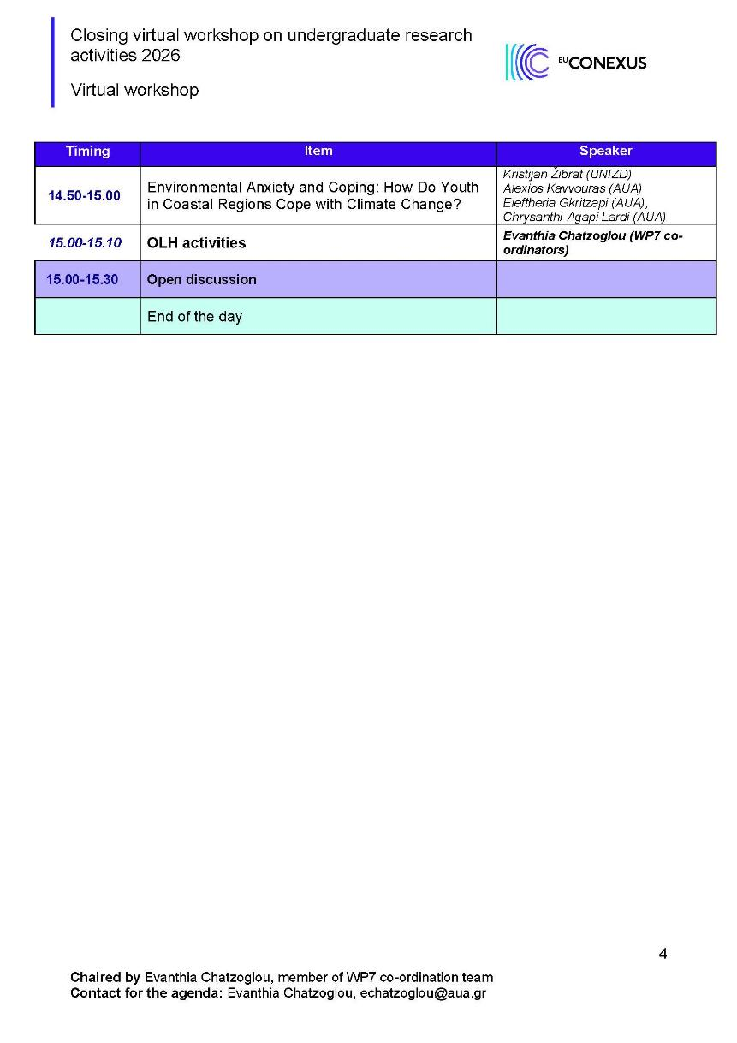

Photos
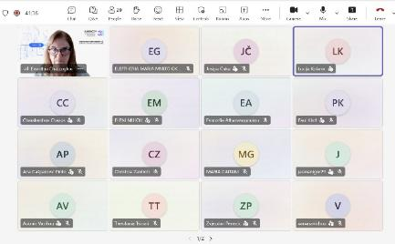 | 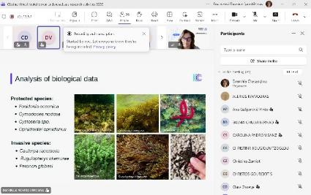
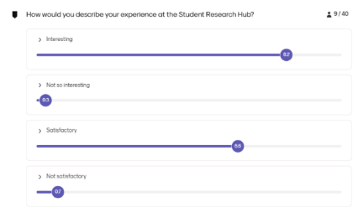 | 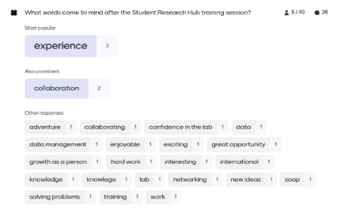

Buffalari D, Fernandes JJ, Chase L, Lom B, McMurray MS, Morrison ME, Stavnezer AJ. Integrating Research into the Undergraduate Curriculum: 1. Early Research Experiences and Training. J Undergrad Neurosci Educ. 2020 Dec 31;19(1):A52-A63. PMID: 33880092; PMCID: PMC8040836.
Healey, Mick & Jenkins, Alan. (2009). Developing Undergraduate Research and Inquiry.
Hayes SM. Engaging Early-Career Students in Research Using a Tiered Mentoring Model. ACS Symp Ser Am Chem Soc. 2018;1275:273-289. doi: 10.1021/bk-2018-1275.ch016. Epub 2018 May 2. PMID: 31534283; PMCID: PMC6750028.
Marcia C. Linn et al. ,Undergraduate research experiences: Impacts and opportunities. Science 347,1261757(2015).DOI:10.1126/science.1261757
Frame, D.L., Owen, P., Mallory, B., Wilkins, H. and Oehlhof, M., 2017. A qualitative review of early undergraduate research from the perspective of faculty members, academic advisors, and undergraduate researchers (students) at a two-year college. The Journal for Research and Practice in College Teaching, 2(1).
Adebisi YA. Undergraduate students' involvement in research: Values, benefits, barriers and recommendations. Ann Med Surg (Lond). 2022 Aug 17;81:104384. doi: 10.1016/j.amsu.2022.104384. PMID: 36042923; PMCID: PMC9420469.
Healey M. Developing Students as Researchers Navigating Between Teaching, Learning and Inquiry: Developing Students as Researchers. 2011;

